**The Definitive Guide  
for the  
Amplitude Invariant Clarke Transforms  
and the  
Park Transforms**

**A-B-C $⇔$ Alpha-Beta-Zero**

**Alpha-Beta-Zero $⇔$ D-Q-Zero**

**A-B-C $⇔$ D-Q-Zero**

**Siyu Gao**

**2017**

# Abstract

This document serves as a reference for different versions of the Clarke Transforms and the Park Transforms (including the inverse transforms). Detailed mathematical procedures are included.

The purpose of the Clarke Transforms is to convert the three-phase $abc$ quantities to the equivalent three-phase $αβ0$ quantities (general) or to the equivalent 2-phase $αβ$ quantities (special).

The different versions of the Clarke Transforms discussed in this document are:

1. General Amplitude Invariant Clarke Transform (with zero sequence, A-B-C $⇔$ Alpha-Beta-Zero)
2. Special Amplitude Invariant Clarke Transform (without zero sequence, A-B-C $⇔$ Alpha-Beta)

Please refer to Section 1 for the mathematical details of these versions of the Clarke Transforms.

The purpose of the Park Transforms is to convert the three-phase $αβ0$ quantities to the equivalent three-phase $dq0$ quantities (general) or to convert the 2-phase $αβ$ quantities to the equivalent 2-phase $dq$ quantities (special).

Note that, by applying the Double Synchronous Reference Frame (DSRF) concept to the Special Park Transform, the DSRF Park Transform can be yielded. The purpose of the DSRF Park Transform is to convert the 2-phase $αβ$ quantities to the equivalent 4-phase $dq$ quantities (with positive sequence components and negative sequence components, these quantities are **Coupled** [1]).

The different versions of the Park Transforms discussed in this document are:

1. General Park Transform (with zero sequence, Alpha-Beta-Zero $⇔$ D-Q-Zero)
2. Special Park Transform (without zero sequence, Alpha-Beta $⇔$ D-Q)
3. DSRF Park Transform (computes the positive sequence components and negative sequence components, Alpha-Beta $⇔$ Dpositive-Qpositive-Dnegative-Qnegative).

Note that the DSRF Park Transform is a version based on the Special Park Transform. The DSRF Park Transform computes the **Coupled $dq$** quantities from the $αβ$ quantities (calculated using the Special Amplitude Invariant Clarke Transform). For the definition of the **Coupled $dq$** quantities and the subsequent implications, please consult [1].

Please refer to Section 2 for the mathematical details of the aforementioned versions of the Park Transform.

The different versions of the Clarke Transforms and the Park Transforms can be combined to form combined transforms, in order to achieve one-step transformations.

The different versions of the combined transforms discussed in this document are:

1. General Combined Clarke and Park Transform (A-B-C $⇔$ D-Q-Zero)
2. Special Combined Clarke and Park Transform (A-B-C $⇔$ D-Q)
3. DSRF Combined Clarke and Park Transform (A-B-C $⇔$ Dpositive-Qpositive-Dnegative-Qnegative)

Please refer to Section **Error! Reference source not found.** for the mathematical details of the aforementioned versions of the combined transforms.

For ease of use, all the transforms are listed in this section (see next page). Note that “Zero” is used to denote the zero sequence component, in order to distinguish it from the numeric value of “0”.

**The Clarke Transforms**

1. ***General Amplitude Invariant Clarke Transform:***

|  |  |
| --- | --- |
| $$\left[\begin{matrix}α \\ β \\ Zero\end{matrix}\right]= \frac{2}{3}\left[\begin{matrix}1 & -\frac{1}{2} & -\frac{1}{2} \\ 0 & \frac{\sqrt{3}}{2} & -\frac{\sqrt{3}}{2} \\ \frac{1}{2} & \frac{1}{2} & \frac{1}{2}\end{matrix}\right]\left[\begin{matrix}a \\ b \\ c\end{matrix}\right]$$ | A.1 |

1. ***Inverse General Amplitude Invariant Clarke Transform:***

|  |  |
| --- | --- |
| $$\left[\begin{matrix}a \\ b \\ c\end{matrix}\right]=\left[\begin{matrix}1 & 0 & 1 \\ -\frac{1}{2} & \frac{\sqrt{3}}{2} & 1 \\ -\frac{1}{2} & -\frac{\sqrt{3}}{2} & 1\end{matrix}\right]\left[\begin{matrix}α \\ β \\ Zero\end{matrix}\right]$$ | A.2 |

1. ***Special Amplitude Invariant Clarke Transform:***

|  |  |
| --- | --- |
| $$\left[\begin{matrix}α \\ β\end{matrix}\right]= \frac{2}{3}\left[\begin{matrix}1 & -\frac{1}{2} & -\frac{1}{2} \\ 0 & \frac{\sqrt{3}}{2} & -\frac{\sqrt{3}}{2}\end{matrix}\right]\left[\begin{matrix}a \\ b \\ c\end{matrix}\right]$$ | A.3 |

1. ***Inverse Special Amplitude Invariant Clarke Transform:***

|  |  |
| --- | --- |
| $$\left[\begin{matrix}a \\ b \\ c\end{matrix}\right]= \left[\begin{matrix}1 & 0 \\ -\frac{1}{2} & \frac{\sqrt{3}}{2} \\ -\frac{1}{2} & -\frac{\sqrt{3}}{2}\end{matrix}\right]\left[\begin{matrix}α \\ β\end{matrix}\right]$$ | A.4 |

**The Park Transforms**

1. ***General Park Transform:***

|  |  |
| --- | --- |
| $$\left[\begin{matrix}d \\ q \\ Zero\end{matrix}\right]= \left[\begin{matrix}cosθ & sinθ & 0 \\ -sinθ & cosθ & 0 \\ 0 & 0 & 1\end{matrix}\right]\left[\begin{matrix}α \\ β \\ Zero\end{matrix}\right]$$ | A.5 |

For ease of implementation in MATLAB, A.5 may be rewritten as A.6:

|  |  |
| --- | --- |
| $$\left[\begin{matrix}d \\ q \\ Zero\end{matrix}\right]= cosθ\left[\begin{matrix}1 & 0 & 0 \\ 0 & 1 & 0 \\ 0 & 0 & 0\end{matrix}\right]\left[\begin{matrix}α \\ β \\ Zero\end{matrix}\right]+sinθ\left[\begin{matrix}0 & 1 & 0 \\ -1 & 0 & 0 \\ 0 & 0 & 0\end{matrix}\right]\left[\begin{matrix}α \\ β \\ Zero\end{matrix}\right]+\left[\begin{matrix}0 & 0 & 0 \\ 0 & 0 & 0 \\ 0 & 0 & 1\end{matrix}\right]\left[\begin{matrix}α \\ β \\ Zero\end{matrix}\right]$$ | A.6 |

1. ***Inverse General Park Transform:***

|  |  |
| --- | --- |
| $$\left[\begin{matrix}α \\ β \\ Zero\end{matrix}\right]= \left[\begin{matrix}cosθ & -sinθ & 0 \\ sinθ & cosθ & 0 \\ 0 & 0 & 1\end{matrix}\right]\left[\begin{matrix}d \\ q \\ Zero\end{matrix}\right]$$ | A.7 |

For ease of implementation in MATLAB, A.7 may be rewritten as A.8:

|  |  |
| --- | --- |
| $$\left[\begin{matrix}α \\ β \\ Zero\end{matrix}\right]=cosθ \left[\begin{matrix}1 & 0 & 0 \\ 0 & 1 & 0 \\ 0 & 0 & 0\end{matrix}\right]\left[\begin{matrix}d \\ q \\ Zero\end{matrix}\right]+sinθ\left[\begin{matrix}0 & -1 & 0 \\ 1 & 0 & 0 \\ 0 & 0 & 0\end{matrix}\right]\left[\begin{matrix}d \\ q \\ Zero\end{matrix}\right]+\left[\begin{matrix}0 & 0 & 0 \\ 0 & 0 & 0 \\ 0 & 0 & 1\end{matrix}\right]\left[\begin{matrix}d \\ q \\ Zero\end{matrix}\right]$$ | A.8 |

1. ***Special Park Transform:***

|  |  |
| --- | --- |
| $$\left[\begin{matrix}d \\ q\end{matrix}\right]= \left[\begin{matrix}cosθ & sinθ \\ -sinθ & cosθ\end{matrix}\right]\left[\begin{matrix}α \\ β\end{matrix}\right]$$ | A.9 |

For ease of implementation in MATLAB, A.9 may be rewritten as A.10:

|  |  |
| --- | --- |
| $$\left[\begin{matrix}d \\ q\end{matrix}\right]=cosθ\left[\begin{matrix}1 & 0 \\ 0 & 1\end{matrix}\right]\left[\begin{matrix}α \\ β\end{matrix}\right]+sinθ\left[\begin{matrix}0 & 1 \\ -1 & 0\end{matrix}\right]\left[\begin{matrix}α \\ β\end{matrix}\right]$$ | A.10 |

1. ***Inverse Special Park Transform:***

|  |  |
| --- | --- |
| $$\left[\begin{matrix}α \\ β\end{matrix}\right]= \left[\begin{matrix}cosθ & -sinθ \\ sinθ & cosθ\end{matrix}\right]\left[\begin{matrix}d \\ q\end{matrix}\right]$$ | A.11 |

For ease of implementation in MATLAB, A.11 may be rewritten as A.12:

|  |  |
| --- | --- |
| $$\left[\begin{matrix}α \\ β\end{matrix}\right]= cosθ\left[\begin{matrix}1 & 0 \\ 0 & 1\end{matrix}\right]\left[\begin{matrix}d \\ q\end{matrix}\right]+sinθ\left[\begin{matrix}0 & -1 \\ 1 & 0\end{matrix}\right]\left[\begin{matrix}d \\ q\end{matrix}\right]$$ | A.12 |

1. ***DSRF Park Transform:***

|  |  |
| --- | --- |
| $$\left[\begin{matrix}d_{+DSRF} \\ q_{+DSRF} \\ \begin{matrix}d_{-DSRF} \\ q_{-DSRF}\end{matrix}\end{matrix}\right]= \left[\begin{matrix}cosθ & sinθ \\ -sinθ & cosθ \\ cosθ & -sinθ \\ sinθ & cosθ\end{matrix}\right]\left[\begin{matrix}α \\ β\end{matrix}\right]$$ | A.13 |

where the subscripts $+$ and $-$ are used denote “positive sequence component” and “negative sequence component” respectively.

For ease of implementation in MATLAB, A.13 may be rewritten as A.14:

|  |  |
| --- | --- |
| $$\left[\begin{matrix}d_{+DSRF} \\ q_{+DSRF} \\ \begin{matrix}d_{-DSRF} \\ q_{-DSRF}\end{matrix}\end{matrix}\right]= cosθ\left[\begin{matrix}1 & 0 \\ 0 & 1 \\ 1 & 0 \\ 0 & 1\end{matrix}\right]\left[\begin{matrix}α \\ β\end{matrix}\right]+sinθ\left[\begin{matrix}0 & 1 \\ -1 & 0 \\ 0 & -1 \\ 1 & 0\end{matrix}\right]\left[\begin{matrix}α \\ β\end{matrix}\right]$$ | A.14 |

1. ***Inverse DSRF Park Transform:***

|  |  |
| --- | --- |
| $$\left[\begin{matrix}α \\ β\end{matrix}\right]= \frac{1}{2}\left[\begin{matrix}cosθ & -sinθ & cosθ & sinθ \\ sinθ & cosθ & -sinθ & cosθ\end{matrix}\right]\left[\begin{matrix}d_{+DSRF} \\ q_{+DSRF} \\ \begin{matrix}d_{-DSRF} \\ q_{-DSRF}\end{matrix}\end{matrix}\right]$$ | A.15 |

For ease of implementation in MATLAB, A.15 may be rewritten as A.16:

|  |  |
| --- | --- |
| $$\left[\begin{matrix}α \\ β\end{matrix}\right]= \frac{1}{2}\left\{cosθ\left[\begin{matrix}1 & 0 & 1 & 0 \\ 0 & 1 & 0 & 1\end{matrix}\right]\left[\begin{matrix}d_{+DSRF} \\ q_{+DSRF} \\ \begin{matrix}d_{-DSRF} \\ q_{-DSRF}\end{matrix}\end{matrix}\right]+sinθ\left[\begin{matrix}0 & -1 & 0 & 1 \\ 1 & 0 & -1 & 0\end{matrix}\right]\left[\begin{matrix}d_{+DSRF} \\ q_{+DSRF} \\ \begin{matrix}d_{-DSRF} \\ q_{-DSRF}\end{matrix}\end{matrix}\right]\right\}$$ | A.16 |

**Combined Clarke and Park Transforms**

1. ***General Combined Clarke and Park Transform:***

|  |  |
| --- | --- |
| $$\left[\begin{matrix}d \\ q \\ Zero\end{matrix}\right]=\frac{2}{3}\left[\begin{matrix}cosθ & -\frac{1}{2}cosθ+\frac{\sqrt{3}}{2}sinθ & -\frac{1}{2}cosθ-\frac{\sqrt{3}}{2}sinθ \\ -sinθ & \frac{1}{2}sinθ+\frac{\sqrt{3}}{2}cosθ & \frac{1}{2}sinθ-\frac{\sqrt{3}}{2}cosθ \\ \frac{1}{2} & \frac{1}{2} & \frac{1}{2}\end{matrix}\right]\left[\begin{matrix}a \\ b \\ c\end{matrix}\right]$$ | A.17 |
| $$\left[\begin{matrix}d \\ q \\ Zero\end{matrix}\right]=\frac{2}{3}\left[\begin{matrix}cosθ & cos\left(θ-120°\right) & cos\left(θ+120°\right) \\ -sinθ & -sin\left(θ-120°\right) & -sin\left(θ+120°\right) \\ \frac{1}{2} & \frac{1}{2} & \frac{1}{2}\end{matrix}\right]\left[\begin{matrix}a \\ b \\ c\end{matrix}\right]$$ | A.18 |

For ease of implementation in MATLAB, A.17 may be rewritten as A.19 or A.20:

|  |  |
| --- | --- |
| $$\left[\begin{matrix}d \\ q \\ Zero\end{matrix}\right]=\frac{2}{3}\left\{cosθ\left[\begin{matrix}1 & -\frac{1}{2} & -\frac{1}{2} \\ 0 & \frac{\sqrt{3}}{2} & -\frac{\sqrt{3}}{2} \\ 0 & 0 & 0\end{matrix}\right]+sinθ\left[\begin{matrix}0 & \frac{\sqrt{3}}{2} & -\frac{\sqrt{3}}{2} \\ -1 & \frac{1}{2} & \frac{1}{2} \\ 0 & 0 & 0\end{matrix}\right]+\left[\begin{matrix}0 & 0 & 0 \\ 0 & 0 & 0 \\ \frac{1}{2} & \frac{1}{2} & \frac{1}{2}\end{matrix}\right]\right\}\left[\begin{matrix}a \\ b \\ c\end{matrix}\right]$$ | A.19 |
| $$\left[\begin{matrix}d \\ q \\ Zero\end{matrix}\right]=\frac{2}{3}\left\{cosθ\left[\begin{matrix}1 & -\frac{1}{2} & -\frac{1}{2} \\ 0 & \frac{\sqrt{3}}{2} & -\frac{\sqrt{3}}{2} \\ 0 & 0 & 0\end{matrix}\right]\left[\begin{matrix}a \\ b \\ c\end{matrix}\right]+sinθ\left[\begin{matrix}0 & \frac{\sqrt{3}}{2} & -\frac{\sqrt{3}}{2} \\ -1 & \frac{1}{2} & \frac{1}{2} \\ 0 & 0 & 0\end{matrix}\right]\left[\begin{matrix}a \\ b \\ c\end{matrix}\right]+\left[\begin{matrix}0 & 0 & 0 \\ 0 & 0 & 0 \\ \frac{1}{2} & \frac{1}{2} & \frac{1}{2}\end{matrix}\right]\left[\begin{matrix}a \\ b \\ c\end{matrix}\right]\right\}$$ | A.20 |

1. ***Inverse General Combined Clarke and Park Transform:***

|  |  |
| --- | --- |
| $$\left[\begin{matrix}a \\ b \\ c\end{matrix}\right]=\left[\begin{matrix}cosθ & -sinθ & 1 \\ -\frac{1}{2}cosθ+\frac{\sqrt{3}}{2}sinθ & \frac{1}{2}sinθ+\frac{\sqrt{3}}{2}cosθ & 1 \\ -\frac{1}{2}cosθ-\frac{\sqrt{3}}{2}sinθ & \frac{1}{2}sinθ-\frac{\sqrt{3}}{2}cosθ & 1\end{matrix}\right]\left[\begin{matrix}d \\ q \\ Zero\end{matrix}\right]$$ | A.21 |
| $$\left[\begin{matrix}a \\ b \\ c\end{matrix}\right]=\left[\begin{matrix}cosθ & -sinθ & 1 \\ cos\left(θ-120°\right) & -sin\left(θ-120°\right) & 1 \\ cos\left(θ+120°\right) & -sin\left(θ+120°\right) & 1\end{matrix}\right]\left[\begin{matrix}d \\ q \\ Zero\end{matrix}\right]$$ | A.22 |

For ease of implementation in MATLAB, A.21 may be rewritten as A.23 or A.24:

|  |  |
| --- | --- |
| $$\left[\begin{matrix}a \\ b \\ c\end{matrix}\right]=\left\{cosθ\left[\begin{matrix}1 & 0 & 0 \\ -\frac{1}{2} & \frac{\sqrt{3}}{2} & 0 \\ -\frac{1}{2} & -\frac{\sqrt{3}}{2} & 0\end{matrix}\right]+sinθ\left[\begin{matrix}0 & -1 & 0 \\ \frac{\sqrt{3}}{2} & \frac{1}{2} & 0 \\ -\frac{\sqrt{3}}{2} & \frac{1}{2} & 0\end{matrix}\right]+\left[\begin{matrix}0 & 0 & 1 \\ 0 & 0 & 1 \\ 0 & 0 & 1\end{matrix}\right]\right\}\left[\begin{matrix}d \\ q \\ Zero\end{matrix}\right]$$ | A.23 |
| $$\left[\begin{matrix}a \\ b \\ c\end{matrix}\right]=cosθ\left[\begin{matrix}1 & 0 & 0 \\ -\frac{1}{2} & \frac{\sqrt{3}}{2} & 0 \\ -\frac{1}{2} & -\frac{\sqrt{3}}{2} & 0\end{matrix}\right]\left[\begin{matrix}d \\ q \\ Zero\end{matrix}\right]+sinθ\left[\begin{matrix}0 & -1 & 0 \\ \frac{\sqrt{3}}{2} & \frac{1}{2} & 0 \\ -\frac{\sqrt{3}}{2} & \frac{1}{2} & 0\end{matrix}\right]\left[\begin{matrix}d \\ q \\ Zero\end{matrix}\right]+\left[\begin{matrix}0 & 0 & 1 \\ 0 & 0 & 1 \\ 0 & 0 & 1\end{matrix}\right]\left[\begin{matrix}d \\ q \\ Zero\end{matrix}\right]$$ | A.24 |

1. ***Special Combined Clarke and Park Transform:***

|  |  |
| --- | --- |
| $$\left[\begin{matrix}d \\ q\end{matrix}\right]= \frac{2}{3}\left[\begin{matrix}cosθ & -\frac{1}{2}cosθ+\frac{\sqrt{3}}{2}sinθ & -\frac{1}{2}cosθ-\frac{\sqrt{3}}{2}sinθ \\ sinθ & \frac{1}{2}sinθ+\frac{\sqrt{3}}{2}cosθ & \frac{1}{2}sinθ-\frac{\sqrt{3}}{2}cosθ\end{matrix}\right]\left[\begin{matrix}a \\ b \\ c\end{matrix}\right]$$ | A.25 |
| $$\left[\begin{matrix}d \\ q\end{matrix}\right]= \frac{2}{3}\left[\begin{matrix}cosθ & cos\left(θ-120°\right) & cos\left(θ+120°\right) \\ sinθ & -sin\left(θ-120°\right) & -sin\left(θ+120°\right)\end{matrix}\right]\left[\begin{matrix}a \\ b \\ c\end{matrix}\right]$$ | A.26 |

For ease of implementation in MATLAB, A.25 may be rewritten as A.27 or A.28:

|  |  |
| --- | --- |
| $$\left[\begin{matrix}d \\ q\end{matrix}\right]=\frac{2}{3}\left\{cosθ\left[\begin{matrix}1 & -\frac{1}{2} & -\frac{1}{2} \\ 0 & \frac{\sqrt{3}}{2} & -\frac{\sqrt{3}}{2}\end{matrix}\right]+sinθ\left[\begin{matrix}0 & \frac{\sqrt{3}}{2} & -\frac{\sqrt{3}}{2} \\ -1 & \frac{1}{2} & \frac{1}{2}\end{matrix}\right]\right\}\left[\begin{matrix}a \\ b \\ c\end{matrix}\right]$$ | A.27 |
| $$\left[\begin{matrix}d \\ q\end{matrix}\right]= \frac{2}{3}\left\{cosθ\left[\begin{matrix}1 & -\frac{1}{2} & -\frac{1}{2} \\ 0 & \frac{\sqrt{3}}{2} & -\frac{\sqrt{3}}{2}\end{matrix}\right]\left[\begin{matrix}a \\ b \\ c\end{matrix}\right]+sinθ\left[\begin{matrix}0 & \frac{\sqrt{3}}{2} & -\frac{\sqrt{3}}{2} \\ -1 & \frac{1}{2} & \frac{1}{2}\end{matrix}\right]\left[\begin{matrix}a \\ b \\ c\end{matrix}\right]\right\}$$ | A.28 |

1. ***Inverse Special Combined Clarke and Park Transform:***

|  |  |
| --- | --- |
| $$\left[\begin{matrix}a \\ b \\ c\end{matrix}\right]=\left[\begin{matrix}cosθ & -sinθ \\ -\frac{1}{2}cosθ+\frac{\sqrt{3}}{2}sinθ & \frac{1}{2}sinθ+\frac{\sqrt{3}}{2}cosθ \\ -\frac{1}{2}cosθ-\frac{\sqrt{3}}{2}sinθ & \frac{1}{2}sinθ-\frac{\sqrt{3}}{2}cosθ\end{matrix}\right]\left[\begin{matrix}d \\ q\end{matrix}\right]$$ | A.29 |
| $$\left[\begin{matrix}a \\ b \\ c\end{matrix}\right]=\left[\begin{matrix}cosθ & -sinθ \\ cos\left(θ-120°\right) & -sin\left(θ-120°\right) \\ cos\left(θ+120°\right) & -sin\left(θ+120°\right)\end{matrix}\right]\left[\begin{matrix}d \\ q\end{matrix}\right]$$ | A.30 |

For ease of implementation in MATLAB, A.29 may be rewritten as A.31 or A.32:

|  |  |
| --- | --- |
| $$\left[\begin{matrix}a \\ b \\ c\end{matrix}\right]=\left\{cosθ\left[\begin{matrix}1 & 0 \\ -\frac{1}{2} & \frac{\sqrt{3}}{2} \\ -\frac{1}{2} & -\frac{\sqrt{3}}{2}\end{matrix}\right]+sinθ\left[\begin{matrix}0 & -1 \\ \frac{\sqrt{3}}{2} & \frac{1}{2} \\ -\frac{\sqrt{3}}{2} & \frac{1}{2}\end{matrix}\right]\right\}\left[\begin{matrix}d \\ q\end{matrix}\right]$$ | A.31 |
| $$\left[\begin{matrix}a \\ b \\ c\end{matrix}\right]=cosθ\left[\begin{matrix}1 & 0 \\ -\frac{1}{2} & \frac{\sqrt{3}}{2} \\ -\frac{1}{2} & -\frac{\sqrt{3}}{2}\end{matrix}\right]\left[\begin{matrix}d \\ q\end{matrix}\right]+sinθ\left[\begin{matrix}0 & -1 \\ \frac{\sqrt{3}}{2} & \frac{1}{2} \\ -\frac{\sqrt{3}}{2} & \frac{1}{2}\end{matrix}\right]\left[\begin{matrix}d \\ q\end{matrix}\right]$$ | A.32 |

1. ***DSRF Combined Clarke and Park Transform:***

|  |  |
| --- | --- |
| $$\left[\begin{matrix}d_{+DSRF} \\ q_{+DSRF} \\ \begin{matrix}d_{-DSRF} \\ q_{-DSRF}\end{matrix}\end{matrix}\right]=\frac{2}{3}\left[\begin{matrix}cosθ & -\frac{1}{2}cosθ+\frac{\sqrt{3}}{2}sinθ & -\frac{1}{2}cosθ-\frac{\sqrt{3}}{2}sinθ \\ -sinθ & \frac{1}{2}sinθ+\frac{\sqrt{3}}{2}cosθ & \frac{1}{2}sinθ-\frac{\sqrt{3}}{2}cosθ \\ cosθ & -\frac{1}{2}cosθ-\frac{\sqrt{3}}{2}sinθ & -\frac{1}{2}cosθ+\frac{\sqrt{3}}{2}sinθ \\ sinθ & -\frac{1}{2}sinθ+\frac{\sqrt{3}}{2}cosθ & -\frac{1}{2}sinθ-\frac{\sqrt{3}}{2}cosθ\end{matrix}\right]\left[\begin{matrix}a \\ b \\ c\end{matrix}\right]$$ | A.33 |
| $$\left[\begin{matrix}d_{+DSRF} \\ q_{+DSRF} \\ \begin{matrix}d_{-DSRF} \\ q_{-DSRF}\end{matrix}\end{matrix}\right]=\frac{2}{3}\left[\begin{matrix}cosθ & cos\left(θ-120°\right) & cos\left(θ+120°\right) \\ -sinθ & -sin\left(θ-120°\right) & -sin\left(θ+120°\right) \\ cosθ & cos\left(θ+120°\right) & cos\left(θ-120°\right) \\ sinθ & sin\left(θ+120°\right) & sin\left(θ-120°\right)\end{matrix}\right]\left[\begin{matrix}a \\ b \\ c\end{matrix}\right]$$ | A.34 |

For ease of implementation in MATLAB, A.33 may be rewritten as A.35 or A.36:

|  |  |
| --- | --- |
| $$\left[\begin{matrix}d_{+DSRF} \\ q_{+DSRF} \\ \begin{matrix}d_{-DSRF} \\ q_{-DSRF}\end{matrix}\end{matrix}\right]=\frac{2}{3}\left\{cosθ\left[\begin{matrix}1 & -\frac{1}{2} & -\frac{1}{2} \\ 0 & \frac{\sqrt{3}}{2} & -\frac{\sqrt{3}}{2} \\ 1 & -\frac{1}{2} & -\frac{1}{2} \\ 0 & \frac{\sqrt{3}}{2} & -\frac{\sqrt{3}}{2}\end{matrix}\right]+sinθ\left[\begin{matrix}0 & \frac{\sqrt{3}}{2} & -\frac{\sqrt{3}}{2} \\ -1 & \frac{1}{2} & \frac{1}{2} \\ 0 & -\frac{\sqrt{3}}{2} & \frac{\sqrt{3}}{2} \\ 1 & -\frac{1}{2} & -\frac{1}{2}\end{matrix}\right]\right\}\left[\begin{matrix}a \\ b \\ c\end{matrix}\right]$$ | A.35 |
| $$\left[\begin{matrix}d_{+DSRF} \\ q_{+DSRF} \\ \begin{matrix}d_{-DSRF} \\ q_{-DSRF}\end{matrix}\end{matrix}\right]=\frac{2}{3}\left\{cosθ\left[\begin{matrix}1 & -\frac{1}{2} & -\frac{1}{2} \\ 0 & \frac{\sqrt{3}}{2} & -\frac{\sqrt{3}}{2} \\ 1 & -\frac{1}{2} & -\frac{1}{2} \\ 0 & \frac{\sqrt{3}}{2} & -\frac{\sqrt{3}}{2}\end{matrix}\right]\left[\begin{matrix}a \\ b \\ c\end{matrix}\right]+sinθ\left[\begin{matrix}0 & \frac{\sqrt{3}}{2} & -\frac{\sqrt{3}}{2} \\ -1 & \frac{1}{2} & \frac{1}{2} \\ 0 & -\frac{\sqrt{3}}{2} & \frac{\sqrt{3}}{2} \\ 1 & -\frac{1}{2} & -\frac{1}{2}\end{matrix}\right]\left[\begin{matrix}a \\ b \\ c\end{matrix}\right]\right\}$$ | A.36 |

1. ***Inverse DSRF Combined Clarke and Park Transform:***

|  |  |
| --- | --- |
| $$\left[\begin{matrix}a \\ b \\ c\end{matrix}\right]$$ $$=\frac{1}{2}\left[\begin{matrix}cosθ & -sinθ & cosθ & sinθ \\ -\frac{1}{2}cosθ+\frac{\sqrt{3}}{2}sinθ & \frac{1}{2}sinθ+\frac{\sqrt{3}}{2}cosθ & -\frac{1}{2}cosθ-\frac{\sqrt{3}}{2}sinθ & -\frac{1}{2}sinθ+\frac{\sqrt{3}}{2}cosθ \\ -\frac{1}{2}cosθ-\frac{\sqrt{3}}{2}sinθ & \frac{1}{2}sinθ-\frac{\sqrt{3}}{2}cosθ & -\frac{1}{2}cosθ+\frac{\sqrt{3}}{2}sinθ & -\frac{1}{2}sinθ-\frac{\sqrt{3}}{2}cosθ\end{matrix}\right]\left[\begin{matrix}d_{+DSRF} \\ q_{+DSRF} \\ \begin{matrix}d_{-DSRF} \\ q_{-DSRF}\end{matrix}\end{matrix}\right]$$ | A.37 |
| $$\left[\begin{matrix}a \\ b \\ c\end{matrix}\right]=\frac{1}{2}\left[\begin{matrix}cosθ & -sinθ & cosθ & sinθ \\ cos\left(θ-120°\right) & -sin\left(θ-120°\right) & cos\left(θ+120°\right) & sin\left(θ+120°\right) \\ cos\left(θ+120°\right) & -sin\left(θ+120°\right) & cos\left(θ-120°\right) & sin\left(θ-120°\right)\end{matrix}\right]\left[\begin{matrix}d_{+DSRF} \\ q_{+DSRF} \\ \begin{matrix}d_{+DSRF} \\ q_{+DSRF}\end{matrix}\end{matrix}\right]$$ | A.38 |

For ease of implementation in MATLAB, A.37 may be rewritten as A.39 or A.40:

|  |  |
| --- | --- |
| $$\left[\begin{matrix}a \\ b \\ c\end{matrix}\right]=\frac{1}{2}\left\{cosθ\left[\begin{matrix}1 & 0 & 1 & 0 \\ -\frac{1}{2} & \frac{\sqrt{3}}{2} & -\frac{1}{2} & \frac{\sqrt{3}}{2} \\ -\frac{1}{2} & -\frac{\sqrt{3}}{2} & -\frac{1}{2} & -\frac{\sqrt{3}}{2}\end{matrix}\right]+sinθ\left[\begin{matrix}0 & -1 & 0 & 1 \\ \frac{\sqrt{3}}{2} & \frac{1}{2} & -\frac{\sqrt{3}}{2} & -\frac{1}{2} \\ -\frac{\sqrt{3}}{2} & \frac{1}{2} & \frac{\sqrt{3}}{2} & -\frac{1}{2}\end{matrix}\right]\right\}\left[\begin{matrix}d_{+DSRF} \\ q_{+DSRF} \\ \begin{matrix}d_{+DSRF} \\ q_{+DSRF}\end{matrix}\end{matrix}\right]$$ | A.39 |
| $$\left[\begin{matrix}a \\ b \\ c\end{matrix}\right]=\frac{1}{2}\left\{cosθ\left[\begin{matrix}1 & 0 & 1 & 0 \\ -\frac{1}{2} & \frac{\sqrt{3}}{2} & -\frac{1}{2} & \frac{\sqrt{3}}{2} \\ -\frac{1}{2} & -\frac{\sqrt{3}}{2} & -\frac{1}{2} & -\frac{\sqrt{3}}{2}\end{matrix}\right]\left[\begin{matrix}d_{+DSRF} \\ q_{+DSRF} \\ \begin{matrix}d_{+DSRF} \\ q_{+DSRF}\end{matrix}\end{matrix}\right]+sinθ\left[\begin{matrix}0 & -1 & 0 & 1 \\ \frac{\sqrt{3}}{2} & \frac{1}{2} & -\frac{\sqrt{3}}{2} & -\frac{1}{2} \\ -\frac{\sqrt{3}}{2} & \frac{1}{2} & \frac{\sqrt{3}}{2} & -\frac{1}{2}\end{matrix}\right]\left[\begin{matrix}d_{+DSRF} \\ q_{+DSRF} \\ \begin{matrix}d_{+DSRF} \\ q_{+DSRF}\end{matrix}\end{matrix}\right]\right\}$$ | A.40 |

1. ***DSOGI based Instantaneous Symmetrical Components***

|  |  |
| --- | --- |
| $$\left[\begin{matrix}α_{+} \\ β_{+}\end{matrix}\right]=\frac{1}{2}\left[\begin{matrix}1 & -quad \\ quad & 1\end{matrix}\right]\left[\begin{matrix}α \\ β\end{matrix}\right]$$ | A.41 |
| $$\left[\begin{matrix}α_{-} \\ β_{-}\end{matrix}\right]=\frac{1}{2}\left[\begin{matrix}1 & quad \\ -quad & 1\end{matrix}\right]\left[\begin{matrix}α \\ β\end{matrix}\right]$$ | A.42 |

where $quad=e^{-j\frac{π}{2}}$ and it is a 90° phase shifter (lagging).

|  |  |
| --- | --- |
| $$\left[\begin{matrix}d_{+DSOGI} \\ q_{+DSOGI}\end{matrix}\right]=\frac{1}{2}\left[\begin{matrix}cosθ & sinθ \\ -sinθ & cosθ\end{matrix}\right]\left[\begin{matrix}α-quad_{β} \\ quad_{α}+β\end{matrix}\right]$$ | A.43 |
| $$\left[\begin{matrix}d_{-DSOGI} \\ q_{-DSOGI}\end{matrix}\right]=\frac{1}{2}\left[\begin{matrix}cosθ & sinθ \\ -sinθ & cosθ\end{matrix}\right]\left[\begin{matrix}α+quad_{β} \\ -quad_{α}+β\end{matrix}\right]$$ | A.44 |

For ease of implementation in MATLAB, A.43 may be rewritten as A.45 or A.46:

|  |  |  |
| --- | --- | --- |
| $$\left[\begin{matrix}d_{+DSOGI} \\ q_{+DSOGI}\end{matrix}\right]=\frac{1}{2}\left\{ cosθ\left[\begin{matrix}1 & 0 \\ 0 & 1\end{matrix}\right]+sinθ\left[\begin{matrix}0 & 1 \\ -1 & 0\end{matrix}\right]\right\}\left[\begin{matrix}α-quad_{β} \\ quad_{α}+β\end{matrix}\right]$$ | A.45 | |
| $$\left[\begin{matrix}d_{+DSOGI} \\ q_{+DSOGI}\end{matrix}\right]=\frac{1}{2}cosθ\left[\begin{matrix}1 & 0 \\ 0 & 1\end{matrix}\right]\left[\begin{matrix}α-quad_{β} \\ quad_{α}+β\end{matrix}\right]+\frac{1}{2}sinθ\left[\begin{matrix}0 & 1 \\ -1 & 0\end{matrix}\right]\left[\begin{matrix}α-quad_{β} \\ quad_{α}+β\end{matrix}\right]$$ | | A.46 |

where ${quad}_{α}$ is the quadrature signal of $α$, ${quad}_{β}$ is the quadrature signal of $β$.

For ease of implementation in MATLAB, A.44 may be rewritten as A.47 or A.48:

|  |  |  |
| --- | --- | --- |
| $$\left[\begin{matrix}d_{-DSOGI} \\ q_{-DSOGI}\end{matrix}\right]=\frac{1}{2}\left\{ cosθ\left[\begin{matrix}1 & 0 \\ 0 & 1\end{matrix}\right]+sinθ\left[\begin{matrix}0 & 1 \\ -1 & 0\end{matrix}\right]\right\}\left[\begin{matrix}α+quad_{β} \\ -quad_{α}+β\end{matrix}\right]$$ | A.47 | |
| $$\left[\begin{matrix}d_{-DSOGI} \\ q_{-DSOGI}\end{matrix}\right]=\frac{1}{2}cosθ\left[\begin{matrix}1 & 0 \\ 0 & 1\end{matrix}\right]\left[\begin{matrix}α+quad_{β} \\ -quad_{α}+β\end{matrix}\right]+\frac{1}{2}sinθ\left[\begin{matrix}0 & 1 \\ -1 & 0\end{matrix}\right]\left[\begin{matrix}α+quad_{β} \\ -quad_{α}+β\end{matrix}\right]$$ | | A.48 |

For the implementation of $quad$, please refer to Section 3.2.

# Table of Contents

#### Abstract 2

Table of Contents 15

List of Figures 17

List of Abbreviations and Acronyms 18

List of Nomenclature 20

1. Clarke Transforms and Inverse Transforms (A-B-C $⇔$ Alpha-Beta-Zero) 22

1.1. General Amplitude Invariant Clarke Transform (with zero sequence) 22

1.2. Special Amplitude Invariant Clarke Transform (without zero sequence) 32

2. Park Transforms and Inverse Transforms (Alpha-Beta-Zero $⇔$ D-Q-Zero) 34

2.1. General Park Transform (with zero sequence) 34

2.2. Special Park Transform (without zero sequence) 41

2.3. Double Synchronous Reference Frame Park Transform 43

3. $αβ$ Coordinate based Instantaneous Symmetrical Components (DSOGI) – An Alternative to the DSRF and DDSRF 48

3.1. DSOGI based Instantaneous Symmetrical Components 50

3.2. Second-Order Generalised Integrator based Quadrature Signal Generator 58

4. Impacts of The Clarke Transform on Different Frequency Components 62

4.1. Balanced components 63

4.2. Unbalanced components 71

4.2.1. Special case 1, interharmonics 71

4.2.2. Special case 2, magnitudes imbalance 73

5. Impacts of the Park Transform on Different Frequency Components 75

6. Conclusion 101

Reference 102

Appendix A: Clarke Transform as a Quadrature Signal Generator 103

Appendix B: Clarke Transform as A Common Mode Signal Filter 109

Appendix C: Combined Clarke and Park Transform 110

# List of Figures

Figure 1.1 The General Amplitude Invariant Clarke Transform applied on the three-phase fundamentals (positive sequence component) 24

Figure 1.2 The General Amplitude Invariant Clarke Transform applied on the three-phase fundamentals with 3rd harmonics (zero sequence component) 25

Figure 1.3 The General Amplitude Invariant Clarke Transform applied on the 4th order harmonics (positive sequence component) 26

Figure 1.4 The General Amplitude Invariant Clarke Transform applied on the 5th order harmonics (negative sequence component). Note that the component is leading the $α$ component by 90°, while the $α$ component is still the same as the $a$ component of the three-phase inputs 27

Figure 1.5 The General Amplitude Invariant Clarke Transform applied on the three-phase fundamentals with varied order (b-c-a) 28

Figure 1.6 The General Amplitude Invariant Clarke Transform applied on the three-phase fundamentals with varied order (c-a-b) 29

Figure 1.7 The General Amplitude Invariant Clarke Transform applied on the 5th order harmonics with varied order (b-c-a) 30

Figure 1.8 The General Amplitude Invariant Clarke Transform applied on the 5th order harmonics with varied order (c-a-b) 31

Figure 2.1 Three-phase fundamentals after the General Amplitude Invariant Clarke Transform and the General Park Transform (positive sequence component) 37

Figure 2.2 The General Park Transform applied on the three-phase fundamentals with 3rd harmonics (zero sequence component) 38

Figure 2.3 The General Park Transform applied on the 4th order harmonics (positive sequence component) 39

Figure 2.4 The General Park Transform applied on the 5th order harmonics (negative sequence component) 40

Figure 2.5 The DSRF Park Transform applied on the three-phase fundamentals (positive sequence) 45

Figure 2.6 46

Figure 2.7 47

Figure 3.1 DDSRF approach for calculations of the instantaneous symmetrical components 48

Figure 3.2 DSOGI approach for calculations of the instantaneous symmetrical components 49

Figure 3.3 SOGI based QSG 58

Figure 3.4 DSOGI approach for calculations of the instantaneous symmetrical components (QSGs included) 61

Figure 4.1 Output of the Clarke Transform on the 1st harmonic (fundamental). $α$ is leading $β$ by 90° 68

Figure 4.2 Output of the Clarke Transform on the 2nd harmonic. $α$ is lagging $β$ by 90° 68

Figure 4.3 Output of the Clarke Transform on the 3rd harmonic. $α$ and $β$ are zero 69

Figure 4.4 Output of the Clarke Transform on the 4th harmonic. $α$ is leading $β$ by 90° 69

Figure 4.5 Output of the Clarke Transform on the 5th harmonic. $α$ is lagging $β$ by 90° 70

Figure 4.6 Output of the Clarke Transform on the 6th harmonic. $α$ and $β$ are zero 70

Figure 4.7 Output of the Clarke Transform on $1.3×50$ Hz. $α$ and $β$ are unbalanced. The frequencies of all Clarke components remain the same as the three-phase inputs 72

Figure 4.8 Output of the Clarke Transform on $2.4×50$ Hz. $α$ and $β$ are unbalanced. The frequencies of all Clarke components remain the same as the three-phase inputs 72

Figure 4.9 Output of the Clarke Transform on $3.4×50$ Hz. $α$ and $β$ are unbalanced. The frequencies of all Clarke components remain the same as the three-phase inputs 73

Figure 4.10 Output of the Clarke Transform on $1.0×50$ Hz. The magnitude of the three-phase inputs are 0.7, 1.2 and 0.6, respectively. $α$ and $β$ are unbalanced 74

Figure 5.1 80

Figure 5.2 81

Figure 5.3 82

Figure 5.4 83

Figure 5.5 84

Figure 5.6 85

Figure 5.7 86

Figure 5.8 87

Figure 5.9 88

Figure 5.10 89

Figure 5.11 90

Figure 5.12 91

Figure 5.13 92

Figure 5.14 93

Figure 5.15 94

Figure 5.16 95

Figure 5.17 96

Figure 5.18 97

Figure 5.19 98

Figure 5.20 99

# List of Abbreviations and Acronyms

|  |  |
| --- | --- |
| **Shortform** | **Definition** |
| AC | Alternating Current |
|  |  |
|  |  |
| DDSRF | Decoupled Double Synchronous Reference Frame |
| DSOGI | Dual Seconder-Order Integrator |
| DSRF | Double Synchronous Reference Frame |
| EPLL | Enhanced Phase-Lock Loop |
| FLTR | Filter |
| MATLAB | Matrix Laboratory |
| PR | Proportional-Resonant |
| QSG | Quadrature Signal Generator / Generation |
| SOGI | Seconder-Order Integrator |

# List of Nomenclature

| **Symbol** | **Definition** |
| --- | --- |
| $$abc$$ | three-phase quantities (balance is assumed) |
| $$αβ0$$ | General Amplitude Invariant Clarke Transform quantities |
| $$αβ$$ | Special Amplitude Invariant Clarke Transform quantities |
| $$dq0$$ | General Park Transform quantities |
| $$dq$$ | Special Park Transform quantities |
| $$d_{+DSRF}$$ | DSRF Park Transform positive direct component |
| $$q_{+DSRF}$$ | DSRF Park Transform positive quadrature component |
| $$d_{-DSRF}$$ | DSRF Park Transform negative direct component |
| $$q_{-DSRF}$$ | DSRF Park Transform negative quadrature component |
| $$d_{+DDSRF}$$ | DDSRF positive direct component |
| $$q_{+DDSRF}$$ | DDSRF positive quadrature component |
| $$d_{-DDSRF}$$ | DDSRF negative direct component |
| $$q_{-DDSRF}$$ | DDSRF negative quadrature component |
| $$FLTR\left(d_{+DDSRF}\right)$$ | DDSRF positive direct component |
| $$FLTR\left(q_{+DDSRF}\right)$$ | DDSRF positive quadrature component |
| $$FLTR\left(d_{-DDSRF}\right)$$ | DDSRF negative direct component |
| $$FLTR\left(q_{-DDSRF}\right)$$ | DDSRF negative quadrature component |
| $$d_{+DSOGI}$$ | DSOGI positive direct component |
| $$q_{+DSOGI}$$ | DSOGI positive quadrature component |
| $$d_{-DSOGI}$$ | DSOGI negative direct component |
| $$q_{-DSOGI}$$ | DSOGI negative quadrature component |
| $$K_{ClkGen}$$ | General Amplitude Invariant Clarke Transformation matrix |
| $$K_{ClkGen}^{-1}$$ | Inverse General Amplitude Invariant Clarke Transformation matrix |
| $$K_{ParkGen}$$ | General Park Transformation matrix |
| $$K_{ParkGen}^{-1}$$ | Inverse General Park Transformation matrix |
| $$K_{ClkSpl}$$ | Special Amplitude Invariant Clarke Transformation matrix |
| $$K_{ClkSpl}^{-1}$$ | Inverse Special Amplitude Invariant Clarke Transformation matrix |
| $$K_{ParkSpl}$$ | Special Park Transformation matrix |
| $$K_{ParkSpl}^{-1}$$ | Inverse Special Park Transformation matrix |
| $$K_{ParkDSRF}$$ | DSRF Park Transformation matrix |
| $$K_{ParkDSRF}^{-1}$$ | Inverse DSRF Park Transformation matrix |
| $$K_{abc+}$$ | Positive sequence component extraction matrix for three-phase $abc$ quantities |
| $$K_{abc-}$$ | Negative sequence component extraction matrix for three-phase $abc$ quantities |
| $$Α$$ | 120° phase shifter (leading). Equals $e^{j\frac{2}{3}π}$. |
| $$j$$ | Imaginary unit. 90° phase shifter (leading). Equals $e^{j\frac{1}{2} π}$. |
| $$quad$$ | 90° phase shifter (lagging). Equals $-j$. Also equals $e^{-j\frac{1}{2} π}$. |

# Clarke Transforms and Inverse Transforms (A-B-C $⇔$ Alpha-Beta-Zero)

This section describes two commonly used definitions of the Clarke Transform. The first one is the General Amplitude Invariant Clarke Transform (with zero sequence). The second one is the Special Amplitude Invariant Clarke Transform (without zero sequence).

## General Amplitude Invariant Clarke Transform (with zero sequence)

The General Amplitude Invariant Clarke Transform is given as the following in Eq.1 [2]:

|  |  |
| --- | --- |
| $$\left[\begin{matrix}α \\ β \\ Zero\end{matrix}\right]= \frac{2}{3}\left[\begin{matrix}1 & -\frac{1}{2} & -\frac{1}{2} \\ 0 & \frac{\sqrt{3}}{2} & -\frac{\sqrt{3}}{2} \\ \frac{1}{2} & \frac{1}{2} & \frac{1}{2}\end{matrix}\right]\left[\begin{matrix}a \\ b \\ c\end{matrix}\right]$$ | Eq.1 |

The inverse General Amplitude Invariant Clarke Transform is thus:

|  |  |
| --- | --- |
| $$\left[\begin{matrix}a \\ b \\ c\end{matrix}\right]=\left[\begin{matrix}1 & 0 & 1 \\ -\frac{1}{2} & \frac{\sqrt{3}}{2} & 1 \\ -\frac{1}{2} & -\frac{\sqrt{3}}{2} & 1\end{matrix}\right]\left[\begin{matrix}α \\ β \\ Zero\end{matrix}\right]$$ | Eq.2 |

Proof:

$$\left[\begin{matrix}1 & 0 & 1 \\ -\frac{1}{2} & \frac{\sqrt{3}}{2} & 1 \\ -\frac{1}{2} & -\frac{\sqrt{3}}{2} & 1\end{matrix}\right]\left[\begin{matrix}α \\ β \\ Zero\end{matrix}\right]=\left[\begin{matrix}1 & 0 & 1 \\ -\frac{1}{2} & \frac{\sqrt{3}}{2} & 1 \\ -\frac{1}{2} & -\frac{\sqrt{3}}{2} & 1\end{matrix}\right]\frac{2}{3}\left[\begin{matrix}1 & -\frac{1}{2} & -\frac{1}{2} \\ 0 & \frac{\sqrt{3}}{2} & -\frac{\sqrt{3}}{2} \\ \frac{1}{2} & \frac{1}{2} & \frac{1}{2}\end{matrix}\right]\left[\begin{matrix}a \\ b \\ c\end{matrix}\right]$$

$$=\frac{2}{3}\left[\begin{matrix}1+\frac{1}{2} & -\frac{1}{2}+\frac{1}{2} & -\frac{1}{2}+\frac{1}{2} \\ -\frac{1}{2}+\frac{1}{2} & \frac{1}{4}+\frac{3}{4}+\frac{1}{2} & \frac{1}{4}-\frac{3}{4}+\frac{1}{2} \\ -\frac{1}{2}+\frac{1}{2} & \frac{1}{4}-\frac{3}{4}+\frac{1}{2} & \frac{1}{4}+\frac{3}{4}+\frac{1}{2}\end{matrix}\right]\left[\begin{matrix}a \\ b \\ c\end{matrix}\right]$$

$$=\frac{2}{3}\left[\begin{matrix}\frac{3}{2} & 0 & 0 \\ 0 & \frac{3}{2} & 0 \\ 0 & 0 & \frac{3}{2}\end{matrix}\right]\left[\begin{matrix}a \\ b \\ c\end{matrix}\right]=\left[\begin{matrix}1 & 0 & 0 \\ 0 & 1 & 0 \\ 0 & 0 & 1\end{matrix}\right]\left[\begin{matrix}a \\ b \\ c\end{matrix}\right]=\left[\begin{matrix}a+0+0 \\ 0+b+0 \\ 0+0+c\end{matrix}\right]=\left[\begin{matrix}a \\ b \\ c\end{matrix}\right]$$

Proof complete.

Figure 1.1 shows the results when this transform is applied onto three-phase fundamental inputs.

The General Amplitude Invariant Clarke Transform has the following properties:

1. It is able to extract the zero sequence component from the three-phase inputs. This is demonstrated in Figure 1.2.
2. For positive sequence components, the $β$ component lags the $α$ component by 90°; for negative sequence components, the $β$ component leads the $α$ component by 90°.This is demonstrated in Figure 1.1, Figure 1.3 and Figure 1.4.
3. It does not alter the frequencies of the frequency components.
4. The $α$ component transformed from a specific frequency is the same as the $a$ component of that specific frequency. This is demonstrated in Figure 1.1, Figure 1.3 and Figure 1.4. Note that this remains true even if the three-phase input order is varied (i.e., not in the order of a-b-c). The phase shift of the $β$ component from the $α$ component is unaffected. See Figure 1.5 to Figure 1.8 for details.

The impacts of the General Amplitude Invariant Clarke Transform on different frequency components are discussed in details in Section 4.

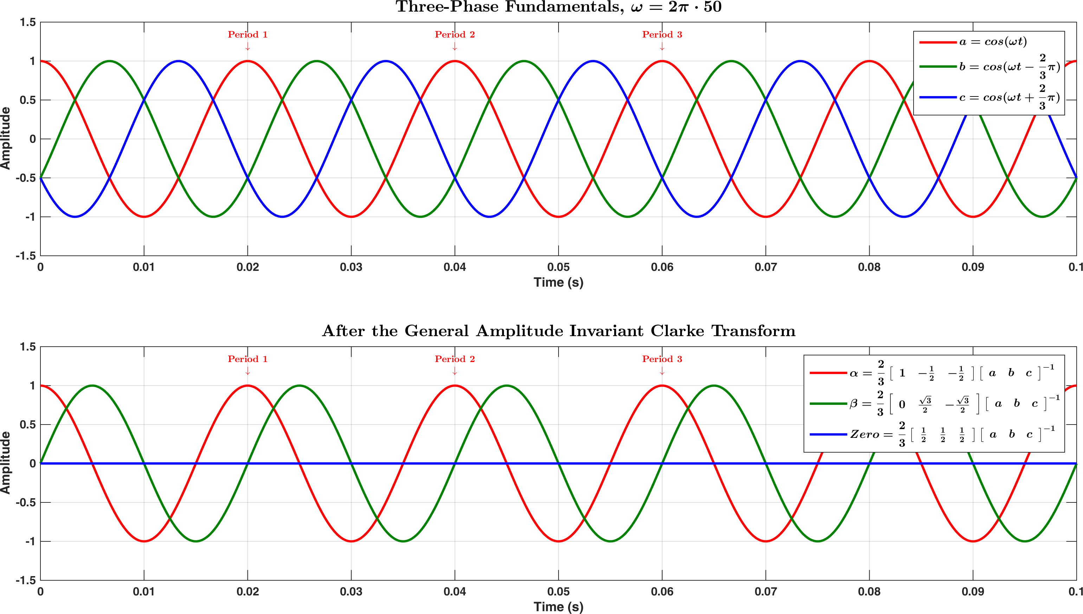

Figure . The General Amplitude Invariant Clarke Transform applied on the three-phase fundamentals (positive sequence component)

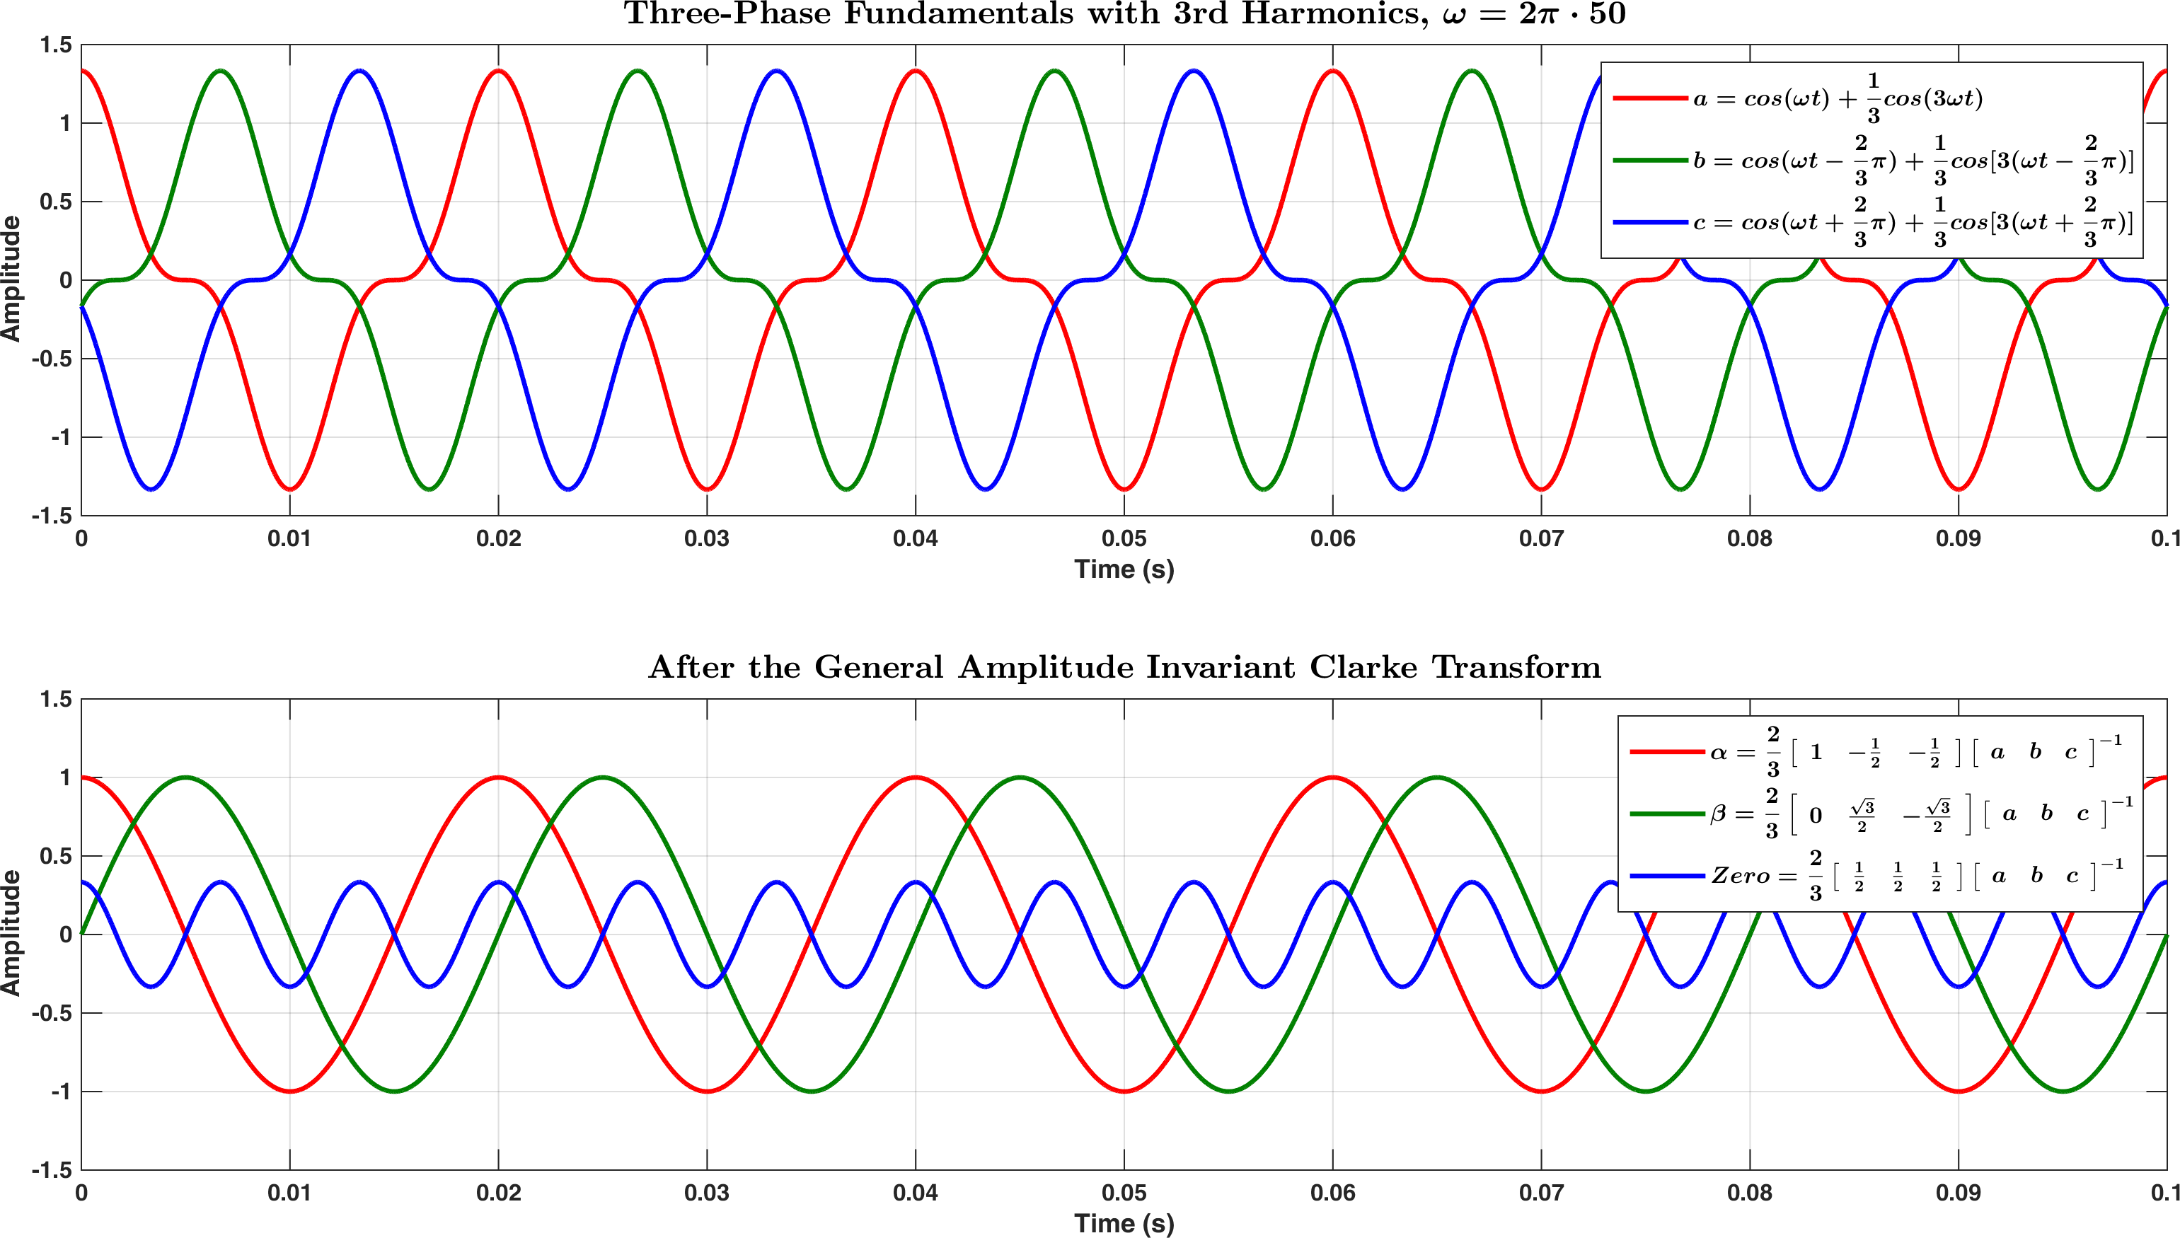

Figure . The General Amplitude Invariant Clarke Transform applied on the three-phase fundamentals with 3rd harmonics (zero sequence component)

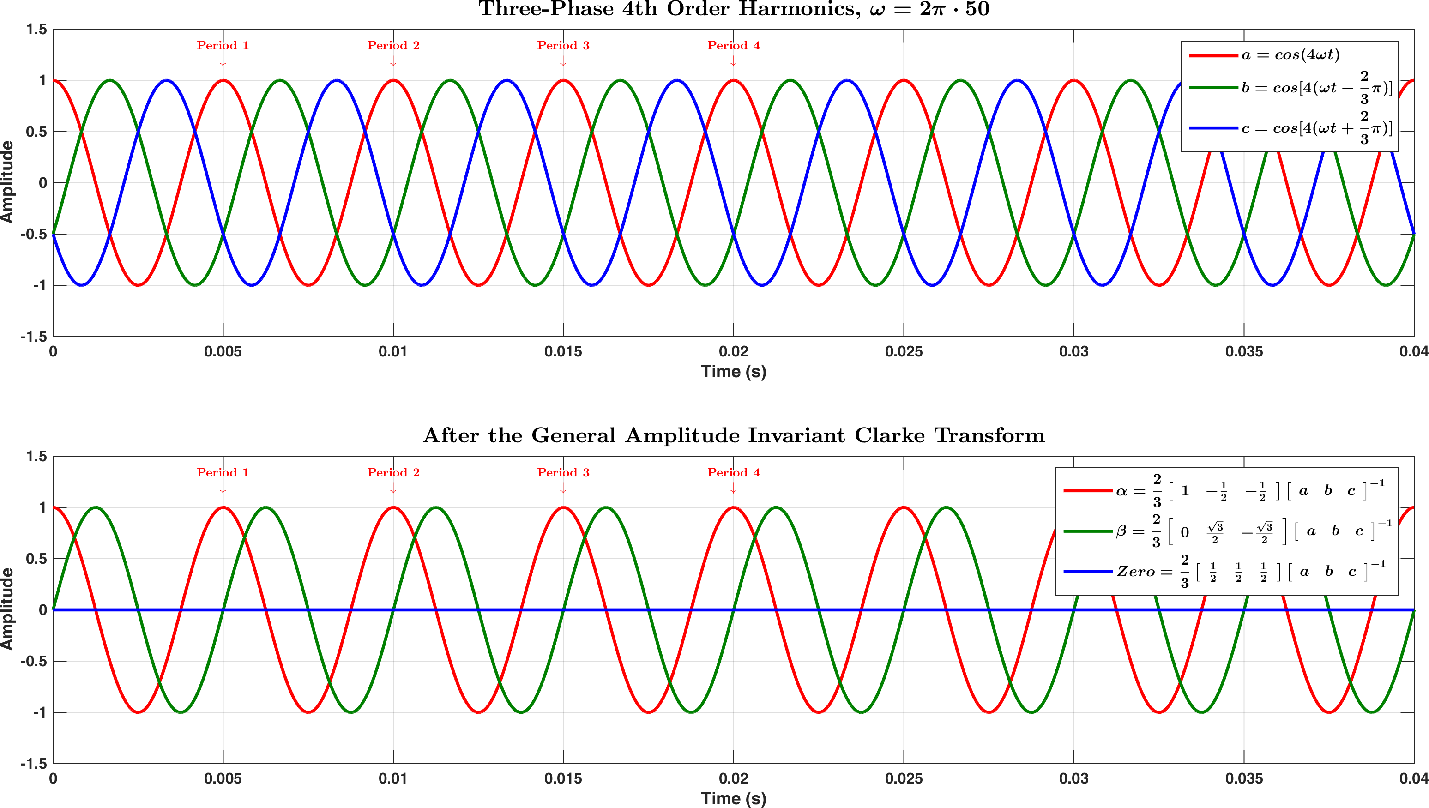

Figure . The General Amplitude Invariant Clarke Transform applied on the 4th order harmonics (positive sequence component)

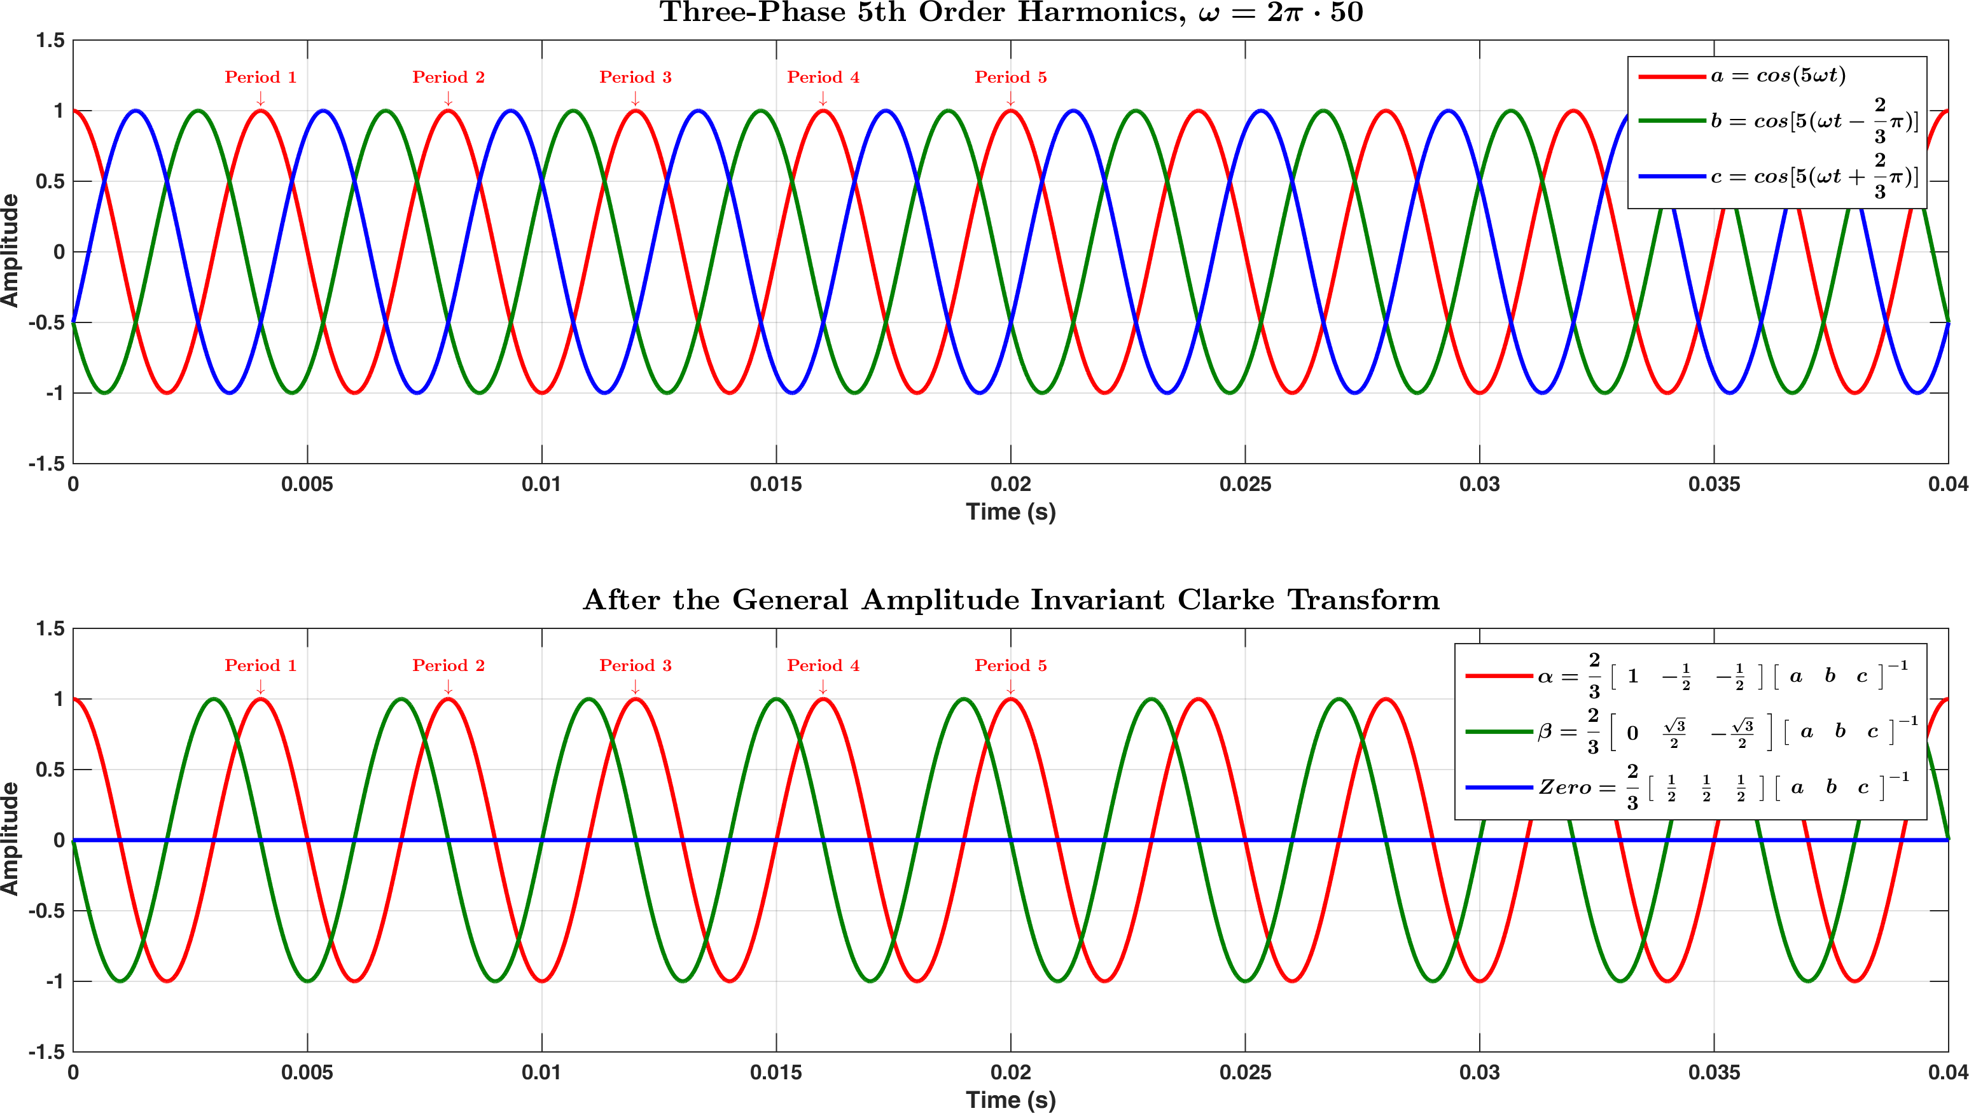

Figure . The General Amplitude Invariant Clarke Transform applied on the 5th order harmonics (negative sequence component). Note that the component is leading the component by 90°, while the $α$ component is still the same as the $a$ component of the three-phase inputs

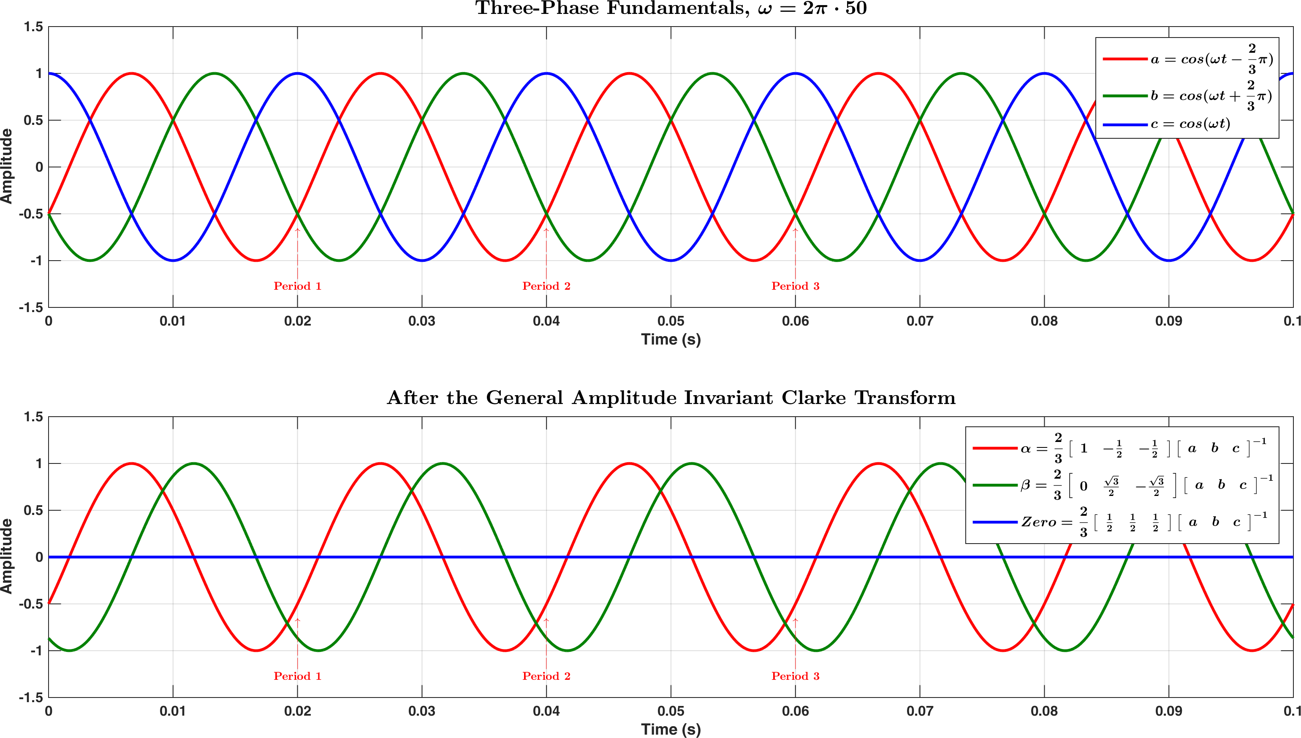

Figure . The General Amplitude Invariant Clarke Transform applied on the three-phase fundamentals with varied order (b-c-a)

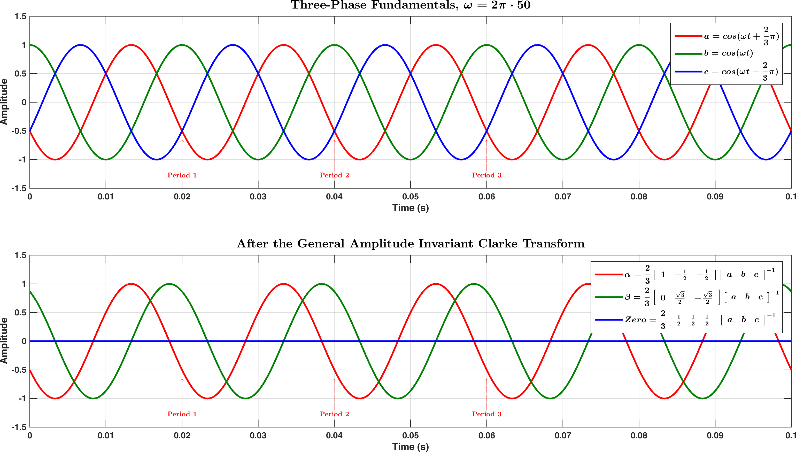

Figure . The General Amplitude Invariant Clarke Transform applied on the three-phase fundamentals with varied order (c-a-b)

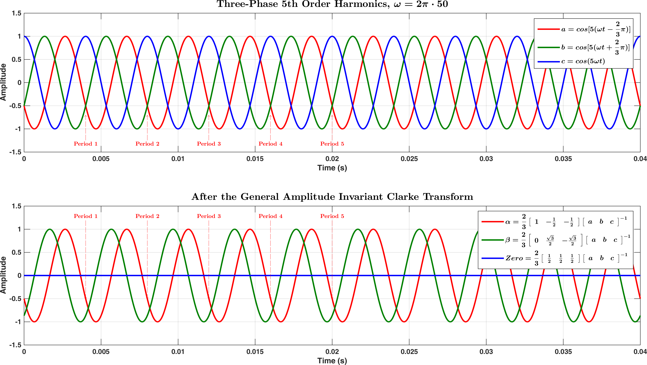

Figure . The General Amplitude Invariant Clarke Transform applied on the 5th order harmonics with varied order (b-c-a)

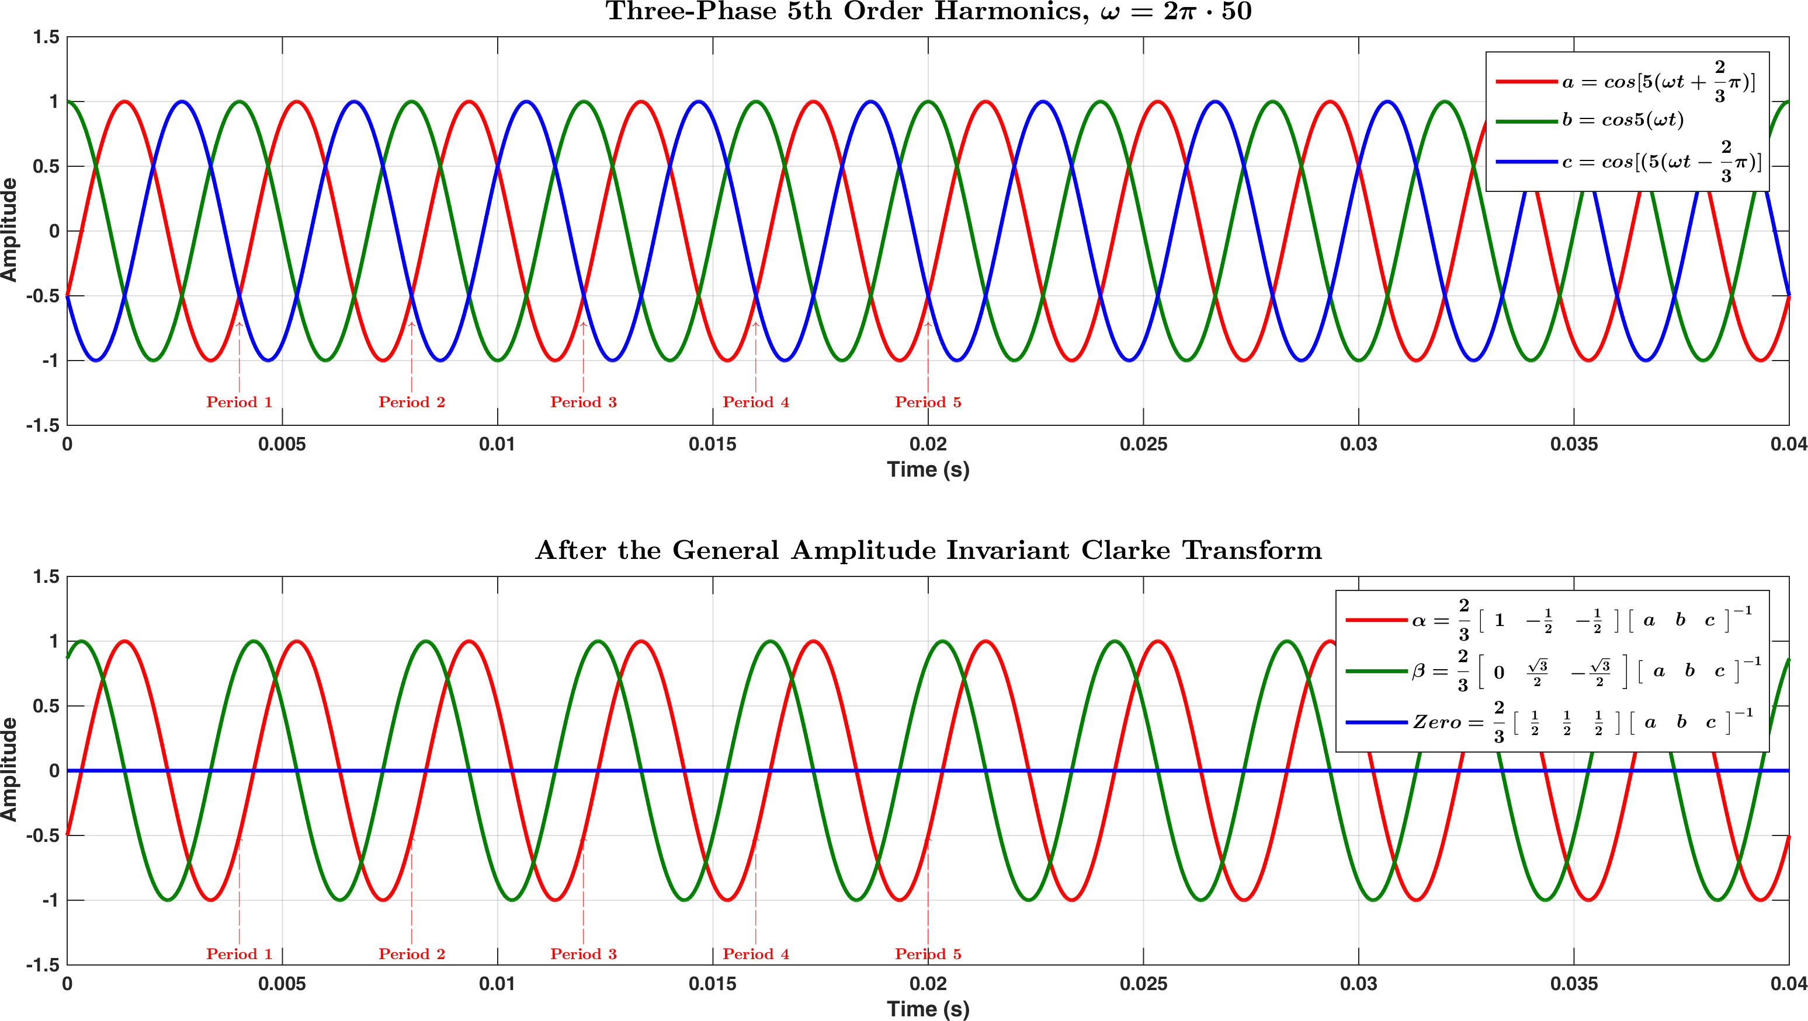

Figure . The General Amplitude Invariant Clarke Transform applied on the 5th order harmonics with varied order (c-a-b)

## Special Amplitude Invariant Clarke Transform (without zero sequence)

The Special Amplitude Invariant Clarke Transform is given as the following in Eq.3:

|  |  |
| --- | --- |
| $$\left[\begin{matrix}α \\ β\end{matrix}\right]= \frac{2}{3}\left[\begin{matrix}1 & -\frac{1}{2} & -\frac{1}{2} \\ 0 & \frac{\sqrt{3}}{2} & -\frac{\sqrt{3}}{2}\end{matrix}\right]\left[\begin{matrix}a \\ b \\ c\end{matrix}\right]$$ | Eq.3 |

The assumption of Eq.3 is that the three-phase $abc$ quantities are balanced and thus the values of the zero sequence components are zero. Therefore, the zero sequence could be omitted. Also, note the similarity between Eq.1 and Eq.3.

The inverse Special Amplitude Invariant Clarke Transform is thus:

|  |  |
| --- | --- |
| $$\left[\begin{matrix}a \\ b \\ c\end{matrix}\right]= \left[\begin{matrix}1 & 0 \\ -\frac{1}{2} & \frac{\sqrt{3}}{2} \\ -\frac{1}{2} & -\frac{\sqrt{3}}{2}\end{matrix}\right]\left[\begin{matrix}α \\ β\end{matrix}\right]$$ | Eq.4 |

Proof:

$$\left[\begin{matrix}1 & 0 \\ -\frac{1}{2} & \frac{\sqrt{3}}{2} \\ -\frac{1}{2} & -\frac{\sqrt{3}}{2}\end{matrix}\right]\left[\begin{matrix}α \\ β\end{matrix}\right]=\left[\begin{matrix}1 & 0 \\ -\frac{1}{2} & \frac{\sqrt{3}}{2} \\ -\frac{1}{2} & -\frac{\sqrt{3}}{2}\end{matrix}\right]\frac{2}{3}\left[\begin{matrix}1 & -\frac{1}{2} & -\frac{1}{2} \\ 0 & \frac{\sqrt{3}}{2} & -\frac{\sqrt{3}}{2}\end{matrix}\right]\left[\begin{matrix}a \\ b \\ c\end{matrix}\right]$$

$$=\frac{2}{3}\left[\begin{matrix}1+0 & -\frac{1}{2} & -\frac{1}{2} \\ -\frac{1}{2} & \frac{1}{4}+\frac{3}{4} & \frac{1}{4}-\frac{3}{4} \\ -\frac{1}{2} & \frac{1}{4}-\frac{3}{4} & \frac{1}{4}+\frac{3}{4}\end{matrix}\right]\left[\begin{matrix}a \\ b \\ c\end{matrix}\right]$$

$$=\frac{2}{3}\left[\begin{matrix}1 & -\frac{1}{2} & -\frac{1}{2} \\ -\frac{1}{2} & 1 & -\frac{1}{2} \\ -\frac{1}{2} & -\frac{1}{2} & 1\end{matrix}\right]\left[\begin{matrix}a \\ b \\ c\end{matrix}\right]$$

$$=\frac{2}{3}\left[\begin{matrix}a-\frac{1}{2}\left(b+c\right) \\ b-\frac{1}{2}\left(a+c\right) \\ c-\frac{1}{2}\left(a+b\right)\end{matrix}\right]$$

(continues to the next page)

For three-phase balanced systems:

$$a+b+c=0$$

$$⇒$$

$$\left\{\begin{aligned}b+c=-a \\ a+c=-b \\ a+b=-c\end{aligned}\right.$$

$$⇒$$

$$\frac{2}{3}\left[\begin{matrix}a-\frac{1}{2}\left(b+c\right) \\ b-\frac{1}{2}\left(a+c\right) \\ c-\frac{1}{2}\left(a+b\right)\end{matrix}\right]=\frac{2}{3}\left[\begin{matrix}a-\frac{1}{2}\left(-a\right) \\ b-\frac{1}{2}\left(-b\right) \\ c-\frac{1}{2}\left(-c\right)\end{matrix}\right]=\frac{2}{3}\left[\begin{matrix}\frac{3}{2}a \\ \frac{3}{2}b \\ \frac{3}{2}c\end{matrix}\right]=\left[\begin{matrix}a \\ b \\ c\end{matrix}\right]$$

Proof complete.

# Park Transforms and Inverse Transforms (Alpha-Beta-Zero $⇔$ D-Q-Zero)

This section describes three definitions of the Park Transform. The first one is the General Park Transform (with zero sequence). The second one is the Special Park Transform (without zero sequence). The third one is the Double Synchronous Reference Frame (DSRF) Park Transform, which gives the **Coupled** positive and negative $dq$ components. To decouple them, the procedures described in [1] should be used.

## General Park Transform (with zero sequence)

The General Park Transform is given as the following in Eq.5 [3], [4]:

|  |  |
| --- | --- |
| $$\left[\begin{matrix}d \\ q \\ Zero\end{matrix}\right]= \left[\begin{matrix}cosθ & sinθ & 0 \\ -sinθ & cosθ & 0 \\ 0 & 0 & 1\end{matrix}\right]\left[\begin{matrix}α \\ β \\ Zero\end{matrix}\right]$$ | Eq.5 |

For ease of implementation in MATLAB, Eq.5 may be rewritten as Eq.6 or Eq.7:

|  |  |
| --- | --- |
| $$\left[\begin{matrix}d \\ q \\ Zero\end{matrix}\right]= \left\{cosθ\left[\begin{matrix}1 & 0 & 0 \\ 0 & 1 & 0 \\ 0 & 0 & 0\end{matrix}\right]+sinθ\left[\begin{matrix}0 & 1 & 0 \\ -1 & 0 & 0 \\ 0 & 0 & 0\end{matrix}\right]+\left[\begin{matrix}0 & 0 & 0 \\ 0 & 0 & 0 \\ 0 & 0 & 1\end{matrix}\right]\right\}\left[\begin{matrix}α \\ β \\ Zero\end{matrix}\right]$$ | Eq.6 |
| $$\left[\begin{matrix}d \\ q \\ Zero\end{matrix}\right]= cosθ\left[\begin{matrix}1 & 0 & 0 \\ 0 & 1 & 0 \\ 0 & 0 & 0\end{matrix}\right]\left[\begin{matrix}α \\ β \\ Zero\end{matrix}\right]+sinθ\left[\begin{matrix}0 & 1 & 0 \\ -1 & 0 & 0 \\ 0 & 0 & 0\end{matrix}\right]\left[\begin{matrix}α \\ β \\ Zero\end{matrix}\right]+\left[\begin{matrix}0 & 0 & 0 \\ 0 & 0 & 0 \\ 0 & 0 & 1\end{matrix}\right]\left[\begin{matrix}α \\ β \\ Zero\end{matrix}\right]$$ | Eq.7 |

The inverse General Park Transform is:

|  |  |
| --- | --- |
| $$\left[\begin{matrix}α \\ β \\ Zero\end{matrix}\right]= \left[\begin{matrix}cosθ & -sinθ & 0 \\ sinθ & cosθ & 0 \\ 0 & 0 & 1\end{matrix}\right]\left[\begin{matrix}d \\ q \\ Zero\end{matrix}\right]$$ | Eq.8 |

Proof:

$$\left[\begin{matrix}cosθ & -sinθ & 0 \\ sinθ & cosθ & 0 \\ 0 & 0 & 1\end{matrix}\right]\left[\begin{matrix}d \\ q \\ Zero\end{matrix}\right]=\left[\begin{matrix}cosθ & -sinθ & 0 \\ sinθ & cosθ & 0 \\ 0 & 0 & 1\end{matrix}\right]\left[\begin{matrix}cosθ & sinθ & 0 \\ -sinθ & cosθ & 0 \\ 0 & 0 & 1\end{matrix}\right]\left[\begin{matrix}α \\ β \\ Zero\end{matrix}\right]$$

$$=\left[\begin{matrix}\cos^{2}{θ}+\sin^{2}{θ}+0 & cosθsinθ-cosθsinθ & 0 \\ sinθcosθ-sinθcosθ & \cos^{2}{θ}+\sin^{2}{θ}+0 & 0 \\ 0 & 0 & 1\end{matrix}\right]\left[\begin{matrix}α \\ β \\ Zero\end{matrix}\right]$$

(continues to the next page)

Note that:

$$\cos^{2}{θ}+\sin^{2}{θ}=1$$

$$⇒$$

$$\left[\begin{matrix}\cos^{2}{θ}+\sin^{2}{θ}+0 & cosθsinθ-cosθsinθ & 0 \\ sinθcosθ-sinθcosθ & \cos^{2}{θ}+\sin^{2}{θ}+0 & 0 \\ 0 & 0 & 1\end{matrix}\right]\left[\begin{matrix}α \\ β \\ Zero\end{matrix}\right]=\left[\begin{matrix}1 & 0 & 0 \\ 0 & 1 & 0 \\ 0 & 0 & 1\end{matrix}\right]\left[\begin{matrix}α \\ β \\ Zero\end{matrix}\right]$$

$$=\left[\begin{matrix}α+0+0 \\ 0+β+0 \\ 0+0+Zero\end{matrix}\right]$$

$$=\left[\begin{matrix}α \\ β \\ Zero\end{matrix}\right]$$

Proof complete.

For ease of implementation in MATLAB, Eq.8 may be rewritten as Eq.9:

|  |  |
| --- | --- |
| $$\left[\begin{matrix}α \\ β \\ Zero\end{matrix}\right]= \left[\begin{matrix}cosθ & -sinθ & 0 \\ sinθ & cosθ & 0 \\ 0 & 0 & 1\end{matrix}\right]\left[\begin{matrix}d \\ q \\ Zero\end{matrix}\right]$$ |  |
| $$\left[\begin{matrix}α \\ β \\ Zero\end{matrix}\right]=cosθ \left[\begin{matrix}1 & 0 & 0 \\ 0 & 1 & 0 \\ 0 & 0 & 0\end{matrix}\right]\left[\begin{matrix}d \\ q \\ Zero\end{matrix}\right]+sinθ\left[\begin{matrix}0 & -1 & 0 \\ 1 & 0 & 0 \\ 0 & 0 & 0\end{matrix}\right]\left[\begin{matrix}d \\ q \\ Zero\end{matrix}\right]+\left[\begin{matrix}0 & 0 & 0 \\ 0 & 0 & 0 \\ 0 & 0 & 1\end{matrix}\right]\left[\begin{matrix}d \\ q \\ Zero\end{matrix}\right]$$ | Eq.9 |

Figure 2.1 shows the results when the General Park Transform is applied onto the three-phase fundamentals.

The General Park Transform has the following properties:

1. It does not alter the zero sequence component calculated by the General Amplitude Invariant Clarke Transform. This is demonstrated in Figure 2.2.
2. It alters the frequencies of the positive sequence components and the negative sequence components.
3. For positive sequence components, this transform would reduce their frequencies by once the rotating frequency of the reference angle $"θ"$ used in the transform. E.g., when $"θ"$ rotates at the fundamental frequency ($θ=2πft$), the fundamental AC components (1st order) would be transformed as DC (0th order) on the $dq$ side; the 4th order AC component would be transformed into 3rd order on the $dq$ side. This is demonstrated in Figure 2.1 and Figure 2.3.
4. For negative sequence components, this transform would increase their frequencies by once the rotating frequency of the reference angle $"θ"$ used in the transform. E.g., when $"θ"$ rotates at the fundamental frequency ($θ=2πft$), the 5th order AC component would be transformed into 6th order on the $dq$ side. This is demonstrated in Figure 2.4.

The impacts of the General Park Transform on different frequency components are discussed in details in Section 5.

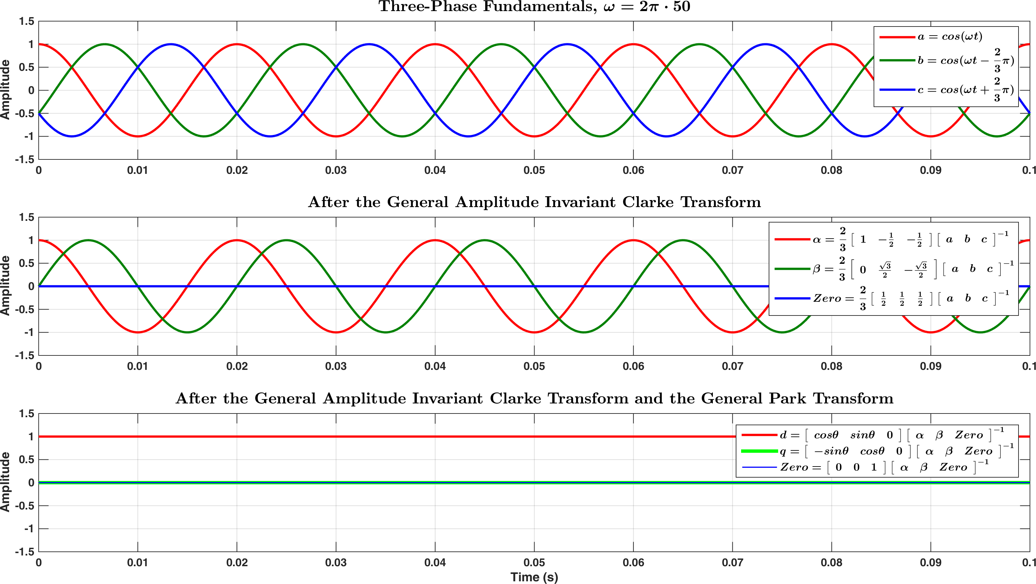

Figure . Three-phase fundamentals after the General Amplitude Invariant Clarke Transform and the General Park Transform (positive sequence component)

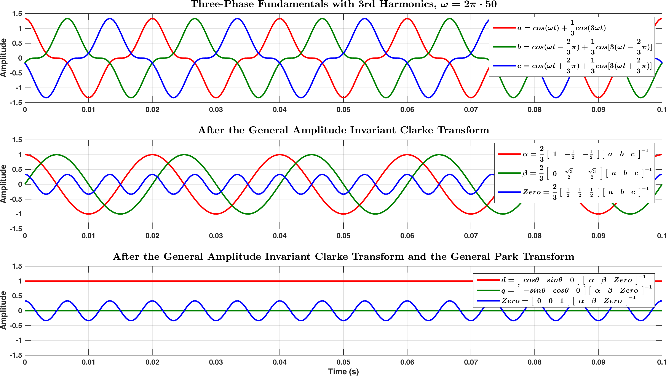

Figure . The General Park Transform applied on the three-phase fundamentals with 3rd harmonics (zero sequence component)

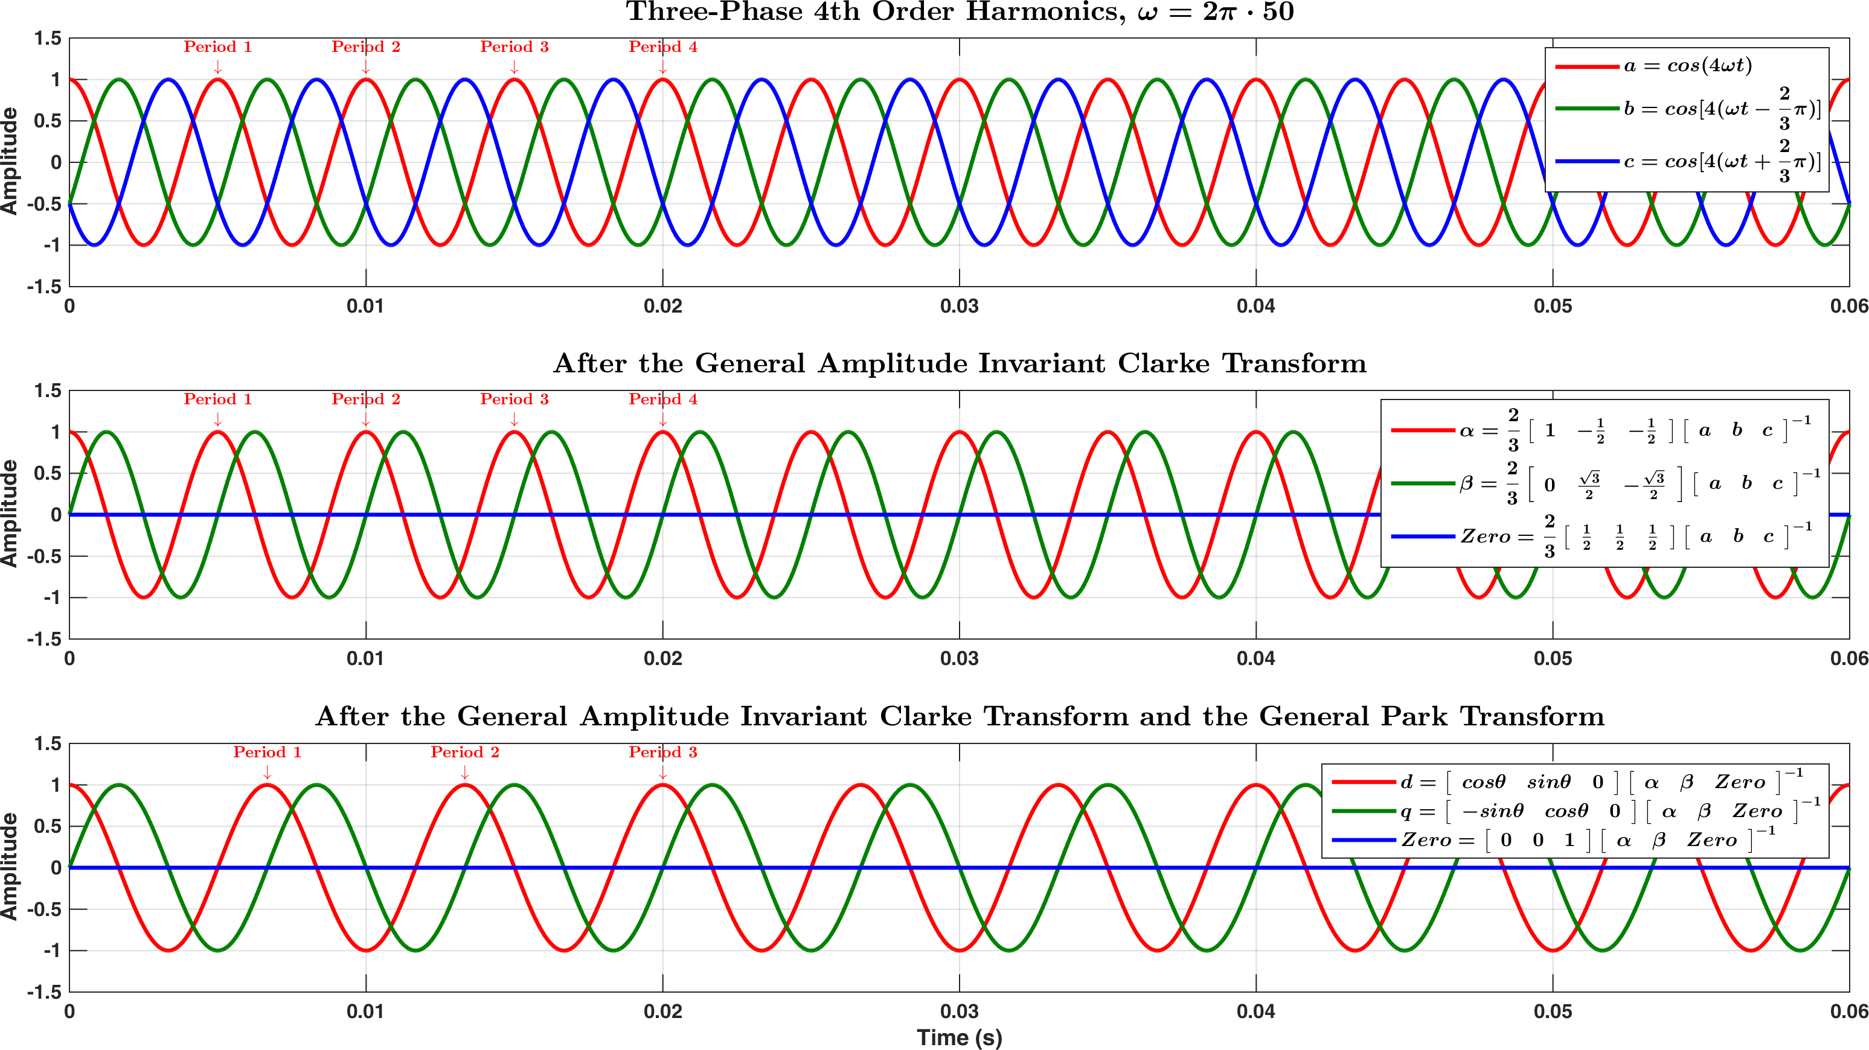

Figure . The General Park Transform applied on the 4th order harmonics (positive sequence component)

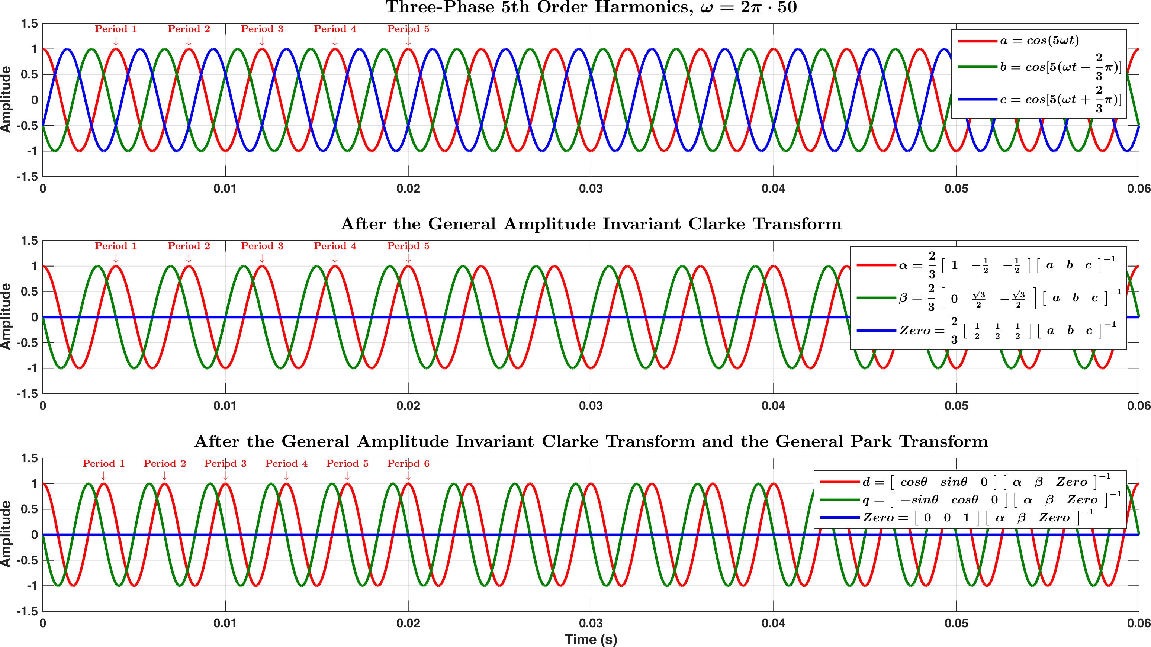

Figure . The General Park Transform applied on the 5th order harmonics (negative sequence component)

## Special Park Transform (without zero sequence)

The Special Park Transform is given as the following in Eq.10:

|  |  |
| --- | --- |
| $$\left[\begin{matrix}d \\ q\end{matrix}\right]= \left[\begin{matrix}cosθ & sinθ \\ -sinθ & cosθ\end{matrix}\right]\left[\begin{matrix}α \\ β\end{matrix}\right]$$ | Eq.10 |

Similar to Eq.3, Eq.10 here is also assuming balanced three-phase quantities. Also, note the similarity between Eq.5 and Eq.10.

For ease of implementation in MATLAB, Eq.10 may be rewritten as Eq.11 or Eq.12:

|  |  |
| --- | --- |
| $$\left[\begin{matrix}d \\ q\end{matrix}\right]=\left\{ cosθ\left[\begin{matrix}1 & 0 \\ 0 & 1\end{matrix}\right]+sinθ\left[\begin{matrix}0 & 1 \\ -1 & 0\end{matrix}\right]\right\}\left[\begin{matrix}α \\ β\end{matrix}\right]$$ | Eq.11 |
| $$\left[\begin{matrix}d \\ q\end{matrix}\right]=cosθ\left[\begin{matrix}1 & 0 \\ 0 & 1\end{matrix}\right]\left[\begin{matrix}α \\ β\end{matrix}\right]+sinθ\left[\begin{matrix}0 & 1 \\ -1 & 0\end{matrix}\right]\left[\begin{matrix}α \\ β\end{matrix}\right]$$ | Eq.12 |

The inverse Special Park Transform is:

|  |  |
| --- | --- |
| $$\left[\begin{matrix}α \\ β\end{matrix}\right]= \left[\begin{matrix}cosθ & -sinθ \\ sinθ & cosθ\end{matrix}\right]\left[\begin{matrix}d \\ q\end{matrix}\right]$$ | Eq.13 |

Proof:

$$\left[\begin{matrix}cosθ & -sinθ \\ sinθ & cosθ\end{matrix}\right]\left[\begin{matrix}d \\ q\end{matrix}\right]=\left[\begin{matrix}cosθ & -sinθ \\ sinθ & cosθ\end{matrix}\right]\left[\begin{matrix}cosθ & sinθ \\ -sinθ & cosθ\end{matrix}\right]\left[\begin{matrix}α \\ β\end{matrix}\right]$$

$$=\left[\begin{matrix}\cos^{2}{θ+\sin^{2}{θ}} & cosθsinθ-cosθsinθ \\ sinθcosθ-sinθcosθ & \sin^{2}{θ+\cos^{2}{θ}}\end{matrix}\right]\left[\begin{matrix}α \\ β\end{matrix}\right]$$

Note that:

$$\cos^{2}{θ}+\sin^{2}{θ}=1$$

$$⇒$$

$$\left[\begin{matrix}\cos^{2}{θ+\sin^{2}{θ}} & cosθsinθ-cosθsinθ \\ sinθcosθ-sinθcosθ & \sin^{2}{θ+\cos^{2}{θ}}\end{matrix}\right]\left[\begin{matrix}α \\ β\end{matrix}\right]=\left[\begin{matrix}1 & 0 \\ 0 & 1\end{matrix}\right]\left[\begin{matrix}α \\ β\end{matrix}\right]$$

$$=\left[\begin{matrix}α+0 \\ 0+β\end{matrix}\right]$$

$$=\left[\begin{matrix}α \\ β\end{matrix}\right]$$

Proof complete.

For ease of implementation in MATLAB, Eq.13 may be rewritten as Eq.14:

|  |  |
| --- | --- |
| $$\left[\begin{matrix}α \\ β\end{matrix}\right]= cosθ\left[\begin{matrix}1 & 0 \\ 0 & 1\end{matrix}\right]\left[\begin{matrix}d \\ q\end{matrix}\right]+sinθ\left[\begin{matrix}0 & -1 \\ 1 & 0\end{matrix}\right]\left[\begin{matrix}d \\ q\end{matrix}\right]$$ | Eq.14 |

## Double Synchronous Reference Frame Park Transform

The derivation of the Double Synchronous Reference Frame (DSRF) Park Transform can be found in [1]. Note that the positive $dq$ components and the negative $dq$ components calculated from the DSRF Park Transform are **Coupled**. To decouple them, the procedures described in [1], namely the Decoupled Double Synchronous Reference Frame (DDSRF), must be applied. The decoupling procedures are not included in this document since they are highly complex and excessive. Also, since the procedures are already complete in [1], the best way to understand them is to consult [1].

The DSRF Park Transform is given as the following in Eq.15 and Eq.16 [1] (a more intuitive explanation can be found in [5]):

|  |  |
| --- | --- |
| $$\left[\begin{matrix}d_{+DSRF} \\ q_{+DSRF}\end{matrix}\right]= \left[\begin{matrix}cosθ & sinθ \\ -sinθ & cosθ\end{matrix}\right]\left[\begin{matrix}α \\ β\end{matrix}\right]$$ | Eq.15 |
| $$\left[\begin{matrix}d_{-DSRF} \\ q_{-DSRF}\end{matrix}\right]= \left[\begin{matrix}cosθ & -sinθ \\ sinθ & cosθ\end{matrix}\right]\left[\begin{matrix}α \\ β\end{matrix}\right]$$ | Eq.16 |
| where the subscripts $+$ and $-$ are used to denote “positive sequence component” and “negative sequence component” respectively. | |

Eq.15 and Eq.16 can be merged as Eq.17:

|  |  |
| --- | --- |
| $$\left[\begin{matrix}d_{+DSRF} \\ q_{+DSRF} \\ \begin{matrix}d_{-DSRF} \\ q_{-DSRF}\end{matrix}\end{matrix}\right]= \left[\begin{matrix}cosθ & sinθ \\ -sinθ & cosθ \\ cosθ & -sinθ \\ sinθ & cosθ\end{matrix}\right]\left[\begin{matrix}α \\ β\end{matrix}\right]$$ | Eq.17 |

For ease of implementation in MATLAB, Eq.17 may be rewritten as Eq.18 or Eq.19:

|  |  |
| --- | --- |
| $$\left[\begin{matrix}d_{+DSRF} \\ q_{+DSRF} \\ \begin{matrix}d_{-DSRF} \\ q_{-DSRF}\end{matrix}\end{matrix}\right]=\left\{cosθ\left[\begin{matrix}1 & 0 \\ 0 & 1 \\ 1 & 0 \\ 0 & 1\end{matrix}\right]+sinθ\left[\begin{matrix}0 & 1 \\ -1 & 0 \\ 0 & -1 \\ 1 & 0\end{matrix}\right]\right\}\left[\begin{matrix}α \\ β\end{matrix}\right]$$ | Eq.18 |
| $$\left[\begin{matrix}d_{+DSRF} \\ q_{+DSRF} \\ \begin{matrix}d_{-DSRF} \\ q_{-DSRF}\end{matrix}\end{matrix}\right]= cosθ\left[\begin{matrix}1 & 0 \\ 0 & 1 \\ 1 & 0 \\ 0 & 1\end{matrix}\right]\left[\begin{matrix}α \\ β\end{matrix}\right]+sinθ\left[\begin{matrix}0 & 1 \\ -1 & 0 \\ 0 & -1 \\ 1 & 0\end{matrix}\right]\left[\begin{matrix}α \\ β\end{matrix}\right]$$ | Eq.19 |

The inverse DSRF Park Transform is:

|  |  |
| --- | --- |
| $$\left[\begin{matrix}α \\ β\end{matrix}\right]= \frac{1}{2}\left[\begin{matrix}cosθ & -sinθ & cosθ & sinθ \\ sinθ & cosθ & -sinθ & cosθ\end{matrix}\right]\left[\begin{matrix}d_{+DSRF} \\ q_{+DSRF} \\ \begin{matrix}d_{-DSRF} \\ q_{-DSRF}\end{matrix}\end{matrix}\right]$$ | Eq.20 |

The proof is in the next page.

Proof:

$$\frac{1}{2}\left[\begin{matrix}cosθ & -sinθ & cosθ & sinθ \\ sinθ & cosθ & -sinθ & cosθ\end{matrix}\right]\left[\begin{matrix}d_{+DSRF} \\ q_{+DSRF} \\ \begin{matrix}d_{-DSRF} \\ q_{-DSRF}\end{matrix}\end{matrix}\right]$$

$$=\frac{1}{2}\left[\begin{matrix}cosθ & -sinθ & cosθ & sinθ \\ sinθ & cosθ & -sinθ & cosθ\end{matrix}\right]\left[\begin{matrix}cosθ & sinθ \\ -sinθ & cosθ \\ cosθ & -sinθ \\ sinθ & cosθ\end{matrix}\right]\left[\begin{matrix}α \\ β\end{matrix}\right]$$

$$=\frac{1}{2}\left[\begin{matrix}\cos^{2}{θ+\sin^{2}{θ+\cos^{2}{θ+\sin^{2}{θ}}}} & cosθsinθ-cosθsinθ-cosθsinθ+cosθsinθ \\ sinθcosθ-sinθcosθ-sinθcosθ+sinθcosθ & \sin^{2}{θ+\cos^{2}{θ+\sin^{2}{θ+\cos^{2}{θ}}}}\end{matrix}\right]\left[\begin{matrix}α \\ β\end{matrix}\right]$$

Note that:

$$\cos^{2}{θ}+\sin^{2}{θ}=1$$

$$⇒$$

$$\frac{1}{2}\left[\begin{matrix}\cos^{2}{θ+\sin^{2}{θ+\cos^{2}{θ+\sin^{2}{θ}}}} & cosθsinθ-cosθsinθ-cosθsinθ+cosθsinθ \\ sinθcosθ-sinθcosθ-sinθcosθ+sinθcosθ & \sin^{2}{θ+\cos^{2}{θ+\sin^{2}{θ+\cos^{2}{θ}}}}\end{matrix}\right]\left[\begin{matrix}α \\ β\end{matrix}\right]$$

$$=\frac{1}{2}\left[\begin{matrix}2 & 0 \\ 0 & 2\end{matrix}\right]\left[\begin{matrix}α \\ β\end{matrix}\right]$$

$$=\left[\begin{matrix}1 & 0 \\ 0 & 1\end{matrix}\right]\left[\begin{matrix}α \\ β\end{matrix}\right]$$

$$=\left[\begin{matrix}α+0 \\ 0+β\end{matrix}\right]$$

$$=\left[\begin{matrix}α \\ β\end{matrix}\right]$$

Proof complete.

For ease of implementation in MATLAB, Eq.20 may be rewritten as Eq.21:

|  |  |  |
| --- | --- | --- |
| $$\left[\begin{matrix}α \\ β\end{matrix}\right]= \frac{1}{2}\left[\begin{matrix}cosθ & -sinθ & cosθ & sinθ \\ sinθ & cosθ & -sinθ & cosθ\end{matrix}\right]\left[\begin{matrix}d_{+DSRF} \\ q_{+DSRF} \\ \begin{matrix}d_{-DSRF} \\ q_{-DSRF}\end{matrix}\end{matrix}\right]$$ |  | |
| $$\left[\begin{matrix}α \\ β\end{matrix}\right]= \frac{1}{2}\left\{cosθ\left[\begin{matrix}1 & 0 & 1 & 0 \\ 0 & 1 & 0 & 1\end{matrix}\right]\left[\begin{matrix}d_{+DSRF} \\ q_{+DSRF} \\ \begin{matrix}d_{-DSRF} \\ q_{-DSRF}\end{matrix}\end{matrix}\right]+sinθ\left[\begin{matrix}0 & -1 & 0 & 1 \\ 1 & 0 & -1 & 0\end{matrix}\right]\left[\begin{matrix}d_{+DSRF} \\ q_{+DSRF} \\ \begin{matrix}d_{-DSRF} \\ q_{-DSRF}\end{matrix}\end{matrix}\right]\right\}$$ | | Eq.21 |

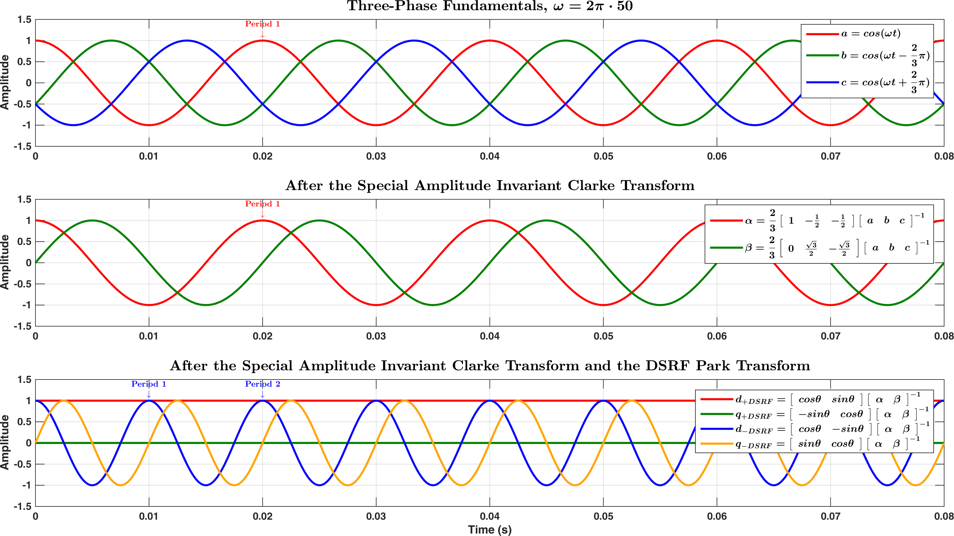

Figure . The DSRF Park Transform applied on the three-phase fundamentals (positive sequence)

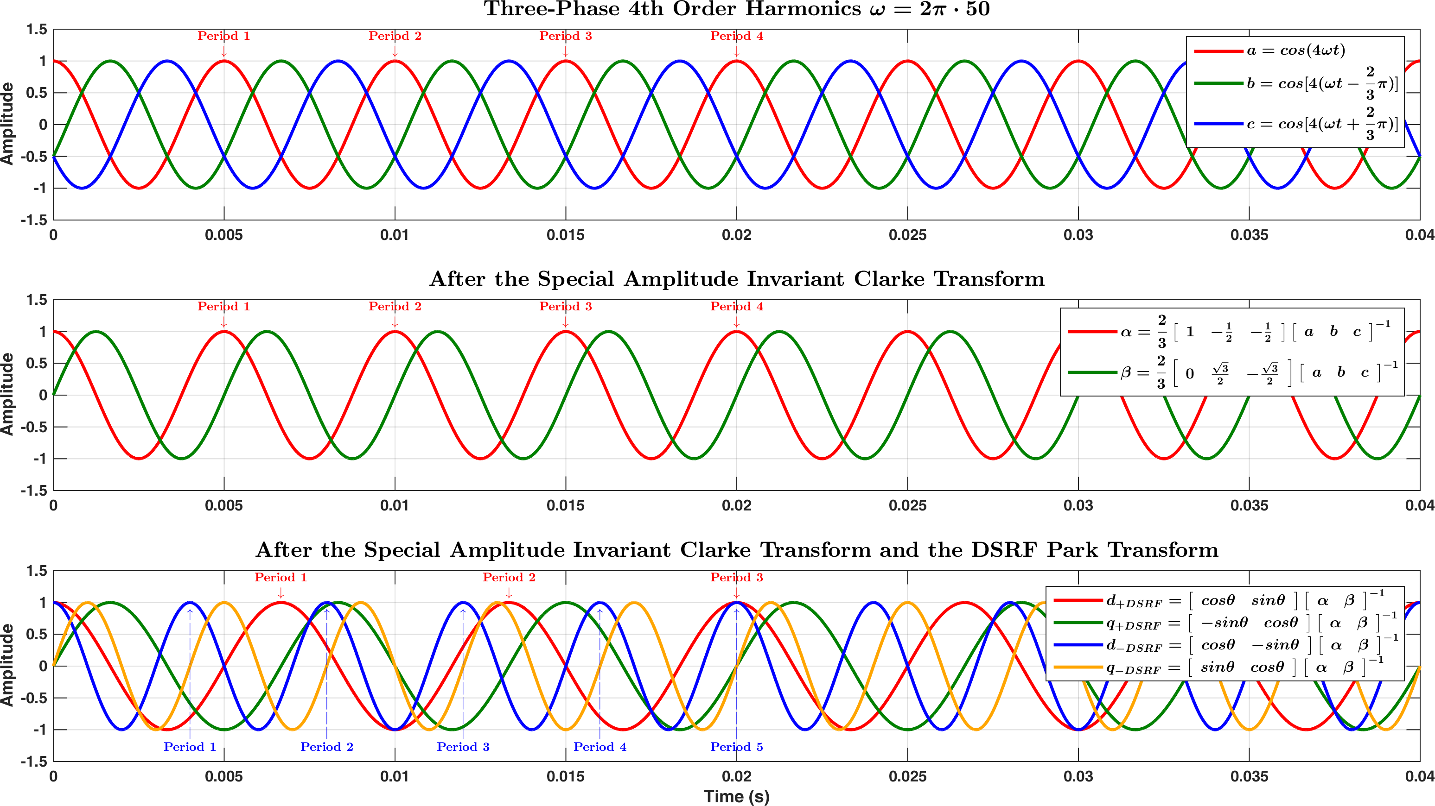

Figure .

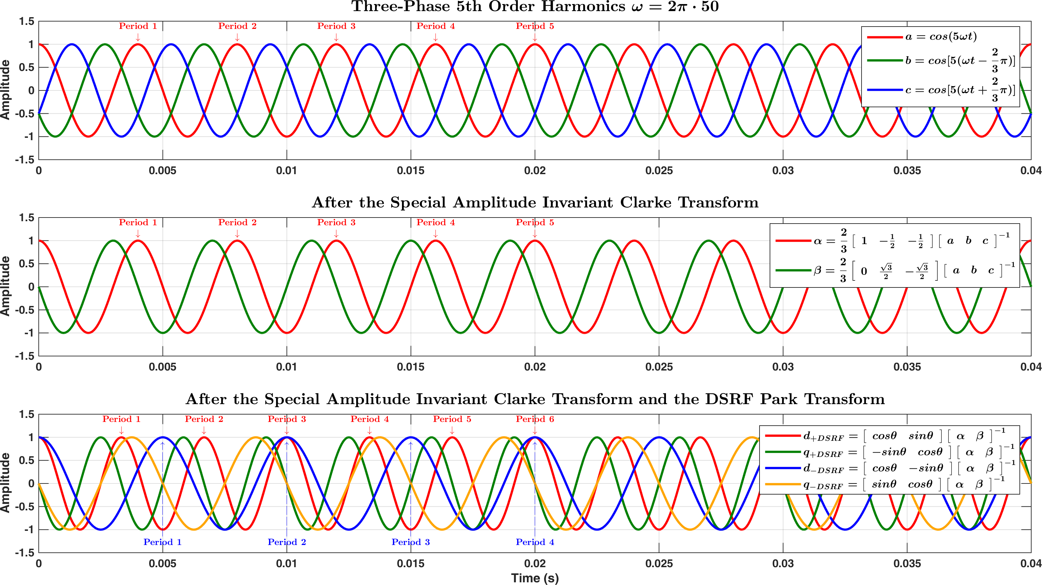

Figure .

# Coordinate based Instantaneous Symmetrical Components (DSOGI) – An Alternative to the DSRF and DDSRF

This section offers an alternative way to calculate the positive components and negative components of the SRF quantities ( $dq$ quantities). Note that the approach discussed here was developed by the same group of researchers who also developed the DSRF and DDSRF. The approach described in this section is based on [6]. This approach is also known as the DSOGI based approach (Dual Second-Order Integrator).

The underlining philosophy of the DSOGI based approach is that, instead of extracting the symmetrical components in the SRF, i.e., extracting the positive sequence components and negative sequence components out of the $dq$ quantities and then decouple them (DSRF then DDSRF), what one can do is to extract the symmetrical components out of the three-phase $abc$ quantities and then convert them into respective SRF symmetrical components. Since the symmetrical components of the three-phase $abc$ quantities are naturally decoupled (by their own definitions), the subsequent SRF symmetrical components calculated via the DSOGI approach are also naturally decoupled. Thus, the DSOGI approach does not need the complex procedures used in the DDSRF.



Figure . DDSRF approach for calculations of the instantaneous symmetrical components



Figure . DSOGI approach for calculations of the instantaneous symmetrical components

The DDSRF approach for calculations of the instantaneous symmetrical components is shown in Figure 3.1, while the DSOGI approach is shown in Figure 3.2. It can be observed that the DSOGI approach is simpler and more intuitive.

The mathematical procedures of the DSOGI approach would now be discussed, followed by the implementation of the 90° phase shifter (lagging).

## DSOGI based Instantaneous Symmetrical Components

Define the following term:

|  |  |
| --- | --- |
| $$Α=e^{j\frac{2}{3}π}=∠120°$$ | Eq.22 |

where $Α$ (capital alpha) is a 120° phase shifter (leading). $Α$ in here is usually written as $α$ (lower case alpha). In order to distinguish this phase shifter from the in-phase Clarke quantity, the capital version is used instead.

For the positive sequence components of $abc$ quantities:

|  |  |
| --- | --- |
| $$\left[\begin{matrix}a_{+} \\ b_{+} \\ c_{+}\end{matrix}\right]=\frac{1}{3}\left[\begin{matrix}1 & Α & Α^{2} \\ Α^{2} & 1 & Α \\ Α & Α^{2} & 1\end{matrix}\right]\left[\begin{matrix}a \\ b \\ c\end{matrix}\right]$$ | Eq.23 |

where the subscript “+” is used to denote “positive sequence component”.

Define the following term:

|  |  |
| --- | --- |
| $$K_{abc+}=\frac{1}{3}\left[\begin{matrix}1 & Α & Α^{2} \\ Α^{2} & 1 & Α \\ Α & Α^{2} & 1\end{matrix}\right]$$ | Eq.24 |

By referencing Eq.2 and Eq.117, the positive sequence components of $αβ$ quantities can be yielded:

|  |  |
| --- | --- |
| $$\left[\begin{matrix}α_{+} \\ β_{+}\end{matrix}\right]=K_{ClkSpl}\left[\begin{matrix}a_{+} \\ b_{+} \\ c_{+}\end{matrix}\right]=K_{ClkSpl}K_{abc+}\left[\begin{matrix}a \\ b \\ c\end{matrix}\right]$$ | Eq.25 |

By referencing Eq.4 and Eq.118, Eq.25 can be rewritten as:

|  |  |
| --- | --- |
| $$\left[\begin{matrix}α_{+} \\ β_{+}\end{matrix}\right]=K_{ClkSpl}\left[\begin{matrix}a_{+} \\ b_{+} \\ c_{+}\end{matrix}\right]=K_{ClkSpl}K_{abc+}K_{ClkSpl}^{-1}\left[\begin{matrix}α \\ β\end{matrix}\right]$$ | Eq.26 |

(continues to the next page)

$$K_{ClkSpl}K_{abc+}K_{ClkSpl}^{-1}=\frac{2}{3}\left[\begin{matrix}1 & -\frac{1}{2} & -\frac{1}{2} \\ 0 & \frac{\sqrt{3}}{2} & -\frac{\sqrt{3}}{2}\end{matrix}\right]\frac{1}{3}\left[\begin{matrix}1 & Α & Α^{2} \\ Α^{2} & 1 & Α \\ Α & Α^{2} & 1\end{matrix}\right]\left[\begin{matrix}1 & 0 \\ -\frac{1}{2} & \frac{\sqrt{3}}{2} \\ -\frac{1}{2} & -\frac{\sqrt{3}}{2}\end{matrix}\right]$$

$$=\frac{1}{9}\left[\begin{matrix}2 & -1 & -1 \\ 0 & \sqrt{3} & -\sqrt{3}\end{matrix}\right]\left[\begin{matrix}1 & Α & Α^{2} \\ Α^{2} & 1 & Α \\ Α & Α^{2} & 1\end{matrix}\right]\left[\begin{matrix}1 & 0 \\ -\frac{1}{2} & \frac{\sqrt{3}}{2} \\ -\frac{1}{2} & -\frac{\sqrt{3}}{2}\end{matrix}\right]$$

$$=\frac{1}{9}\left[\begin{matrix}2-Α^{2}-Α & 2Α-1-Α^{2} & 2Α^{2}-Α-1 \\ \sqrt{3}Α^{2}-\sqrt{3}Α & \sqrt{3}-\sqrt{3}Α^{2} & \sqrt{3}Α-\sqrt{3}\end{matrix}\right]\left[\begin{matrix}1 & 0 \\ -\frac{1}{2} & \frac{\sqrt{3}}{2} \\ -\frac{1}{2} & -\frac{\sqrt{3}}{2}\end{matrix}\right]$$

$$=\frac{1}{9}\left[\begin{matrix}2-Α^{2}-Α-Α+\frac{1}{2}+\frac{Α^{2}}{2}-Α^{2}+\frac{Α}{2}+\frac{1}{2} & \sqrt{3}Α-\frac{\sqrt{3}}{2}-\frac{\sqrt{3}}{2}Α^{2}-\sqrt{3}Α^{2}+\frac{\sqrt{3}}{2}Α+\frac{\sqrt{3}}{2} \\ \sqrt{3}Α^{2}-\sqrt{3}Α-\frac{\sqrt{3}}{2}+\frac{\sqrt{3}}{2}Α^{2}-\frac{\sqrt{3}}{2}Α+\frac{\sqrt{3}}{2} & \frac{3}{2}-\frac{3}{2}Α^{2}-\frac{3}{2}Α+\frac{3}{2}\end{matrix}\right]$$

|  |  |
| --- | --- |
| $$=\frac{1}{9}\left[\begin{matrix}3-\frac{3}{2}Α^{2}-\frac{3}{2}Α & \frac{3\sqrt{3}}{2}Α-\frac{3\sqrt{3}}{2}Α^{2} \\ -\left(\frac{3\sqrt{3}}{2}Α-\frac{3\sqrt{3}}{2}Α^{2}\right) & 3-\frac{3}{2}Α^{2}-\frac{3}{2}Α\end{matrix}\right]$$ | Eq.27 |

(continues to next page)

By referencing Eq.22, Eq.28 can be yielded:

|  |  |
| --- | --- |
| $$3-\frac{3}{2}Α^{2}-\frac{3}{2}Α=3-\frac{3}{2}{\left(e^{j\frac{2}{3}π}\right)}^{2}-\frac{3}{2}e^{j\frac{2}{3}π}=3-\frac{3}{2}\left(e^{j\frac{4}{3}π}+e^{j\frac{2}{3}π}\right)$$ | Eq.28 |

Note Euler’s law: $e^{jx}=cosx+jsinx$

$$⇒$$

$$3-\frac{3}{2}\left(e^{j\frac{4}{3}π}+e^{j\frac{2}{3}π}\right)=3-\frac{3}{2}\left[\cos\left(\frac{4}{3}π\right) +jsin\left(\frac{4}{3}π\right)+cos\left(\frac{2}{3}π\right)+jsin\left(\frac{2}{3}π\right)\right]$$

$$=3-\frac{3}{2}\left[-\frac{1}{2}+j\left(-\frac{\sqrt{3}}{2}\right)-\frac{1}{2}+j\left(\frac{\sqrt{3}}{2}\right)\right]=3+\frac{3}{2}$$

$$⇒$$

|  |  |
| --- | --- |
| $$3-\frac{3}{2}Α^{2}-\frac{3}{2}Α=3+\frac{3}{2}=\frac{9}{2}$$ | Eq.29 |

Similarly, Eq.30 can be yielded:

|  |  |
| --- | --- |
| $$\frac{3\sqrt{3}}{2}Α-\frac{3\sqrt{3}}{2}Α^{2}=\frac{3\sqrt{3}}{2}\left(e^{j\frac{2}{3}π}-e^{j\frac{4}{3}π}\right)$$ | Eq.30 |

|  |  |
| --- | --- |
|  | Eq.31 |

By referencing Eq.31, Eq.32 can be yielded:

|  |  |
| --- | --- |
| $$-\left(\frac{3\sqrt{3}}{2}Α-\frac{3\sqrt{3}}{2}Α^{2}\right)=-j\frac{9}{2}$$ | Eq.32 |

(continues to the next page)

By referencing Eq.29, Eq.31 and Eq.32, Eq.27 can be rewritten as Eq.33:

|  |  |
| --- | --- |
| $$K_{ClkSpl}K_{abc+}K_{ClkSpl}^{-1}=\frac{1}{9}\left[\begin{matrix}3-\frac{3}{2}Α^{2}-\frac{3}{2}Α & \frac{3\sqrt{3}}{2}Α-\frac{3\sqrt{3}}{2}Α^{2} \\ -\left(\frac{3\sqrt{3}}{2}Α-\frac{3\sqrt{3}}{2}Α^{2}\right) & 3-\frac{3}{2}Α^{2}-\frac{3}{2}Α\end{matrix}\right]$$ |  |
| $$=\frac{1}{9}\left[\begin{matrix}\frac{9}{2} & j\frac{9}{2} \\ -j\frac{9}{2} & \frac{9}{2}\end{matrix}\right]=\left[\begin{matrix}\frac{1}{2} & j\frac{1}{2} \\ -j\frac{1}{2} & \frac{1}{2}\end{matrix}\right]=\frac{1}{2}\left[\begin{matrix}1 & j \\ -j & 1\end{matrix}\right]$$ | Eq.33 |

where $j$ is the imaginary unit and:

$$j=e^{j\frac{π}{2}}$$

Define the following term:

|  |  |
| --- | --- |
| $$quad=e^{-j\frac{π}{2}}$$ | Eq.34 |

By apply Euler’s law:

|  |  |
| --- | --- |
| $$quad=e^{-j\frac{π}{2}}=cos\left(-\frac{π}{2}\right)+jsin\left(-\frac{π}{2}\right)=0+j\left(-1\right)=-j$$ |  |

Thus, Eq.33 can be rewritten as Eq.35:

|  |  |
| --- | --- |
| $$K_{ClkSpl}K_{abc+}K_{ClkSpl}^{-1}=\frac{1}{2}\left[\begin{matrix}1 & j \\ -j & 1\end{matrix}\right]$$ |  |
| $$=\frac{1}{2}\left[\begin{matrix}1 & -quad \\ quad & 1\end{matrix}\right]$$ | Eq.35 |

where $quad$ is a 90° phase shifter (lagging).

By referencing Eq.35, Eq.26 can be rewritten as Eq.36:

|  |  |
| --- | --- |
| $$\left[\begin{matrix}α_{+} \\ β_{+}\end{matrix}\right]=K_{ClkSpl}K_{abc+}K_{ClkSpl}^{-1}\left[\begin{matrix}α \\ β\end{matrix}\right]$$ |  |
| $$=\frac{1}{2}\left[\begin{matrix}1 & -quad \\ quad & 1\end{matrix}\right]\left[\begin{matrix}α \\ β\end{matrix}\right]$$ | Eq.36 |

An implementation of $quad$ is available in Section 3.2.

(continues to the next page for the negative sequence components)

For the negative sequence components of $abc$ quantities:

|  |  |
| --- | --- |
| $$\left[\begin{matrix}a_{-} \\ b_{-} \\ c_{-}\end{matrix}\right]=\frac{1}{3}\left[\begin{matrix}1 & Α^{2} & Α \\ Α & 1 & Α^{2} \\ Α^{2} & Α & 1\end{matrix}\right]\left[\begin{matrix}a \\ b \\ c\end{matrix}\right]$$ | Eq.37 |

where the subscript “-” is used to denote “negative sequence component”.

Define the following term:

|  |  |
| --- | --- |
| $$K_{abc-}=\frac{1}{3}\left[\begin{matrix}1 & Α^{2} & Α \\ Α & 1 & Α^{2} \\ Α^{2} & Α & 1\end{matrix}\right]$$ | Eq.38 |

By referencing Eq.2 and Eq.117, the negative sequence components of $αβ$ quantities can be yielded:

|  |  |
| --- | --- |
| $$\left[\begin{matrix}α_{-} \\ β_{-}\end{matrix}\right]=K_{ClkSpl}\left[\begin{matrix}a_{-} \\ b_{-} \\ c_{-}\end{matrix}\right]=K_{ClkSpl}K_{abc-}\left[\begin{matrix}a \\ b \\ c\end{matrix}\right]$$ | Eq.39 |

By referencing Eq.4 and Eq.118, Eq.39 can be rewritten as:

|  |  |
| --- | --- |
| $$\left[\begin{matrix}α_{-} \\ β_{-}\end{matrix}\right]=K_{ClkSpl}\left[\begin{matrix}a_{-} \\ b_{-} \\ c_{-}\end{matrix}\right]=K_{ClkSpl}K_{abc-}K_{ClkSpl}^{-1}\left[\begin{matrix}α \\ β\end{matrix}\right]$$ | Eq.40 |

(continues to the next page)

$$K_{ClkSpl}K_{abc-}K_{ClkSpl}^{-1}=\frac{2}{3}\left[\begin{matrix}1 & -\frac{1}{2} & -\frac{1}{2} \\ 0 & \frac{\sqrt{3}}{2} & -\frac{\sqrt{3}}{2}\end{matrix}\right]\frac{1}{3}\left[\begin{matrix}1 & Α^{2} & Α \\ Α & 1 & Α^{2} \\ Α^{2} & Α & 1\end{matrix}\right]\left[\begin{matrix}1 & 0 \\ -\frac{1}{2} & \frac{\sqrt{3}}{2} \\ -\frac{1}{2} & -\frac{\sqrt{3}}{2}\end{matrix}\right]$$

$$=\frac{1}{9}\left[\begin{matrix}2 & -1 & -1 \\ 0 & \sqrt{3} & -\sqrt{3}\end{matrix}\right]\left[\begin{matrix}1 & Α^{2} & Α \\ Α & 1 & Α^{2} \\ Α^{2} & Α & 1\end{matrix}\right]\left[\begin{matrix}1 & 0 \\ -\frac{1}{2} & \frac{\sqrt{3}}{2} \\ -\frac{1}{2} & -\frac{\sqrt{3}}{2}\end{matrix}\right]$$

$$=\frac{1}{9}\left[\begin{matrix}2-Α-Α^{2} & 2Α^{2}-1-Α & 2Α-Α^{2}-1 \\ \sqrt{3}Α-\sqrt{3}Α^{2} & \sqrt{3}-\sqrt{3}Α & \sqrt{3}Α^{2}-\sqrt{3}\end{matrix}\right]\left[\begin{matrix}1 & 0 \\ -\frac{1}{2} & \frac{\sqrt{3}}{2} \\ -\frac{1}{2} & -\frac{\sqrt{3}}{2}\end{matrix}\right]$$

$$=\frac{1}{9}\left[\begin{matrix}2-Α-Α^{2}-Α^{2}+\frac{1}{2}+\frac{Α}{2}-Α+\frac{Α^{2}}{2}+\frac{1}{2} & \sqrt{3}Α^{2}-\frac{\sqrt{3}}{2}-\frac{\sqrt{3}}{2}Α-\sqrt{3}Α+\frac{\sqrt{3}}{2}Α^{2}+\frac{\sqrt{3}}{2} \\ \sqrt{3}Α-\sqrt{3}Α^{2}-\frac{\sqrt{3}}{2}+\frac{\sqrt{3}}{2}Α-\frac{\sqrt{3}}{2}Α^{2}+\frac{\sqrt{3}}{2} & \frac{3}{2}-\frac{3}{2}Α-\frac{3}{2}Α^{2}+\frac{3}{2}\end{matrix}\right]$$

|  |  |
| --- | --- |
| $$=\frac{1}{9}\left[\begin{matrix}3-\frac{3}{2}Α-\frac{3}{2}Α^{2} & -\left(\frac{3\sqrt{3}}{2}Α-\frac{3\sqrt{3}}{2}Α^{2}\right) \\ \frac{3\sqrt{3}}{2}Α-\frac{3\sqrt{3}}{2}Α^{2} & 3-\frac{3}{2}Α-\frac{3}{2}Α^{2}\end{matrix}\right]$$ | Eq.41 |

By referencing Eq.27, Eq.33 and Eq.35, Eq.41 can be rewritten as Eq.42:

|  |  |
| --- | --- |
| $$K_{ClkSpl}K_{abc-}K_{ClkSpl}^{-1}=\frac{1}{9}\left[\begin{matrix}3-\frac{3}{2}Α-\frac{3}{2}Α^{2} & -\left(\frac{3\sqrt{3}}{2}Α-\frac{3\sqrt{3}}{2}Α^{2}\right) \\ \frac{3\sqrt{3}}{2}Α-\frac{3\sqrt{3}}{2}Α^{2} & 3-\frac{3}{2}Α-\frac{3}{2}Α^{2}\end{matrix}\right]$$ |  |
| $$=\frac{1}{2}\left[\begin{matrix}1 & quad \\ -quad & 1\end{matrix}\right]$$ | Eq.42 |

By referencing Eq.42, Eq.40 can be rewritten as Eq.43:

|  |  |
| --- | --- |
| $$\left[\begin{matrix}α_{-} \\ β_{-}\end{matrix}\right]=K_{ClkSpl}K_{abc-}K_{ClkSpl}^{-1}\left[\begin{matrix}α \\ β\end{matrix}\right]$$ |  |
| $$=\frac{1}{2}\left[\begin{matrix}1 & quad \\ -quad & 1\end{matrix}\right]\left[\begin{matrix}α \\ β\end{matrix}\right]$$ | Eq.43 |

The calculation of the Zero sequence is the same as the General Amplitude Invariant Clarke Transform.

To summarise, the positive sequence components and negative sequence components of the $αβ$ quantities are:

|  |  |
| --- | --- |
| $$\left[\begin{matrix}α_{+} \\ β_{+}\end{matrix}\right]=\frac{1}{2}\left[\begin{matrix}1 & -quad \\ quad & 1\end{matrix}\right]\left[\begin{matrix}α \\ β\end{matrix}\right]$$ | Eq.44 |
| $$\left[\begin{matrix}α_{-} \\ β_{-}\end{matrix}\right]=\frac{1}{2}\left[\begin{matrix}1 & quad \\ -quad & 1\end{matrix}\right]\left[\begin{matrix}α \\ β\end{matrix}\right]$$ | Eq.45 |

By applying the Special Park Transform (Eq.10), the following can be yielded:

|  |  |
| --- | --- |
| $$\left[\begin{matrix}d_{+DSOGI} \\ q_{+DSOGI}\end{matrix}\right]=\left[\begin{matrix}cosθ & sinθ \\ -sinθ & cosθ\end{matrix}\right]\left[\begin{matrix}α_{+} \\ β_{+}\end{matrix}\right]$$ | Eq.46 |
| $$\left[\begin{matrix}d_{-DSOGI} \\ q_{-DSOGI}\end{matrix}\right]=\left[\begin{matrix}cosθ & sinθ \\ -sinθ & cosθ\end{matrix}\right]\left[\begin{matrix}α_{-} \\ β_{-}\end{matrix}\right]$$ | Eq.47 |

By referencing Eq.44 and Eq.45, Eq.46 and Eq.47 can be further expanded as Eq.48 and Eq.49 respectively:

|  |  |
| --- | --- |
| $$\left[\begin{matrix}d_{+DSOGI} \\ q_{+DSOGI}\end{matrix}\right]=\frac{1}{2}\left[\begin{matrix}cosθ & sinθ \\ -sinθ & cosθ\end{matrix}\right]\left[\begin{matrix}α-quad_{β} \\ quad_{α}+β\end{matrix}\right]$$ | Eq.48 |
| $$\left[\begin{matrix}d_{-DSOGI} \\ q_{-DSOGI}\end{matrix}\right]=\frac{1}{2}\left[\begin{matrix}cosθ & sinθ \\ -sinθ & cosθ\end{matrix}\right]\left[\begin{matrix}α+quad_{β} \\ -quad_{α}+β\end{matrix}\right]$$ | Eq.49 |

where ${quad}_{α}$ is the quadrature signal of $α$, ${quad}_{β}$ is the quadrature signal of $β$.

(continues to the next page)

For ease of implementation in MATLAB, Eq.48 may be rewritten as Eq.50 or Eq.51:

|  |  |  |
| --- | --- | --- |
| $$\left[\begin{matrix}d_{+DSOGI} \\ q_{+DSOGI}\end{matrix}\right]=\frac{1}{2}\left\{ cosθ\left[\begin{matrix}1 & 0 \\ 0 & 1\end{matrix}\right]+sinθ\left[\begin{matrix}0 & 1 \\ -1 & 0\end{matrix}\right]\right\}\left[\begin{matrix}α-quad_{β} \\ quad_{α}+β\end{matrix}\right]$$ | Eq.50 | |
| $$\left[\begin{matrix}d_{+DSOGI} \\ q_{+DSOGI}\end{matrix}\right]=\frac{1}{2}cosθ\left[\begin{matrix}1 & 0 \\ 0 & 1\end{matrix}\right]\left[\begin{matrix}α-quad_{β} \\ quad_{α}+β\end{matrix}\right]+\frac{1}{2}sinθ\left[\begin{matrix}0 & 1 \\ -1 & 0\end{matrix}\right]\left[\begin{matrix}α-quad_{β} \\ quad_{α}+β\end{matrix}\right]$$ | | Eq.51 |

For ease of implementation in MATLAB, Eq.49 may be rewritten as Eq.52 or Eq.53:

|  |  |  |
| --- | --- | --- |
| $$\left[\begin{matrix}d_{-DSOGI} \\ q_{-DSOGI}\end{matrix}\right]=\frac{1}{2}\left\{ cosθ\left[\begin{matrix}1 & 0 \\ 0 & 1\end{matrix}\right]+sinθ\left[\begin{matrix}0 & 1 \\ -1 & 0\end{matrix}\right]\right\}\left[\begin{matrix}α+quad_{β} \\ -quad_{α}+β\end{matrix}\right]$$ | Eq.52 | |
| $$\left[\begin{matrix}d_{-DSOGI} \\ q_{-DSOGI}\end{matrix}\right]=\frac{1}{2}cosθ\left[\begin{matrix}1 & 0 \\ 0 & 1\end{matrix}\right]\left[\begin{matrix}α+quad_{β} \\ -quad_{α}+β\end{matrix}\right]+\frac{1}{2}sinθ\left[\begin{matrix}0 & 1 \\ -1 & 0\end{matrix}\right]\left[\begin{matrix}α+quad_{β} \\ -quad_{α}+β\end{matrix}\right]$$ | | Eq.53 |

For the implementation of $quad$, please refer to Section 3.2.

## Second-Order Generalised Integrator based Quadrature Signal Generator

The Second-Order Generalised Integrator (SOGI) is an adaptive filter that is capable of generating a set of in-quadrature signals (in-phase and quadrature-phase, with quadrature-phase meaning a 90° phase lag from the in-phase signal) [6], [7]. Such capability is known as Quadrature Signal Generation, thus the SOGI is a Quadrature Signal Generator (QSG).

The structure of the SOGI based QSG is shown in Figure 3.3. This figure is reproduced according to [6], [7].



Figure . SOGI based QSG

The characteristic transfer functions of the SOGI based QSG are the following 6], [7]:

|  |  |
| --- | --- |
| $$SOGI\left(s\right)=\frac{v^{'}}{Ke}\left(s\right)=\frac{ω^{'}s}{s^{2}+ω^{'2}}$$ | Eq.54 |
| $$Direct\left(s\right)=\frac{v^{'}}{v}\left(s\right)=\frac{Kω^{'}s}{s^{2}+Kω^{'}s+ω^{'2}}$$ | Eq.55 |
| $$Quad\left(s\right)=\frac{quad_{v^{'}} }{v}\left(s\right)=\frac{Kω^{'2}}{s^{2}+Kω^{'}s+ω^{'2}}$$ | Eq.56 |

(continues to the next page)

To calculate the phase of Eq.55, substitute $s$ with $jω$:

|  |  |
| --- | --- |
| $$Direct\left(jω\right)=\frac{v^{'}}{v}\left(jω\right)=\frac{jKω^{'}ω}{{\left(jω\right)}^{2}+jKω^{'}ω+ω^{'2}}$$ $$=\frac{jKω^{'}ω}{\left({ω^{'2}-ω}^{2}\right)+jKω^{'}ω}$$ $$=\frac{-Kω^{'}ω}{-Kω^{'}ω+j\left({ω^{'2}-ω}^{2}\right)}$$ $$=\frac{Kω^{'}ω}{Kω^{'}ω-j\left({ω^{'2}-ω}^{2}\right)}$$ $$=\frac{Kω^{'}ω}{Kω^{'}ω+j\left(ω^{2}-ω^{'2}\right)}$$ $$=\frac{Kω^{'}ω∠0°}{\sqrt{{\left(Kω^{'}ω\right)}^{2}+{\left(ω^{2}-ω^{'2}\right)}^{2}}∠\tan^{-1}\left(\frac{ω^{2}-ω^{'2}}{Kω^{'}ω}\right)}$$ |  |
| $$⇒$$ |  |
| $$Direct\left(jω\right)=\frac{Kω^{'}ω}{\sqrt{{\left(Kω^{'}ω\right)}^{2}+{\left(ω^{2}-ω^{'2}\right)}^{2}}}∠-\tan^{-1}\left(\frac{ω^{2}-ω^{'2}}{Kω^{'}ω}\right)$$ |  |
| $$=\frac{Kω^{'}ω}{\sqrt{{\left(Kω^{'}ω\right)}^{2}+{\left(ω^{2}-ω^{'2}\right)}^{2}}}∠\tan^{-1}\left(\frac{ω^{'2}-ω^{2}}{Kω^{'}ω}\right)$$ | Eq.57 |
| $$⇒$$ |  |
| $$∠Direct=\tan^{-1}\left(\frac{ω^{'2}-ω^{2}}{Kω^{'}ω}\right)$$ | Eq.58 |

To calculate the phase of Eq.56, substitute $s$ with $jω$:

|  |  |
| --- | --- |
| $$Quad\left(jω\right)=\frac{Quad_{v^{'}} }{v}\left(jω\right)=\frac{Kω^{'2}}{{\left(jω\right)}^{2}+jKω^{'}ω+ω^{'2}}$$ $$=\frac{Kω^{'2}}{\left({ω^{'2}-ω}^{2}\right)+jKω^{'}ω}$$ $$=\frac{Kω^{'2}∠0°}{\sqrt{{\left(ω^{'2}{-ω}^{2}\right)}^{2}+{\left(Kω^{'}ω\right)}^{2}}∠\tan^{-1}\left(\frac{Kω^{'}ω}{ω^{'2}-ω^{2}}\right)}$$ |  |
| $$⇒$$ |  |
| $$Quad\left(jω\right)=\frac{Kω^{'2}}{\sqrt{{\left(ω^{'2}{-ω}^{2}\right)}^{2}+{\left(Kω^{'}ω\right)}^{2}}}∠\tan^{-1}\left(\frac{-Kω^{'}ω}{ω^{'2}-ω^{2}}\right)$$ |  |
| $$⇒$$ |  |
| $$∠Quad=\tan^{-1}\left(\frac{-Kω^{'}ω}{ω^{'2}-ω^{2}}\right)$$ | Eq.59 |

Note that for any angle $Θ$, there exists:

$$\tan\left(\frac{π}{2}+Θ\right)=-cotΘ$$

$$⇒$$

|  |  |
| --- | --- |
| $$tan\left(\frac{π}{2}+∠Quad\right)=-cot∠Quad=-cot\left[\tan^{-1}\left(\frac{-Kω^{'}ω}{ω^{'2}-ω^{2}}\right)\right]=\frac{ω^{'2}-ω^{2}}{Kω^{'}ω}$$ | Eq.60 |

By referencing Eq.58, Eq.60 can be rewritten as Eq.61:

|  |  |
| --- | --- |
| $$tan\left(\frac{π}{2}+∠Quad\right)=\frac{ω^{'2}-ω^{2}}{Kω^{'}ω}=tan\left[\tan^{-1}\left(\frac{ω^{'2}-ω^{2}}{Kω^{'}ω}\right)\right]=tan∠Direct$$ |  |
| $$⇒$$ |  |
| $$∠Quad=∠Direct-\frac{ π}{2}$$ | Eq.61 |

Eq.61 thus proves that the SOGI can be used as a QSG. According to [6], [7], the bandwidth of the SOGI based adaptive filter is independent of the filter’s centre frequency $ω^{'}$ and it is only decided by the gain $K$. Also, when the input frequency $ω$ matches the centre frequency $ω^{'}$, the magnitude of $v^{'}$ and the magnitude of $quad_{v^{'}}$ would match the magnitude of the input signal $v$. The property is convenient for implementing the Special Park Transform. According to [7], when $K=\sqrt{2}$, the damping factor is $ξ=\frac{1}{\sqrt{2}}$, which an near optimal relation between the settling time and the overshot in dynamic response is achieved.

From the discussion above, the 90° phase shifter (lagging), i.e., $quad$, can be implemented via the SOGI based QSG. Since one QSG can only generate one pair of in-quadrature signals, two QSGs are needed to implement Eq.36 and Eq.43.

Figure 3.2 can now be reproduce as Figure 3.4 to include the SOGI-QSGs.



Figure . DSOGI approach for calculations of the instantaneous symmetrical components (QSGs included)

There exists other ways to implement a QSG, e.g., the Enhanced Phase-Locked Loop (EPLL) can be used as an QSG [5]. However, the SOGI-QSG can also be used to implement the resonant part of the Proportional-Resonant (PR) controller, which is used in advanced Modular Multilevel Converter (MMC) control schemes. It is thus important to understand the SOGI.

# Impacts of The Clarke Transform on Different Frequency Components

## Balanced components

Define a set of three-phase balanced input as:

|  |  |
| --- | --- |
| $$\left[\begin{matrix}a \\ b \\ c\end{matrix}\right]=Magnitude\left[\begin{matrix}\cos\left(n⋅ωt\right) \\ \cos\left[n⋅\left(ωt-120°\right)\right] \\ \cos\left[n⋅\left(ωt+120°\right)\right]\end{matrix}\right]$$ | Eq.62 |

where $ω$ is fundamental angular frequency and $n=0, 1, 2, 3, 4⋯$

By referencing Eq.1 and Eq.62, there is the following:

$$\left[\begin{matrix}α \\ β \\ Zero\end{matrix}\right]= \frac{2}{3}\left[\begin{matrix}1 & -\frac{1}{2} & -\frac{1}{2} \\ 0 & \frac{\sqrt{3}}{2} & -\frac{\sqrt{3}}{2} \\ \frac{1}{2} & \frac{1}{2} & \frac{1}{2}\end{matrix}\right]\left[\begin{matrix}a \\ b \\ c\end{matrix}\right]$$

$$= \frac{2}{3}\left[\begin{matrix}1 & -\frac{1}{2} & -\frac{1}{2} \\ 0 & \frac{\sqrt{3}}{2} & -\frac{\sqrt{3}}{2} \\ \frac{1}{2} & \frac{1}{2} & \frac{1}{2}\end{matrix}\right]Magnitude\left[\begin{matrix}\cos\left(n⋅ωt\right) \\ \cos\left[n⋅\left(ωt-120°\right)\right] \\ \cos\left[n⋅\left(ωt+120°\right)\right]\end{matrix}\right]$$

$$⇒$$

|  |  |
| --- | --- |
| $$α=\frac{2}{3}Magnitude\left\{\cos\left(n⋅ωt\right)-\frac{1}{2}\cos\left[n⋅\left(ωt-120°\right)\right]-\frac{1}{2}\cos\left[n⋅\left(ωt+120°\right)\right]\right\}$$ | Eq.63 |
| $$β=\frac{\sqrt{3}}{3}Magnitude\left\{\cos\left[n⋅\left(ωt-120°\right)\right]-\cos\left[n⋅\left(ωt+120°\right)\right]\right\}$$ | Eq.64 |
| $$Zero=\frac{1}{3}Magnitude\left\{\cos\left(n⋅ωt\right)+\cos\left[n⋅\left(ωt-120°\right)\right]+\cos\left[n⋅\left(ωt+120°\right)\right]\right\}$$ | Eq.65 |

For Eq.63:

$$\cos\left(n⋅ωt\right)-\frac{1}{2}\cos\left[n⋅\left(ωt-120°\right)\right]-\frac{1}{2}\cos\left[n⋅\left(ωt+120°\right)\right]$$

$$=\cos\left(n⋅ωt\right)-\frac{1}{2}\left[2\cos{\frac{n\left(ωt-120°\right)+n\left(ωt+120°\right)}{2}\cos{\frac{n\left(ωt-120°\right)-n\left(ωt+120°\right)}{2}}}\right]$$

$$=\cos\left(n⋅ωt\right)-\frac{1}{2}\left\{2\cos\left(n⋅ωt\right)⋅cos\left[n\left(-120°\right)\right]\right\}$$

$$=\cos\left(n⋅ωt\right)-\cos\left(n⋅ωt\right)\cos\left(n⋅120°\right)$$

$$=\left[1-\cos\left(n⋅120°\right)\right]\cos\left(n⋅ωt\right)$$

$$⇒$$

$$α=\frac{2}{3}Magnitude\left[1-\cos\left(n⋅120°\right)\right]\cos\left(n⋅ωt\right)$$

For Eq.64:

$$\cos\left[n⋅\left(ωt-120°\right)\right]-\cos\left[n⋅\left(ωt+120°\right)\right]$$

$$=-2\sin{\frac{n\left(ωt-120°\right)+n\left(ωt+120°\right)}{2}}\sin{\frac{n\left(ωt-120°\right)-n\left(ωt+120°\right)}{2}}$$

$$=-2\sin\left(n⋅ωt\right)\sin\left[n\left(-120°\right)\right]$$

$$=2\sin\left(n⋅120°\right)\sin\left(n⋅ωt\right)$$

$$⇒$$

$$β=\frac{\sqrt{3}}{3}Magnitude\left[2\sin\left(n⋅120°\right)\sin\left(n⋅ωt\right)\right] \\ =\frac{2\sqrt{3}}{3}Magnitude⋅\sin\left(n⋅120°\right)\sin\left(n⋅ωt\right)$$

For Eq.65:

$$\cos\left(n⋅ωt\right)+\cos\left[n⋅\left(ωt-120°\right)\right]+\cos\left[n⋅\left(ωt+120°\right)\right]$$

$$=\cos\left(n⋅ωt\right)+2\cos{\frac{n\left(ωt-120°\right)+n\left(ωt+120°\right)}{2}\cos{\frac{n\left(ωt-120°\right)-n\left(ωt+120°\right)}{2}}}$$

$$=\cos\left(n⋅ωt\right)+2\cos\left(n⋅ωt\right)\cos\left[n\left(-120°\right)\right]$$

$$=\cos\left(n⋅ωt\right)+2\cos\left(n⋅ωt\right)\cos\left(n⋅120°\right)$$

$$=\left[1+2\cos\left(n⋅120°\right)\right]\cos\left(n⋅ωt\right)$$

$$⇒$$

$$Zero=\frac{1}{3}Magnitude\left[1+2\cos\left(n⋅120°\right)\right]\cos\left(n⋅ωt\right)$$

The generic forms of $α, β, Zero$ are thus:

|  |  |
| --- | --- |
| $$\left\{\begin{matrix}α=\frac{2}{3}Magnitude\left[1-\cos\left(n⋅120°\right)\right]\cos\left(n⋅ωt\right) \\ β=\frac{2\sqrt{3}}{3}Magnitude⋅\sin\left(n⋅120°\right)\sin\left(n⋅ωt\right) \\ Zero=\frac{1}{3}Magnitude\left[1+2\cos\left(n⋅120°\right)\right]\cos\left(n⋅ωt\right)\end{matrix}\right.$$ | Eq.66 |

where $ω$ is fundamental angular frequency and $n=0, 1, 2, 3, 4⋯$

Changes in *n* would cause $α, β and Zero$ to change accordingly, the analysis is provided in the following paragraphs.

When $n=0+3k, k=0, 1, 2, 3, 4, 5, 6, 7⋯$, the three-phase balanced inputs are said to be **Zero Sequence**. The three-phase inputs are exactly the same and there are:

$$\left\{\begin{matrix}n=0, 3, 6, 9, 12, 15⋯ \\ \cos\left(n⋅120°\right)=1 \\ \sin\left(n⋅120°\right)=0\end{matrix}\right.$$

$$⇒$$

|  |  |
| --- | --- |
| $$\left\{\begin{matrix}α=0 \\ β=0 \\ Zero=Magnitude⋅\cos\left(n⋅ωt\right)\end{matrix}\right.$$ | Eq.67 |

When $n=1+3k, k=0, 1, 2, 3, 4, 5, 6, 7⋯$, the three-phase balanced inputs are said to be **Positive Sequence**. The three-phase input phasors are separated by 120° and in the order of ***a-b-c*** and there are:

$$\left\{\begin{matrix}n=1, 4, 7, 10, 13, 16⋯ \\ \cos\left(n⋅120°\right)=-\frac{1}{2} \\ \sin\left(n⋅120°\right)=\frac{\sqrt{3}}{2}\end{matrix}\right.$$

Also note that:

$$\left\{\begin{matrix}\sin\left(n⋅ωt\right)=\cos\left[\left(n⋅ωt\right)-90°\right] \\ -\sin\left(n⋅ωt\right)=\cos\left[\left(n⋅ωt\right)+90°\right]\end{matrix}\right.$$

$$⇒$$

|  |  |
| --- | --- |
| $$\left\{\begin{matrix}α=Magnitude⋅\cos\left(n⋅ωt\right) \\ β=Magnitude⋅\cos\left[\left(n⋅ωt\right)-90°\right]=α∠-90° \\ Zero=0\end{matrix}\right.$$ | Eq.68 |

When $n=2+3k, k=0, 1, 2, 3, 4, 5, 6, 7⋯$, the three-phase balanced inputs are said to be **Negative Sequence**. The three-phase input phasors are separated by 120° and in the order of ***a-c-b*** and there are:

$$\left\{\begin{matrix}n=2, 5, 8, 11, 14, 17⋯ \\ \cos\left(n⋅120°\right)=-\frac{1}{2} \\ \sin\left(n⋅120°\right)=-\frac{\sqrt{3}}{2}\end{matrix}\right.$$

Also note that:

$$\left\{\begin{matrix}\sin\left(n⋅ωt\right)=\cos\left[\left(n⋅ωt\right)-90°\right] \\ -\sin\left(n⋅ωt\right)=\cos\left[\left(n⋅ωt\right)+90°\right]\end{matrix}\right.$$

$$⇒$$

|  |  |
| --- | --- |
| $$\left\{\begin{matrix}α=Magnitude⋅\cos\left(n⋅ωt\right) \\ β=Magnitude⋅\cos\left[\left(n⋅ωt\right)+90°\right]=α∠+90° \\ Zero=0\end{matrix}\right.$$ | Eq.69 |

The $α, β and Zero$ components can also be categorised as individual sets, as shown in Eq.70 to Eq.73.

|  |  |
| --- | --- |
| $$\left\{\begin{matrix}α=0, & for n=0, 3, 6, 9, 12⋯ & (Zero Sequence) \\ α=Magnitude⋅\cos\left(n⋅ωt\right), & for n=1, 4, 7, 10, 13⋯ & (Positive Sequence) \\ α=Magnitude⋅\cos\left(n⋅ωt\right), & for n=2, 5, 8, 11, 14⋯ & (Negative Sequence)\end{matrix}\right.$$ | Eq.70 |

|  |  |
| --- | --- |
|  | Eq.71 |

|  |  |
| --- | --- |
|  | Eq.72 |

|  |  |
| --- | --- |
|  | Eq.73 |

Thus, the impacts of the Clarke Transform on different frequency components when the three-phase inputs are balanced are the following:

1. The $α$ component of the Clarke domain is equal to the phasor $a$ of the three-phase $abc$ phasors, when the three-phase inputs are not of the Zero Sequence.
2. The $β$ component of the Clarke domain is 90° shifted from the $α$ component. For three-phase Positive Sequence, the $β$ component lags the $α$ component by 90°; for three-phase Negative Sequence, the $β$ component leads the $α$ component by 90°.
3. The Clarke Transform extracts the zero-sequence from the three-phase $abc$ phasors and assigns it to the $Zero$ component of the Clarke domain. The $Zero$ component is the same as the Zero Sequence of the three-phase $abc$ phasors.
4. The Clarke Transform does not alter the frequency of the inputs (while the Park Transform does).

Examples of the response of the Clarke Transform to different balanced three-phase inputs are shown in Figure 4.1 to Figure 4.6.

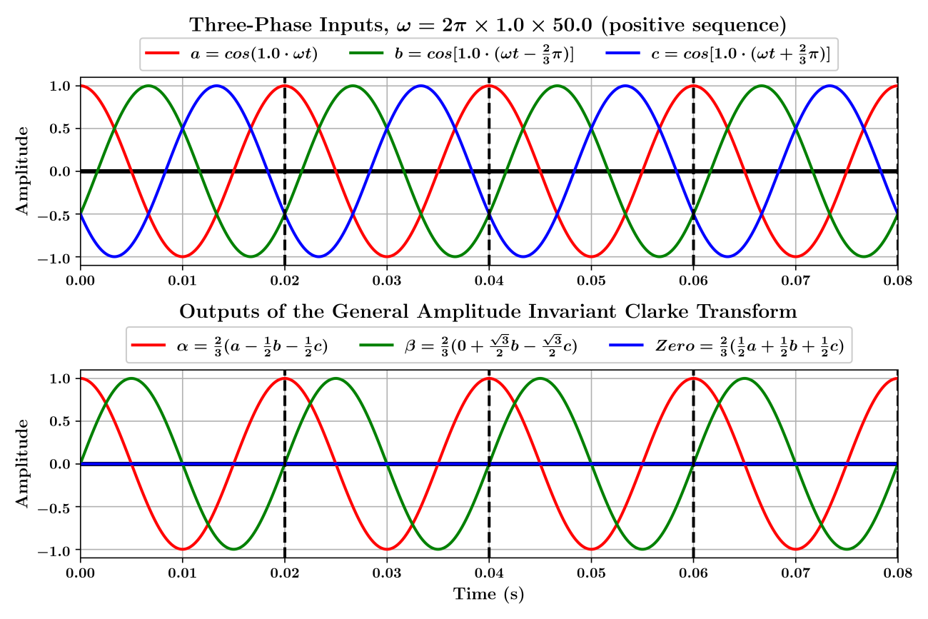

Figure . Output of the Clarke Transform on the 1st harmonic (fundamental). $α$ is leading $β$ by 90°

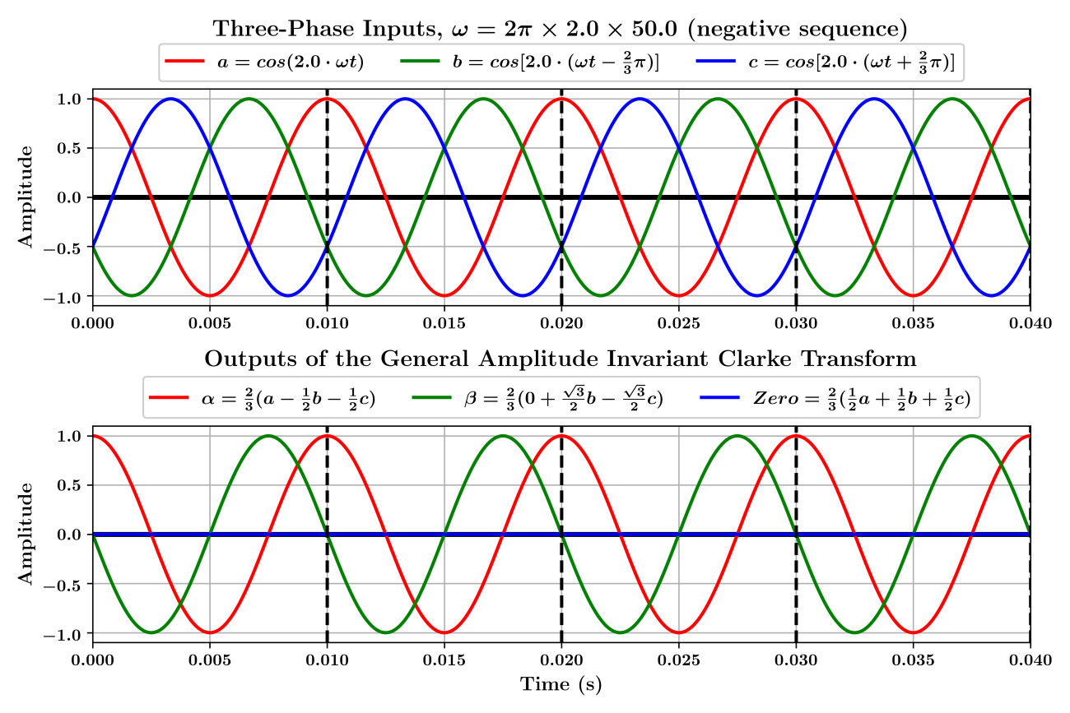

Figure . Output of the Clarke Transform on the 2nd harmonic. $α$ is lagging $β$ by 90°

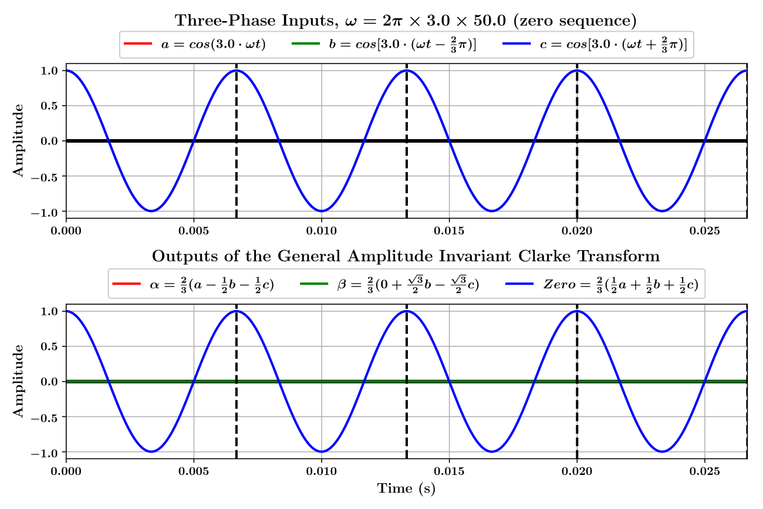

Figure . Output of the Clarke Transform on the 3rd harmonic. $α$ and $β$ are zero

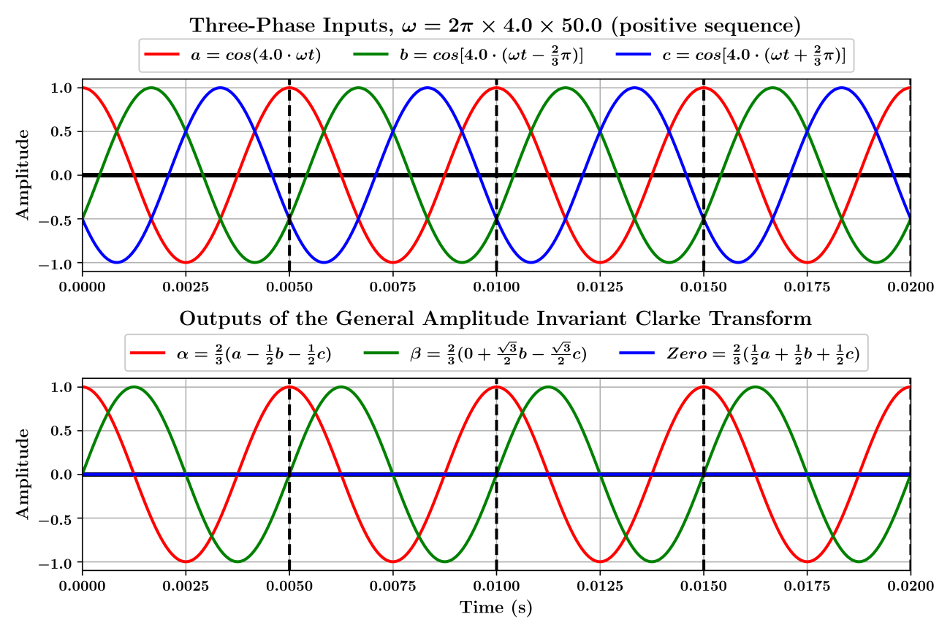

Figure . Output of the Clarke Transform on the 4th harmonic. $α$ is leading $β$ by 90°

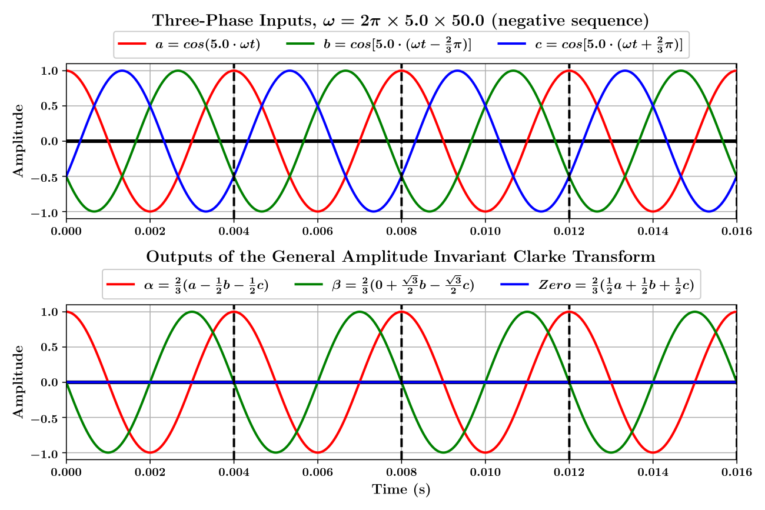

Figure . Output of the Clarke Transform on the 5th harmonic. $α$ is lagging $β$ by 90°

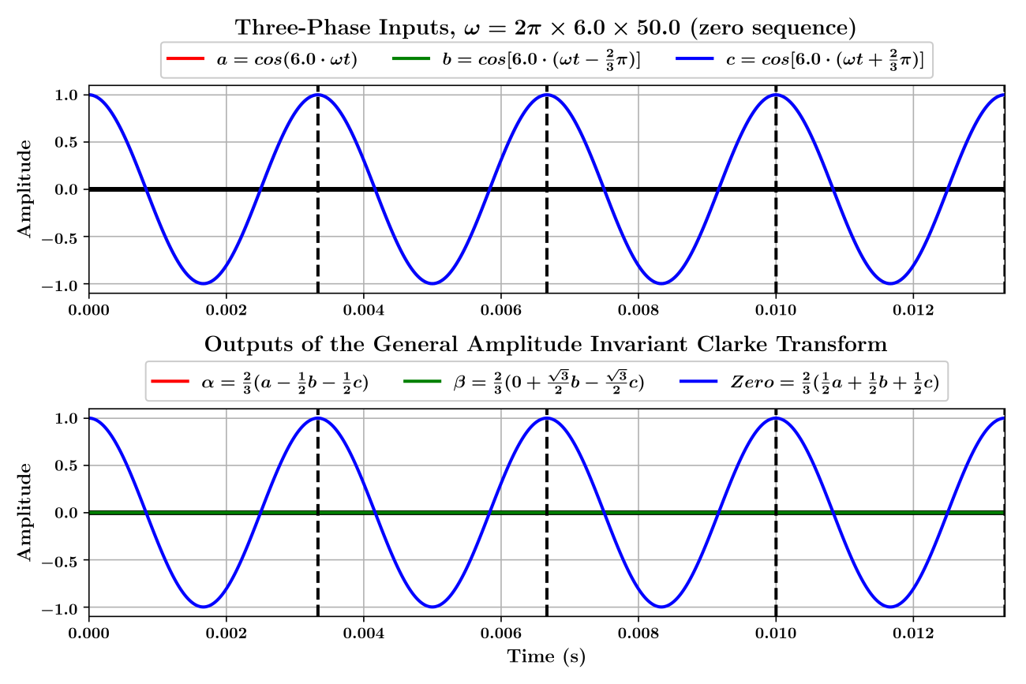

Figure . Output of the Clarke Transform on the 6th harmonic. $α$ and $β$ are zero

## Unbalanced components

Unbalanced analysis could be highly complex, it is better to apply symmetrical component analysis to the three-phase inputs and then analyse the Positive Sequence and the Negative Sequence of $α, β$ separately. This section would only discuss two special cases.

Define a set of three-phase input as:

|  |  |
| --- | --- |
| $$\left[\begin{matrix}a \\ b \\ c\end{matrix}\right]=\left[\begin{matrix}Mag_{a}⋅\cos\left(n_{a}⋅ω_{a}t\right) \\ Mag_{b}⋅cos\left[n_{b}⋅\left(ω_{b}t-120°\right)\right] \\ Mag_{c}⋅\cos\left[n_{c}⋅\left(ω_{c}t+120°\right)\right]\end{matrix}\right]$$ | Eq.74 |

where ${Mag}_{a}$ is the magnitude of Phase-A input; ${Mag}_{b}$ is the magnitude of Phase-B input; ${Mag}_{c}$ is the magnitude of Phase-C input; $n_{a}, n_{b}, n_{c}$ are of any non-negative real numbers; $ω_{a}$ is the angular frequency of Phase-A input; $ω_{b}$ is the angular frequency of Phase-B input; $ω_{c}$ is the angular frequency of Phase-C input.

### Special case 1, interharmonics

In this case, to keep the analysis easy to understand and to keep validity of the generic form of the Clarke Transform, Eq.74 is redefined:

$$\left\{\begin{matrix}{Mag}_{a}=Mag_{b}=Mag_{c}=Magnitude \\ n_{a}=n_{b}=n_{c}=n \\ ω_{a}=ω_{b}=ω_{c}=ω\end{matrix}\right.$$

$$⇒$$

$$\left[\begin{matrix}a \\ b \\ c\end{matrix}\right]=Magnitude\left[\begin{matrix}\cos\left(n⋅ωt\right) \\ \cos\left[n⋅\left(ωt-120°\right)\right] \\ \cos\left[n⋅\left(ωt+120°\right)\right]\end{matrix}\right]$$

where $n$ is a positive non-integer, e.g., $n=1.1$, $n=2.7$

Thus, the generic form of the Clarke components can still be used:

|  |  |
| --- | --- |
| $$\left\{\begin{matrix}α=\frac{2}{3}Magnitude\left[1-\cos\left(n⋅120°\right)\right]\cos\left(n⋅ωt\right) \\ β=\frac{2\sqrt{3}}{3}Magnitude⋅\sin\left(n⋅120°\right)\sin\left(n⋅ωt\right) \\ Zero=\frac{1}{3}Magnitude\left[1+2\cos\left(n⋅120°\right)\right]\cos\left(n⋅ωt\right)\end{matrix}\right.$$ | Eq.75 |

However, since $n$ is a positive non-integer, the magnitude of the $α$ component is not the same as the $β$ component. And the magnitude of the $Zero$ component is never zero. This is because, for interharmonics, the three-phase inputs are not separated by 120° and they do not sum to zero.

Examples are shown in Figure 4.7 to Figure 4.9.

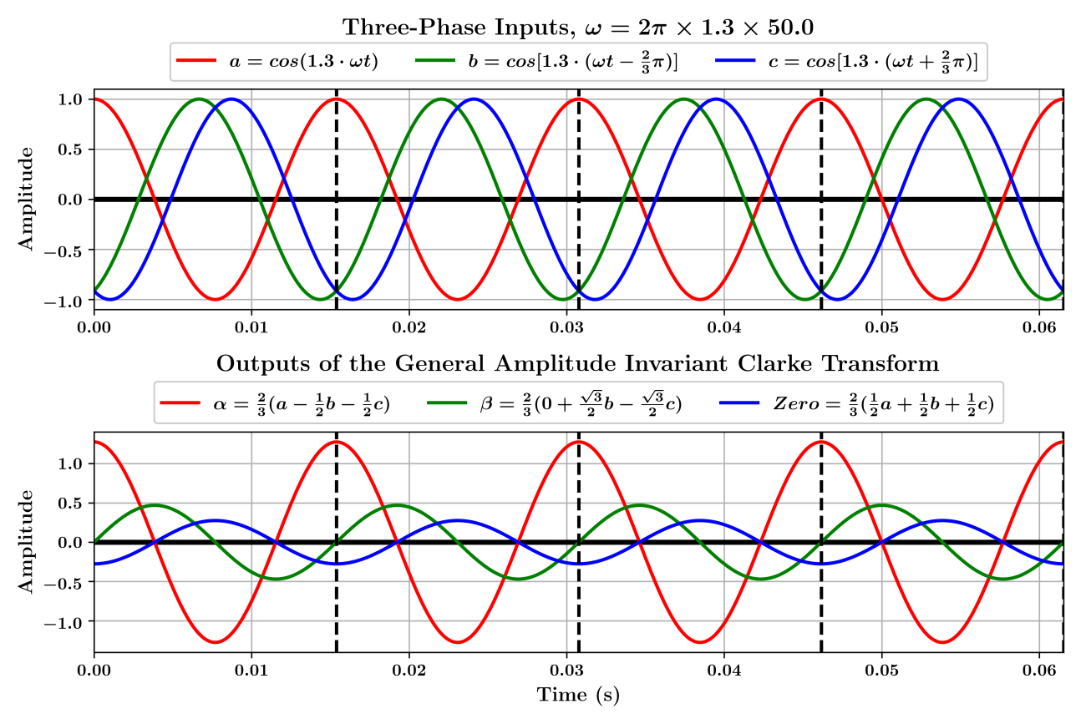

Figure . Output of the Clarke Transform on Hz. and are unbalanced. The frequencies of all Clarke components remain the same as the three-phase inputs

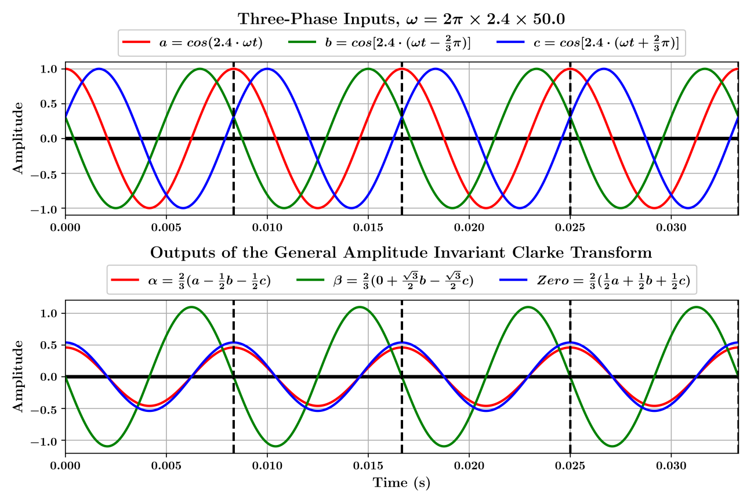

Figure . Output of the Clarke Transform on Hz. and are unbalanced. The frequencies of all Clarke components remain the same as the three-phase inputs

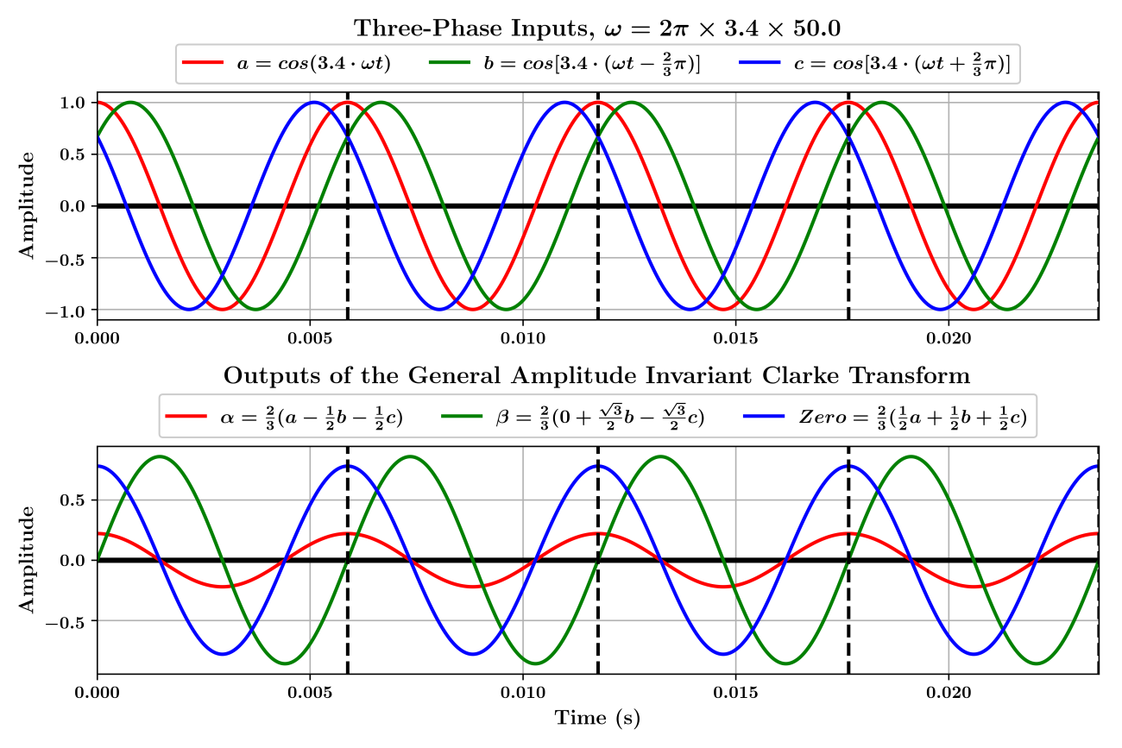

Figure . Output of the Clarke Transform on $3.4×50$ Hz. $α$ and $β$ are unbalanced. The frequencies of all Clarke components remain the same as the three-phase inputs

### Special case 2, magnitudes imbalance

In this case, the assumption is the following:

$$\left\{\begin{matrix}{Mag}_{a}≠Mag_{b}≠Mag_{c} \\ n_{a}=n_{b}=n_{c}=n \\ ω_{a}=ω_{b}=ω_{c}=ω\end{matrix}\right.$$

$$⇒$$

Eq.74 is redefined as:

$$\left[\begin{matrix}a \\ b \\ c\end{matrix}\right]=\left[\begin{matrix}Mag_{a}⋅\cos\left(n⋅ωt\right) \\ Mag_{b}⋅\cos\left[n⋅\left(ωt-120°\right)\right] \\ Mag_{c}⋅\cos\left[n⋅\left(ωt+120°\right)\right]\end{matrix}\right]$$

This time, the generic form of Clarke components cannot be applied because the initial phases are affected and the three-phase inputs are not necessarily evenly spaced by $120°$.

An example is given as the following.

Define the following:

$$\left\{\begin{matrix}{Mag}_{a}=0.7 \\ Mag_{b}=1.2 \\ Mag_{c}=0.6 \\ n_{a}=n_{b}=n_{c}=1 \\ ω_{a}=ω_{b}=ω_{c}=2π⋅50\end{matrix}\right.$$

$$⇒$$

$$\left[\begin{matrix}a \\ b \\ c\end{matrix}\right]=\left[\begin{matrix}0.7⋅\cos\left(2π⋅50t\right) \\ 1.2⋅\cos\left(2π⋅50t-120°\right) \\ 0.6⋅\cos\left(2π⋅50t+120°\right)\end{matrix}\right]$$

${Mag}_{a}, {Mag}_{b}, {Mag}_{c}$ are selected in a way such that the three phases are very unbalanced and the effects are thus easy to observe. The waveforms are shown in Figure 4.10.

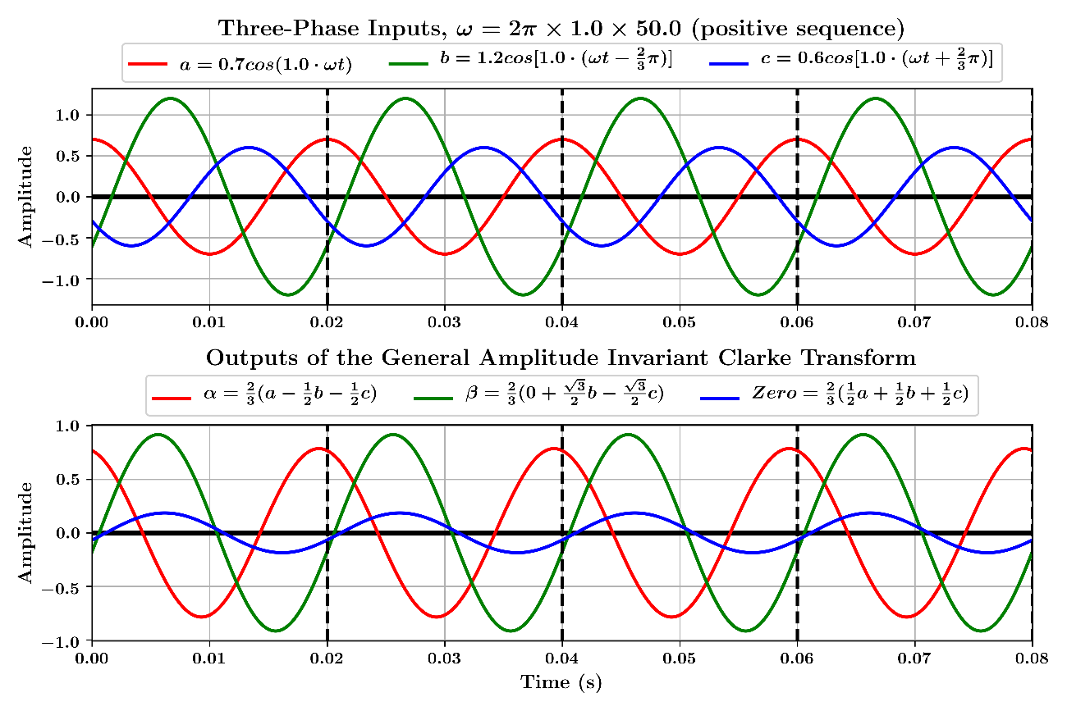

Figure . Output of the Clarke Transform on $1.0×50$ Hz. The magnitude of the three-phase inputs are 0.7, 1.2 and 0.6, respectively. $α$ and $β$ are unbalanced

# Impacts of the Park Transform on Different Frequency Components

For $n=0+3k, k=0, 1, 2, 3, 4, 5, 6, 7⋯$, by referencing Eq.5 and **Error! Reference source not found.**, there is the following:

$$\left[\begin{matrix}d \\ q \\ Zero\end{matrix}\right]= \left[\begin{matrix}cosθ & sinθ & 0 \\ -sinθ & cosθ & 0 \\ 0 & 0 & 1\end{matrix}\right]\left[\begin{matrix}α \\ β \\ Zero\end{matrix}\right] \\ =\left[\begin{matrix}cosθ & sinθ & 0 \\ -sinθ & cosθ & 0 \\ 0 & 0 & 1\end{matrix}\right]\left[\begin{matrix}0 \\ 0 \\ Magnitude∙\cos{n\left(ωt\right)}\end{matrix}\right]$$

$$⇒$$

|  |  |
| --- | --- |
| $$d=0$$ | Eq.76 |
| $$q=0$$ | Eq.77 |
| $$Zero=Magnitude∙\cos{n\left(ωt\right)}$$ | Eq.78 |

For $n=1+3k, k=0, 1, 2, 3, 4, 5, 6, 7⋯$, by referencing Eq.5 and **Error! Reference source not found.**, there is the following:

$$\left[\begin{matrix}d \\ q \\ Zero\end{matrix}\right]= \left[\begin{matrix}cosθ & sinθ & 0 \\ -sinθ & cosθ & 0 \\ 0 & 0 & 1\end{matrix}\right]\left[\begin{matrix}α \\ β \\ Zero\end{matrix}\right] \\ =\left[\begin{matrix}cosθ & sinθ & 0 \\ -sinθ & cosθ & 0 \\ 0 & 0 & 1\end{matrix}\right]\left[\begin{matrix}Magnitude∙\cos{n\left(ωt\right)} \\ Magnitude∙\cos\left[n\left(ωt\right)-90°\right] \\ 0\end{matrix}\right]$$

$$⇒$$

|  |  |
| --- | --- |
| $$d=Magnitude\left\{\cos{n\left(ωt\right)}\cos{θ}+\cos\left[n\left(ωt\right)-90°\right]\sin{θ}\right\}$$ | Eq.79 |
| $$q=Magnitude\left\{\cos\left[n\left(ωt\right)-90°\right]\cos{θ}-\cos{n\left(ωt\right)}\sin{θ}\right\}$$ | Eq.80 |
| $$Zero=0$$ | Eq.81 |

For Eq.79:

$$d=Magnitude\left\{\cos{n\left(ωt\right)}\cos{θ}+\cos\left[n\left(ωt\right)-90°\right]\sin{θ}\right\} \\ =Magnitude\left[\cos{n\left(ωt\right)}\cos{θ}+\sin{n\left(ωt\right)}\sin{θ}\right] \\ =Magnitude∙\cos\left[n\left(ωt\right)-θ\right]$$

For Eq.80:

$$q=Magnitude\left\{\cos\left[n\left(ωt\right)-90°\right]\cos{θ}-\cos{n\left(ωt\right)}\sin{θ}\right\} \\ =Magnitude\left[\sin{n\left(ωt\right)}\cos{θ}-\cos{n\left(ωt\right)}\sin{θ}\right] \\ =Magnitude∙\sin\left[n\left(ωt\right)-θ\right] \\ =Magnitude∙\cos\left\{\left[n\left(ωt\right)-θ\right]-90°\right\}$$

For $n=2+3k, k=0, 1, 2, 3, 4, 5, 6, 7⋯$, by referencing Eq.5 and **Error! Reference source not found.**, there is the following:

$$\left[\begin{matrix}d \\ q \\ Zero\end{matrix}\right]= \left[\begin{matrix}cosθ & sinθ & 0 \\ -sinθ & cosθ & 0 \\ 0 & 0 & 1\end{matrix}\right]\left[\begin{matrix}α \\ β \\ Zero\end{matrix}\right] \\ =\left[\begin{matrix}cosθ & sinθ & 0 \\ -sinθ & cosθ & 0 \\ 0 & 0 & 1\end{matrix}\right]\left[\begin{matrix}Magnitude∙\cos{n\left(ωt\right)} \\ Magnitude∙\cos\left[n\left(ωt\right)+90°\right] \\ 0\end{matrix}\right]$$

$$⇒$$

|  |  |
| --- | --- |
| $$d=Magnitude\left\{\cos{n\left(ωt\right)}\cos{θ}+\cos\left[n\left(ωt\right)+90°\right]\sin{θ}\right\}$$ | Eq.82 |
| $$q=Magnitude\left\{\cos\left[n\left(ωt\right)+90°\right]\cos{θ}-\cos{n\left(ωt\right)}\sin{θ}\right\}$$ | Eq.83 |
| $$Zero=0$$ | Eq.84 |

For Eq.82:

$$d=Magnitude\left\{\cos{n\left(ωt\right)}\cos{θ}+\cos\left[n\left(ωt\right)+90°\right]\sin{θ}\right\} \\ =Magnitude\left\{\cos{n\left(ωt\right)}\cos{θ}-\sin{n\left(ωt\right)}\sin{θ}\right\} \\ =Magnitude∙\cos\left[n\left(ωt\right)+θ\right]$$

For Eq.83:

$$q=Magnitude\left\{\cos\left[n\left(ωt\right)+90°\right]\cos{θ}-\cos{n\left(ωt\right)}\sin{θ}\right\} \\ =Magnitude\left[-\sin{n\left(ωt\right)}\cos{θ}-\cos{n\left(ωt\right)}\cos{θ}\right] \\ =-Magnitude∙\sin\left[n\left(ωt\right)+θ\right] \\ =Magnitude∙\cos\left\{\left[n\left(ωt\right)+θ\right]+90°\right\}$$

If the Park Transform is applied directly to a set of zero-sequence inputs:

$$\left[\begin{matrix}d \\ q \\ Zero\end{matrix}\right]= \left[\begin{matrix}cosθ & sinθ & 0 \\ -sinθ & cosθ & 0 \\ 0 & 0 & 1\end{matrix}\right]\left[\begin{matrix}Magnitude∙\cos{n\left(ωt\right)} \\ Magnitude∙\cos{n\left(ωt\right)} \\ Magnitude∙\cos{n\left(ωt\right)}\end{matrix}\right]$$

$$⇒$$

|  |  |
| --- | --- |
| $$d=Magnitude∙\cos{n\left(ωt\right)}\left(\cos{θ}+\sin{θ}\right)$$ | Eq.85 |
| $$q=Magnitude∙\cos{n\left(ωt\right)}\left(\cos{θ}-\sin{θ}\right)$$ | Eq.86 |
| $$Zero=Magnitude∙\cos{n\left(ωt\right)}$$ | Eq.87 |

For Eq.85:

$$d=Magnitude∙\cos{n\left(ωt\right)}\left(\cos{θ}+\sin{θ}\right) \\ =Magnitude∙\sqrt{2}\cos{n\left(ωt\right)}\cos\left(θ-45°\right) \\ =Magnitude∙\sqrt{2}\left\{\frac{1}{2}\left[\cos\left(nωt+θ-45°\right)+\cos\left(nωt-θ+45°\right)\right]\right\} \\ =Magnitude∙\frac{\sqrt{2}}{2}\left\{\cos\left[n\left(ωt\right)+θ-45°\right]+\cos\left[n\left(ωt\right)-θ+45°\right]\right\}$$

For Eq.86:

$$q=Magnitude∙\cos{n\left(ωt\right)}\left(\cos{θ}-\sin{θ}\right) \\ =Magnitude∙\sqrt{2}\cos{n\left(ωt\right)}\cos\left(θ+45°\right) \\ =Magnitude∙\sqrt{2}\left\{\frac{1}{2}\left[\cos\left(nωt+θ+45°\right)+\cos\left(nωt-θ-45°\right)\right]\right\} \\ =Magnitude∙\frac{\sqrt{2}}{2}\left\{\cos\left[n\left(ωt\right)+θ+45°\right]+\cos\left[n\left(ωt\right)-θ-45°\right]\right\}$$

To conclude,

1. For $n=0+3k, k=0, 1, 2, 3, 4, 5, 6, 7⋯$ (zero sequence)

|  |  |
| --- | --- |
| $$\left\{\begin{matrix}d=0 \\ q=0 \\ Zero=Magnitude∙\cos{n\left(ωt\right)}\end{matrix}\right.$$ | Eq.88 |

1. For $n=1+3k, k=0, 1, 2, 3, 4, 5, 6, 7⋯$ (positive sequence)

|  |  |
| --- | --- |
| $$\left\{\begin{matrix}d=Magnitude∙\cos\left[n\left(ωt\right)-θ\right] \\ q=Magnitude∙\cos\left\{\left[n\left(ωt\right)-θ\right]-90°\right\} \\ Zero=0\end{matrix}\right.$$ | Eq.89 |

1. For $n=2+3k, k=0, 1, 2, 3, 4, 5, 6, 7⋯$ (negative sequence)

|  |  |
| --- | --- |
| $$\left\{\begin{matrix}d=Magnitude∙\cos\left[n\left(ωt\right)+θ\right] \\ q=Magnitude∙\cos\left\{\left[n\left(ωt\right)+θ\right]+90°\right\} \\ Zero=0\end{matrix}\right.$$ | Eq.90 |

Eq.88 shows that the zero sequence is not altered by the General Park Transform. This is demonstrated in Figure 5.1 to Figure 5.4.

The $θ$ used in the General Park Transform is usually provided by a Phase-Locked Loop (PLL), which is usually locked to the fundamental system frequency. This means that, usually, $θ=ωt$. In this case, Eq.89 would become:

|  |  |
| --- | --- |
| $$\left\{\begin{matrix}d=Magnitude∙\cos\left[n\left(ωt\right)-ωt\right]=Magnitude⋅\cos\left[\left(n-1\right)ωt\right] \\ q=Magnitude∙\cos\left\{\left[n\left(ωt\right)-ωt\right]-90°\right\}=Magnitude⋅\cos\left\{\left[\left(n-1\right)ωt\right]-90°\right\} \\ Zero=0\end{matrix}\right.$$ | Eq.91 |

and Eq.90 would become:

|  |  |
| --- | --- |
| $$\left\{\begin{matrix}d=Magnitude∙\cos\left[n\left(ωt\right)+ωt\right]=Magnitude⋅\cos\left[\left(n+1\right)ωt\right] \\ q=Magnitude∙\cos\left\{\left[n\left(ωt\right)+θ\right]+90°\right\}=Magnitude⋅\left\{\cos\left[\left(n+1\right)ωt\right]+90°\right\} \\ Zero=0\end{matrix}\right.$$ | Eq.92 |

Therefore, if $θ$ is locked on to the fundamental system frequency, then the frequency of the $dq$ components of the positive sequence components would be reduced by once the fundamental system frequency. The frequency of the $dq$ components of the negative sequence components would be increased by once the fundamental system frequency. This is demonstrated in Figure 5.5 to Figure 5.12.

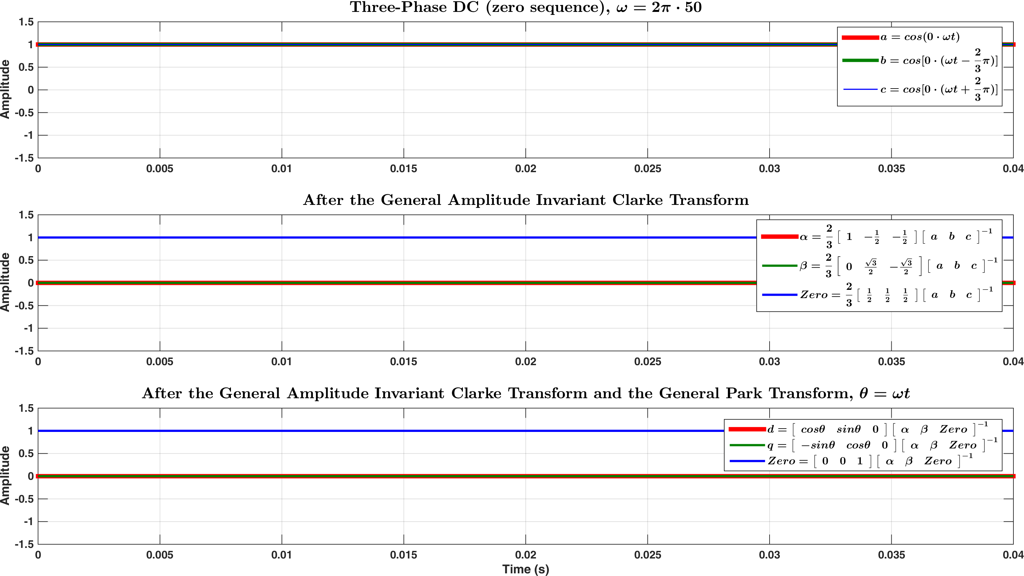

Figure .

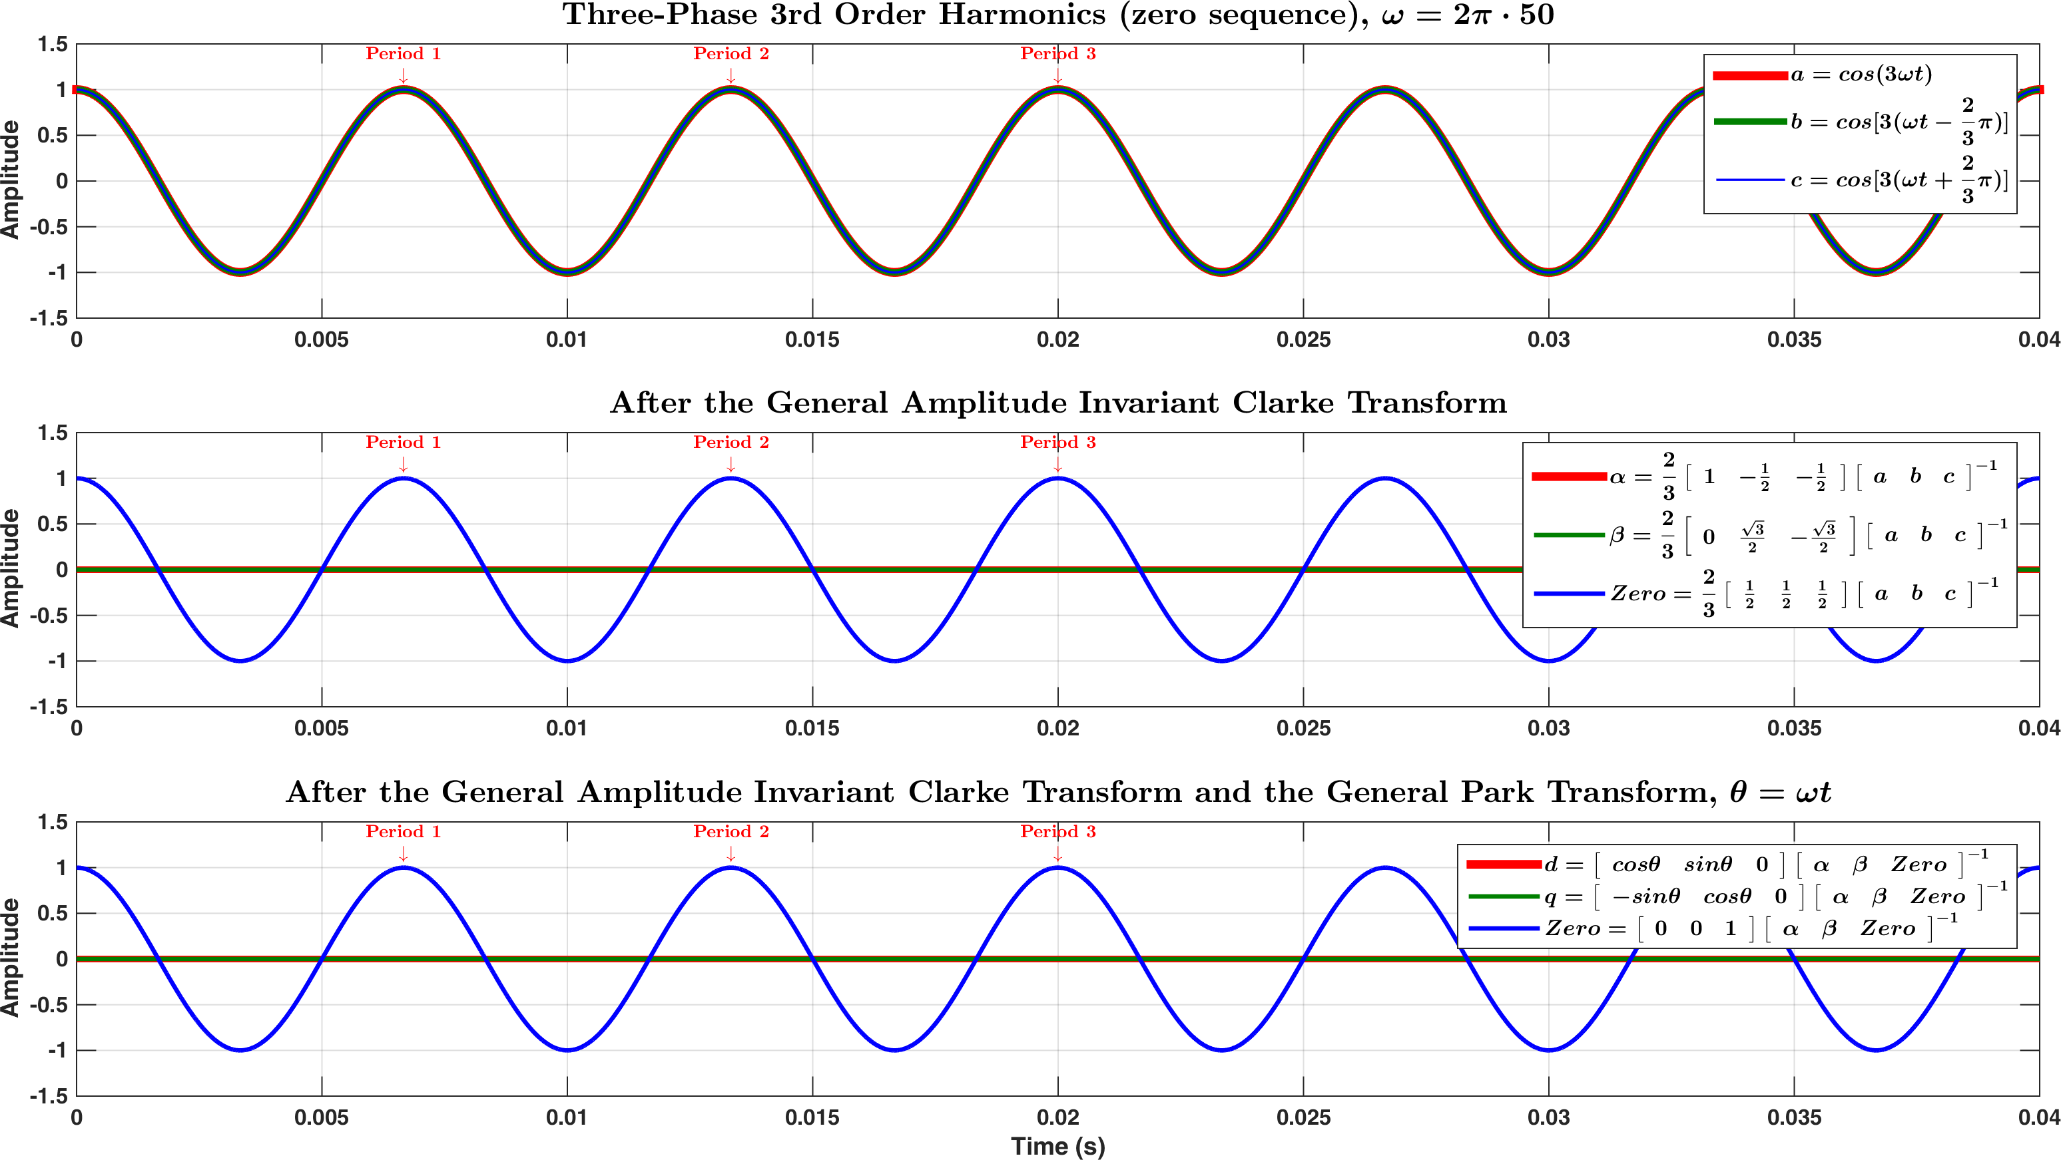

Figure .

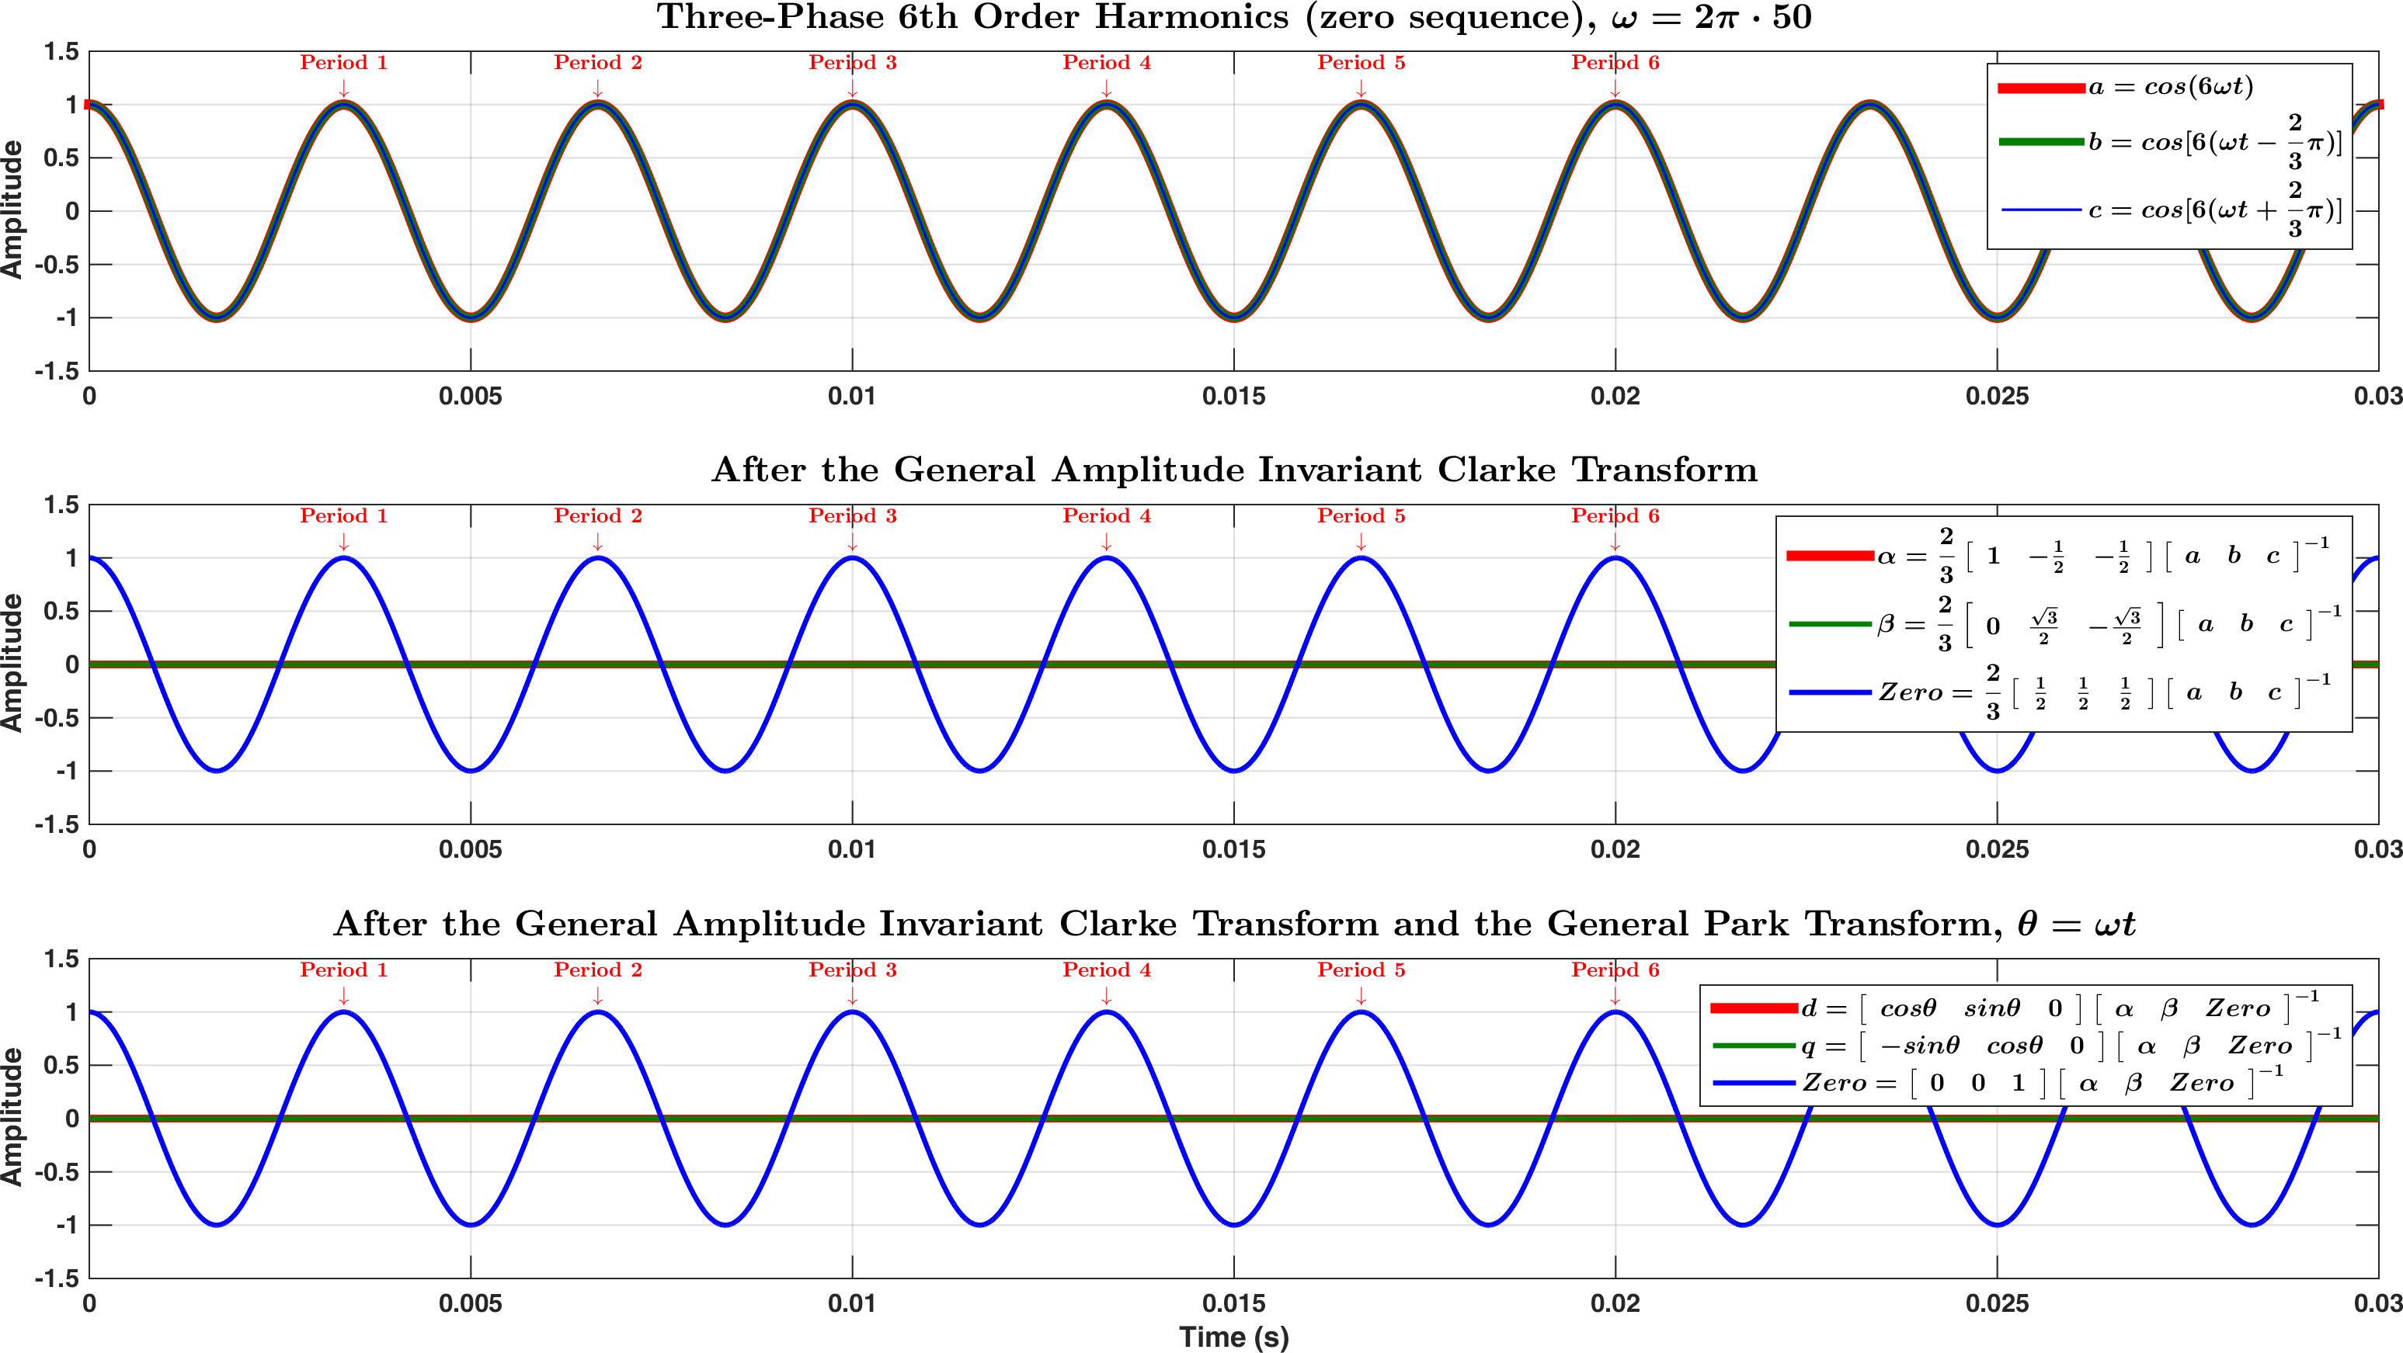

Figure .

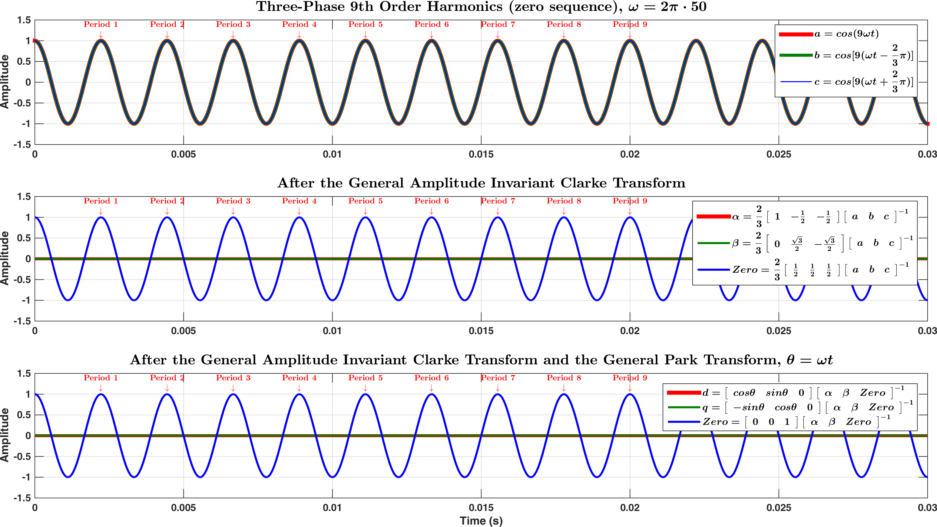

Figure .

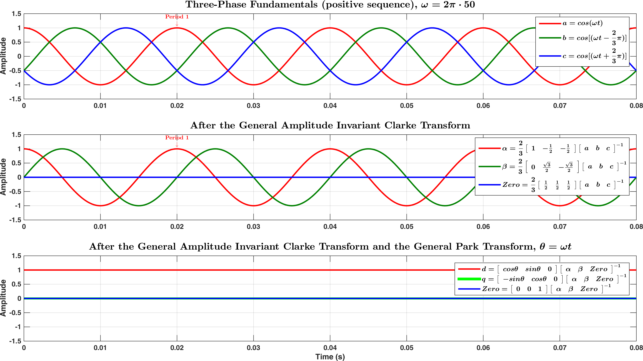

Figure .

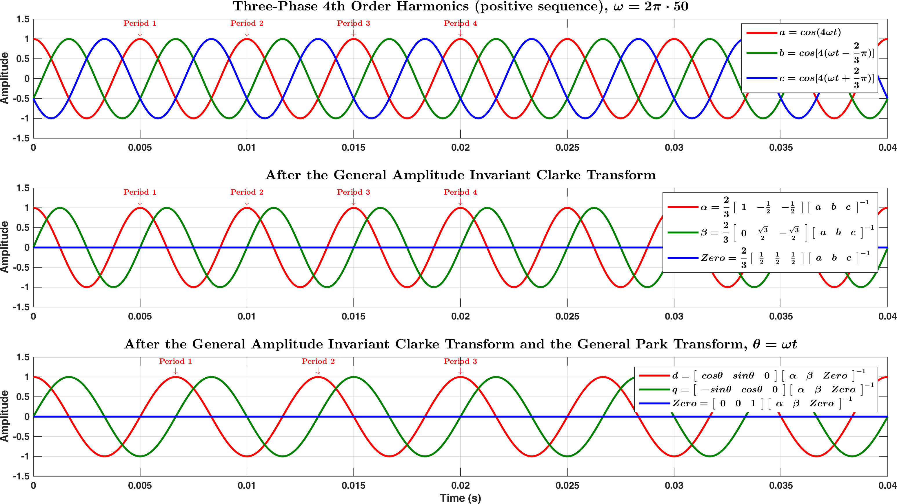

Figure .

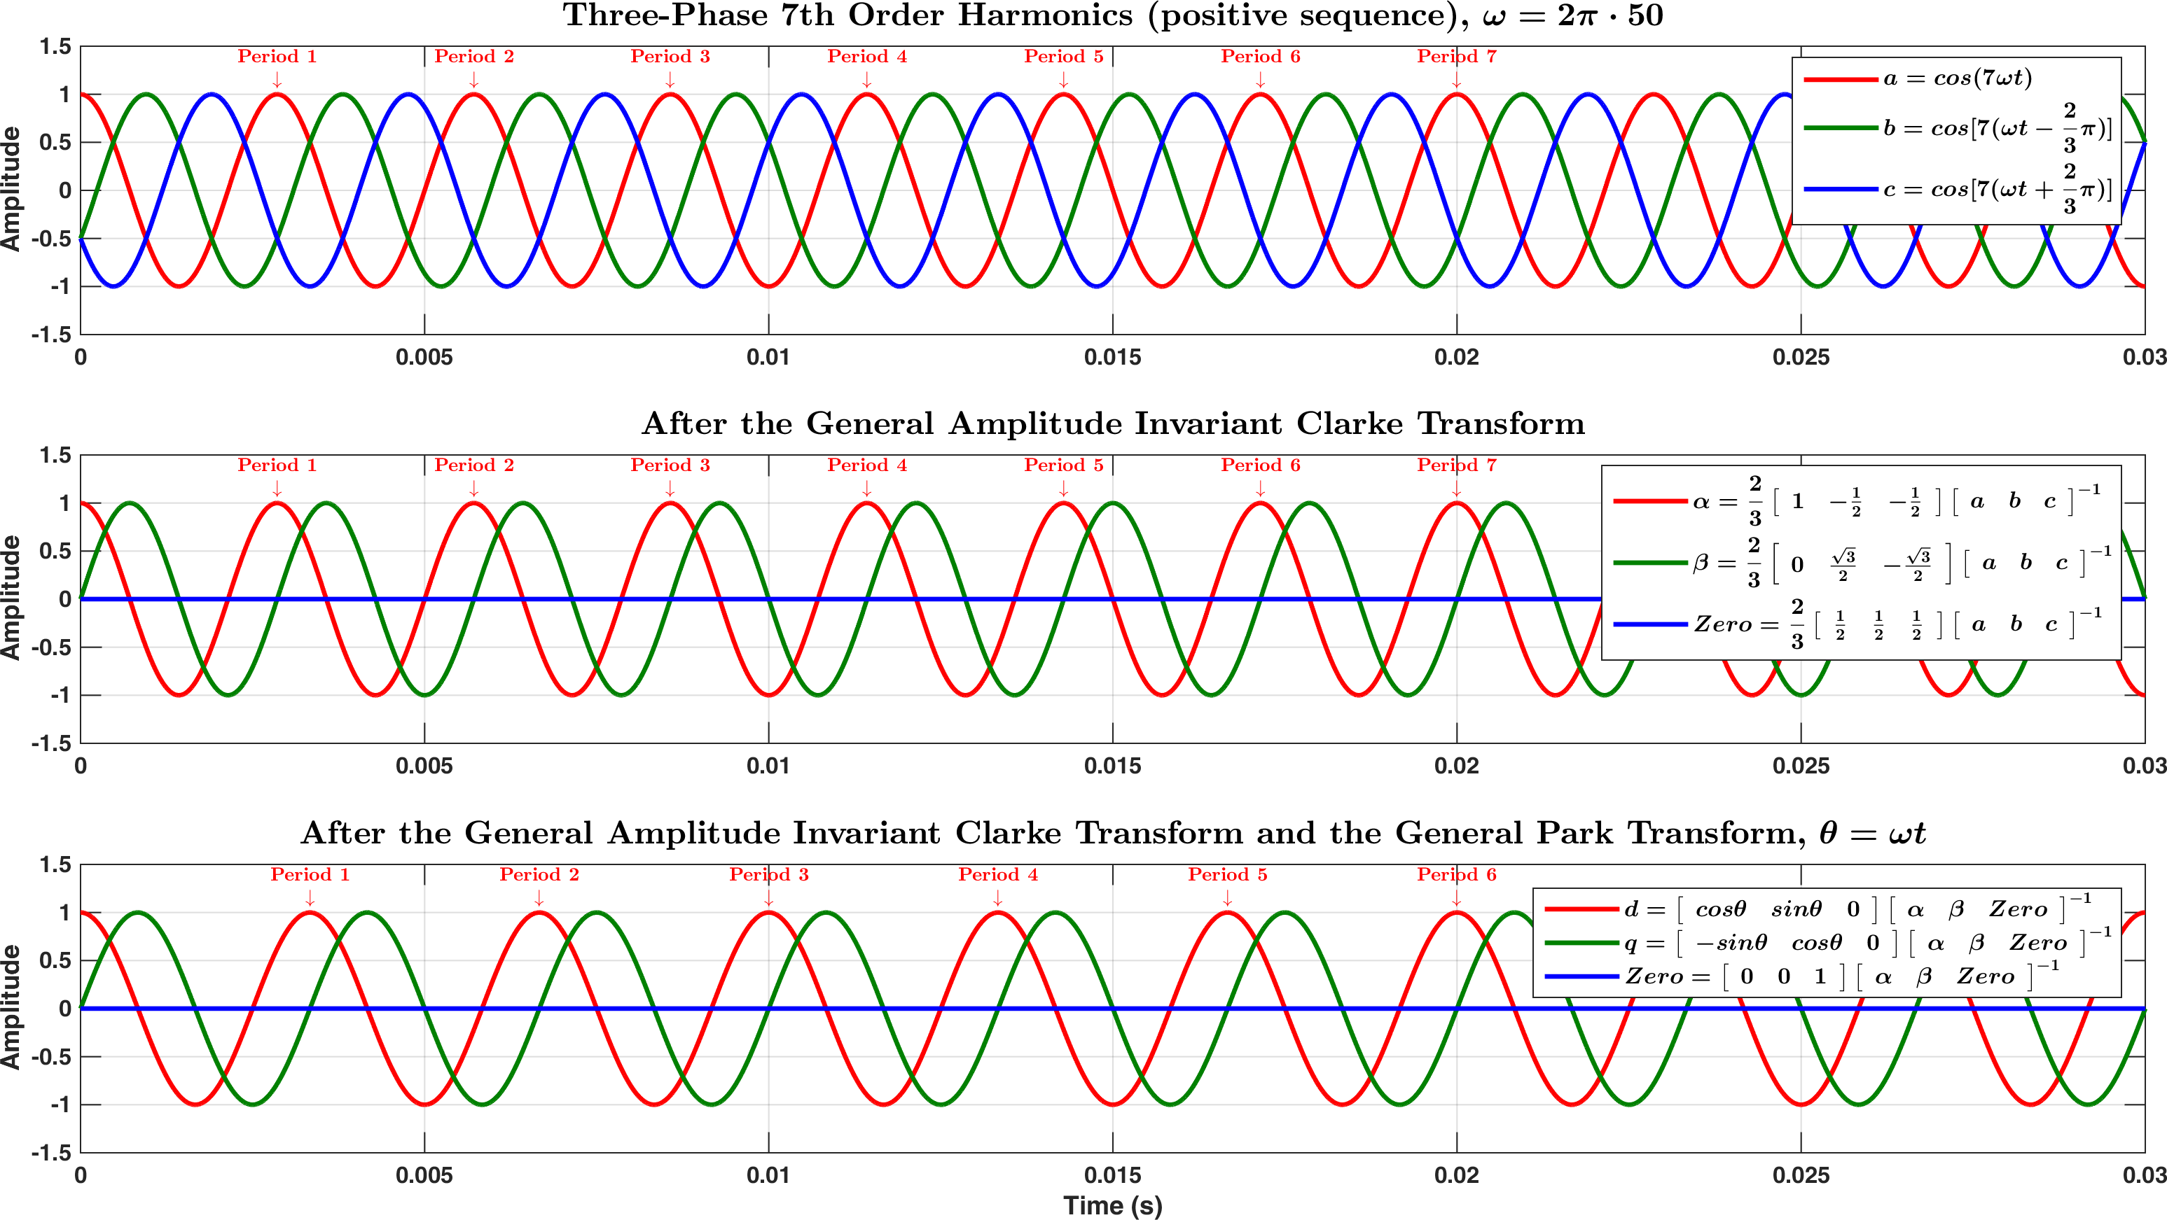

Figure .

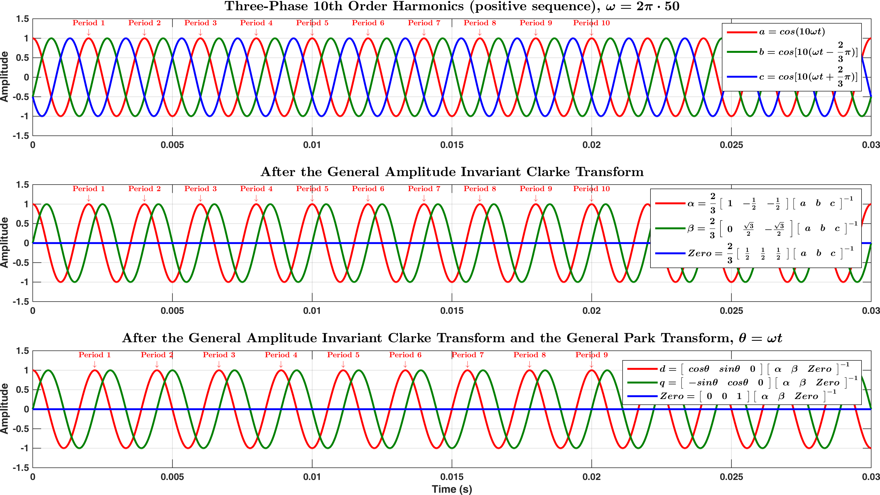

Figure .

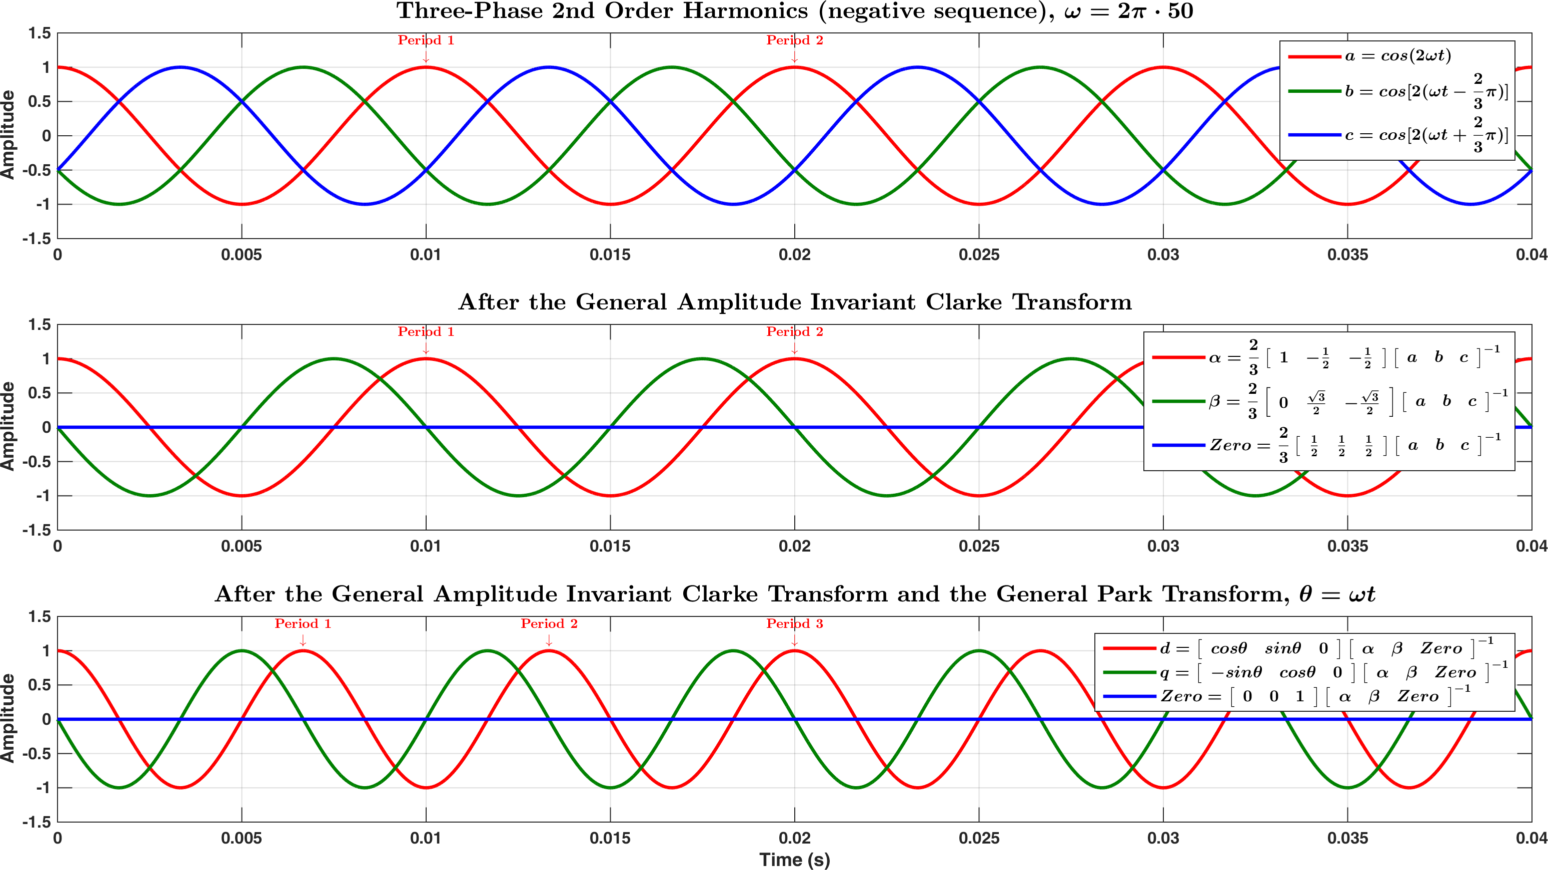

Figure .

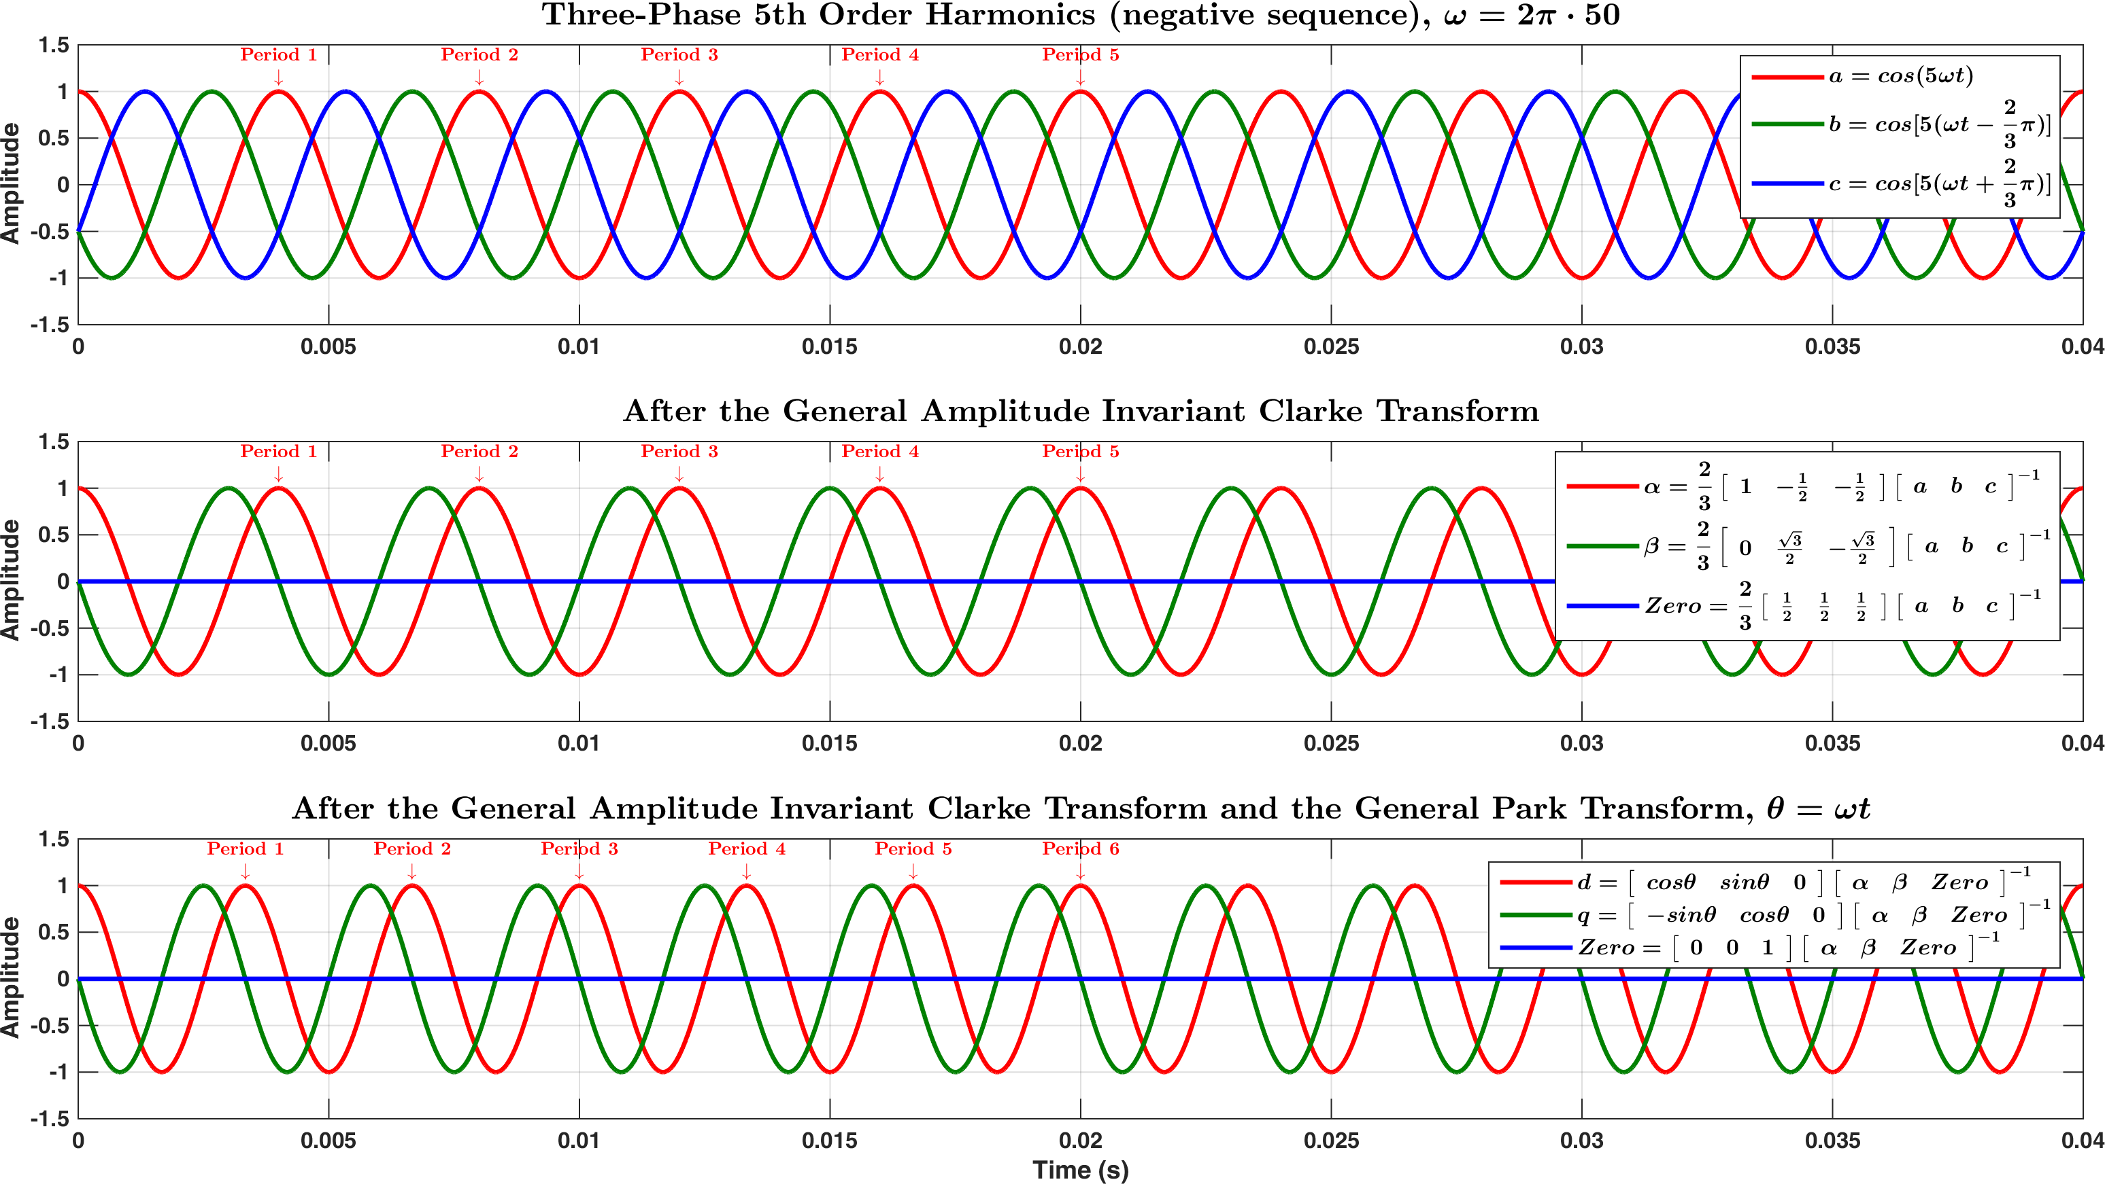

Figure .

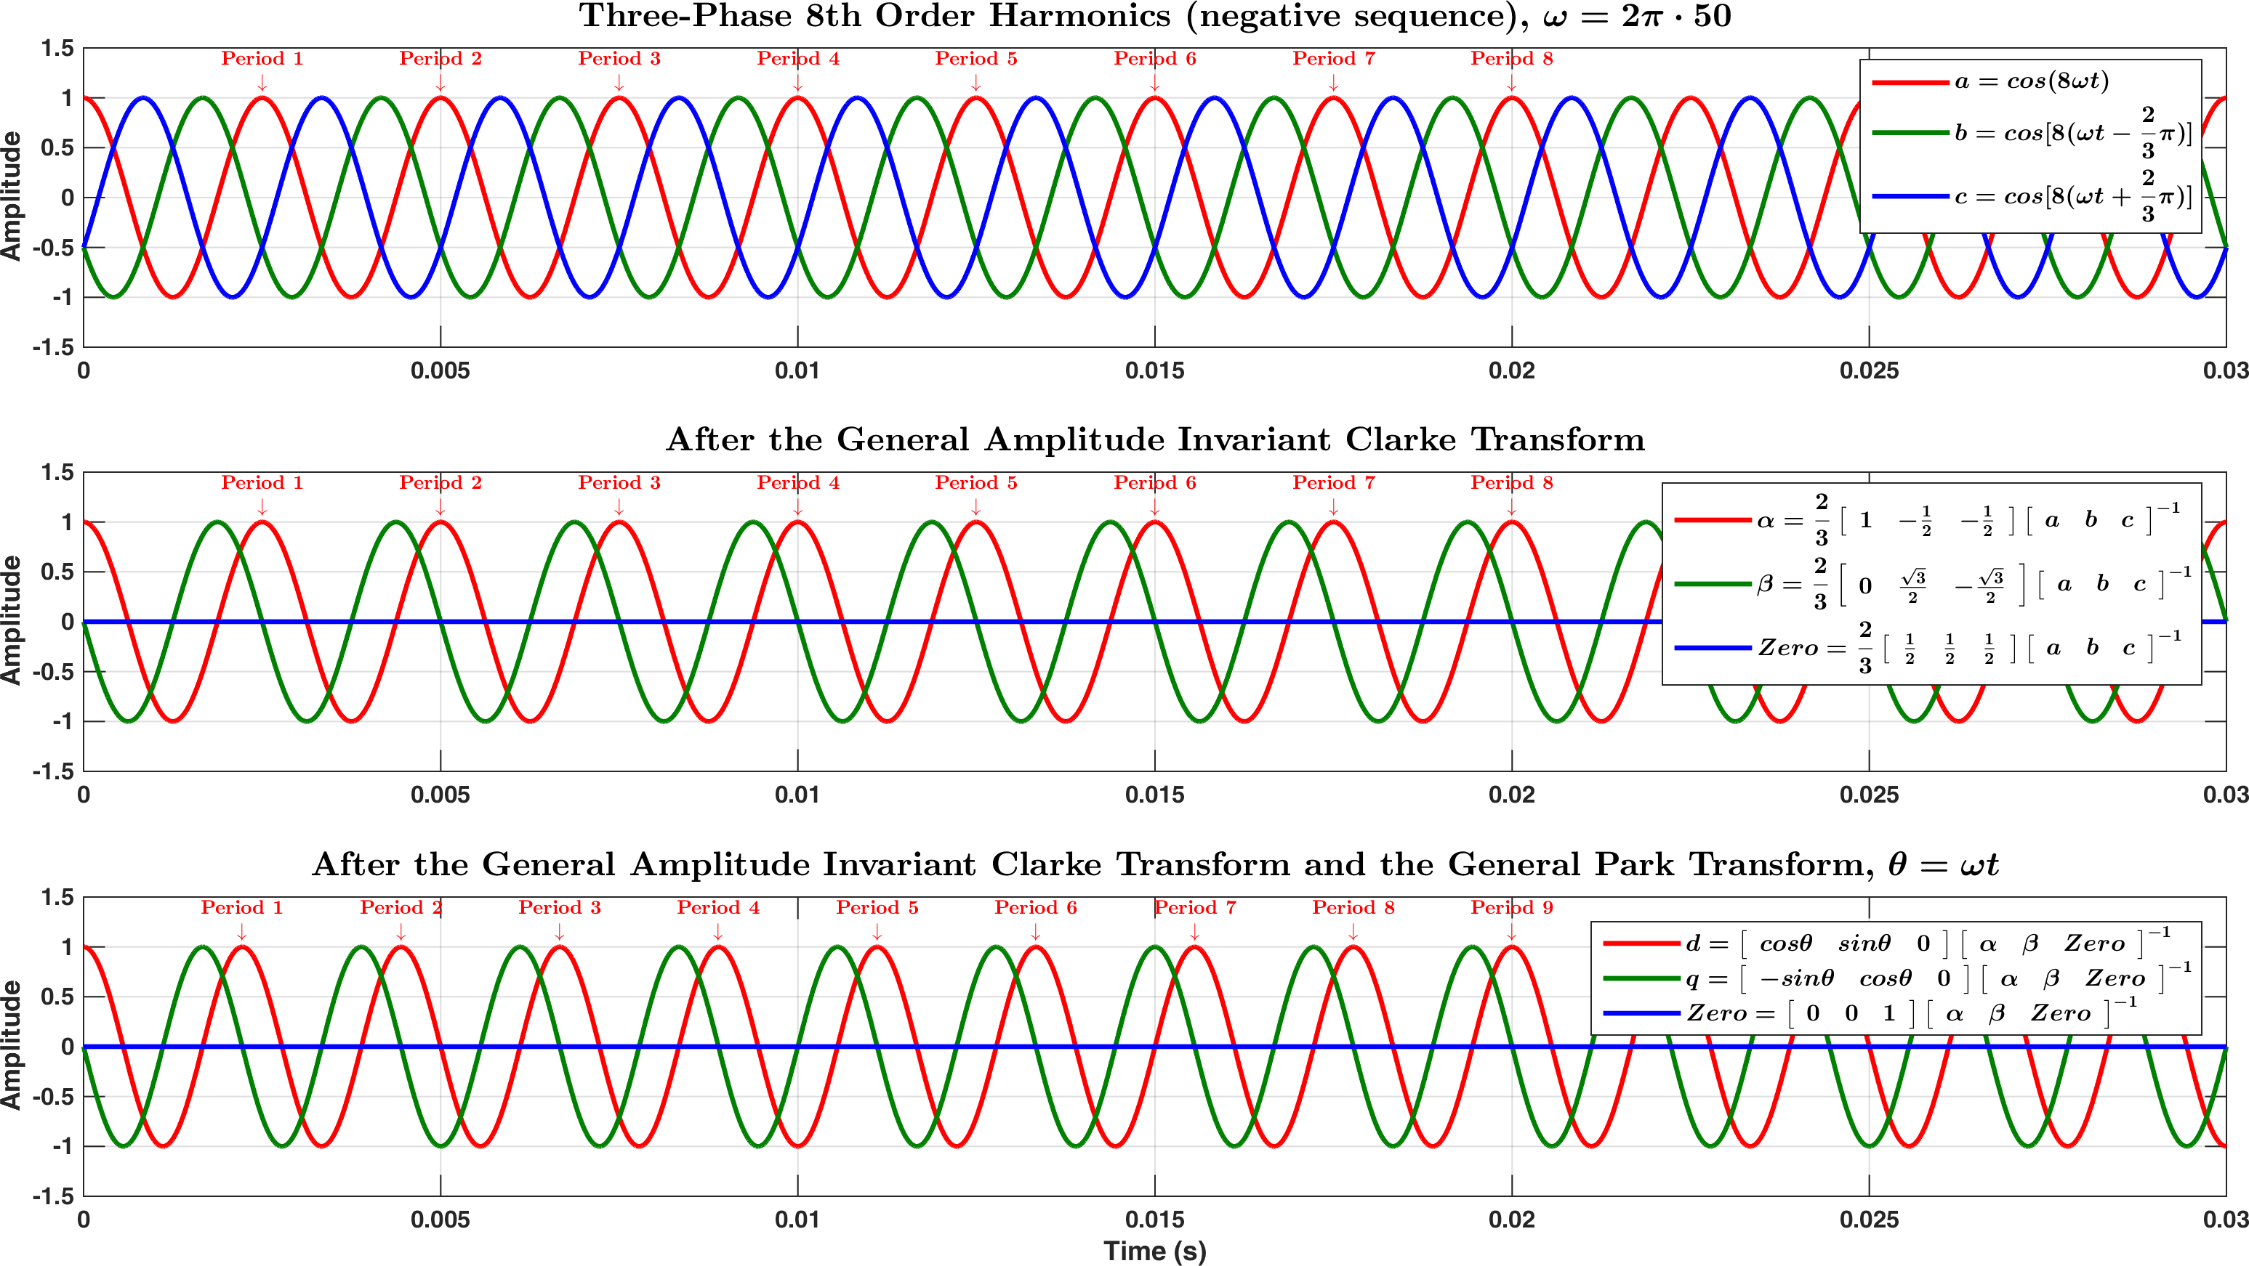

Figure .

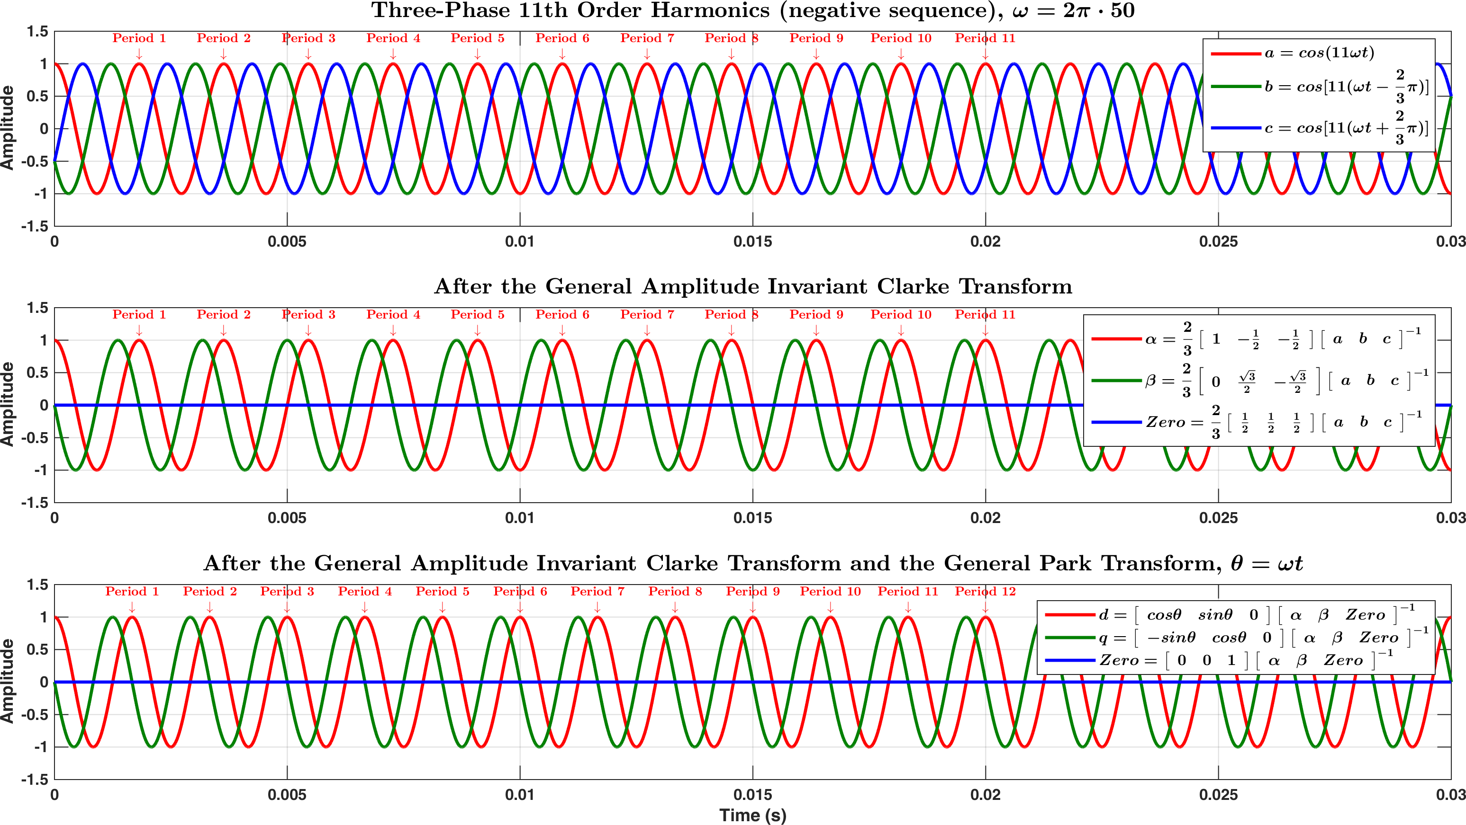

Figure .

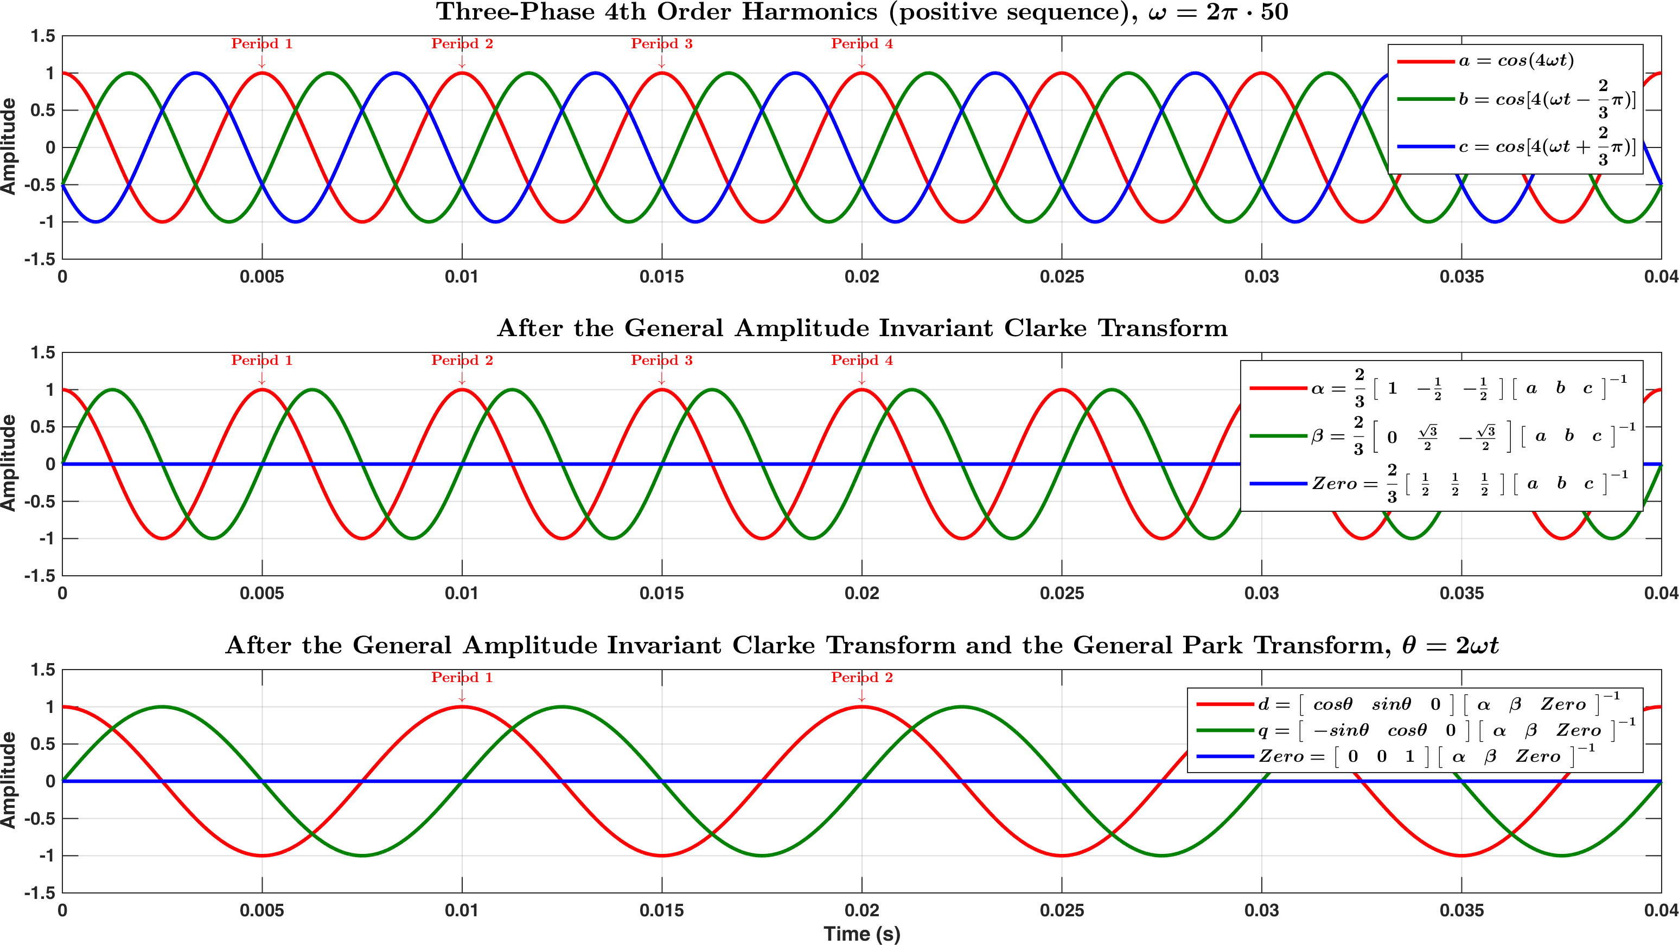

Figure .

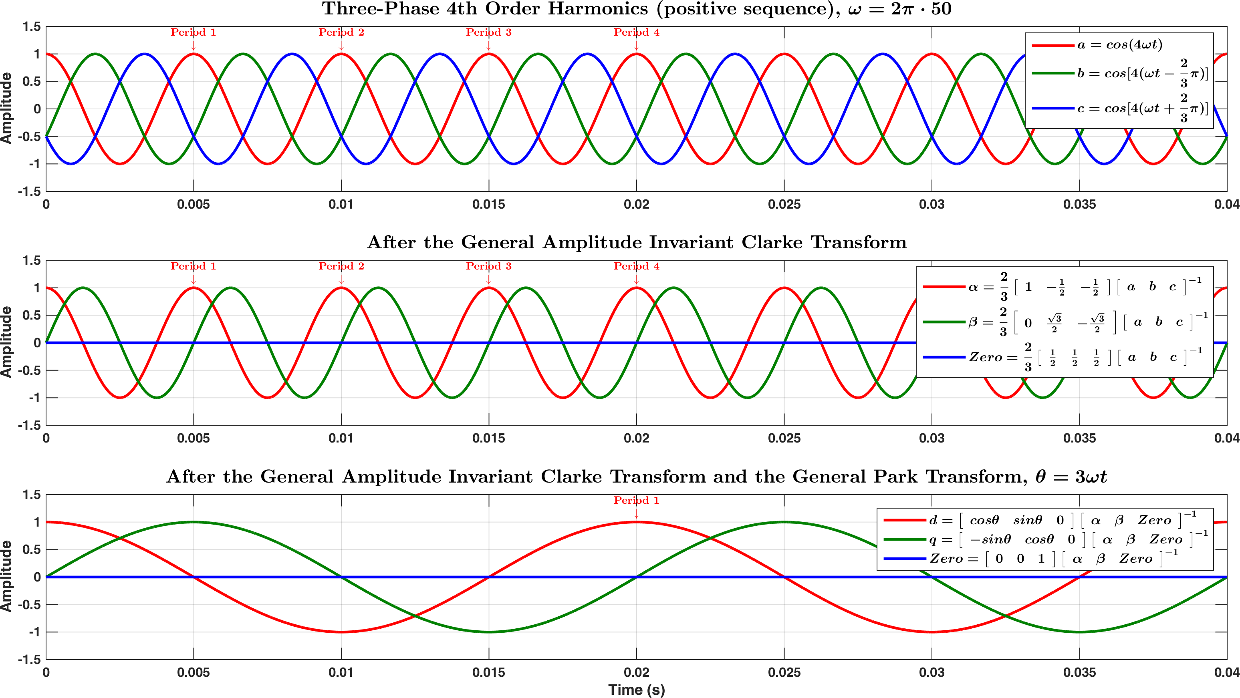

Figure .

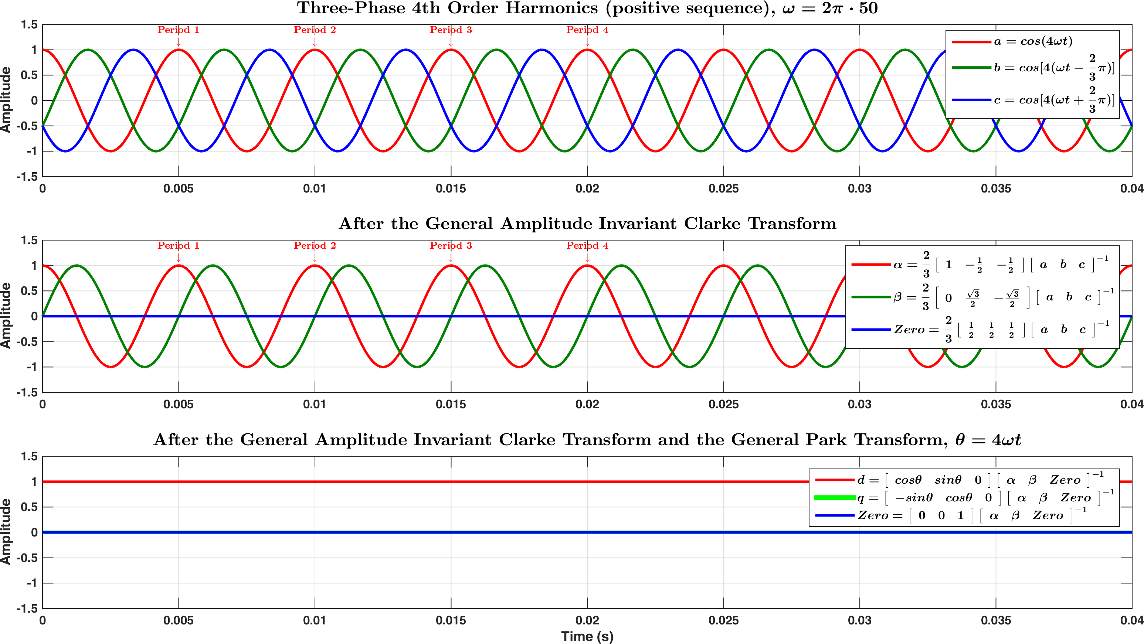

Figure .

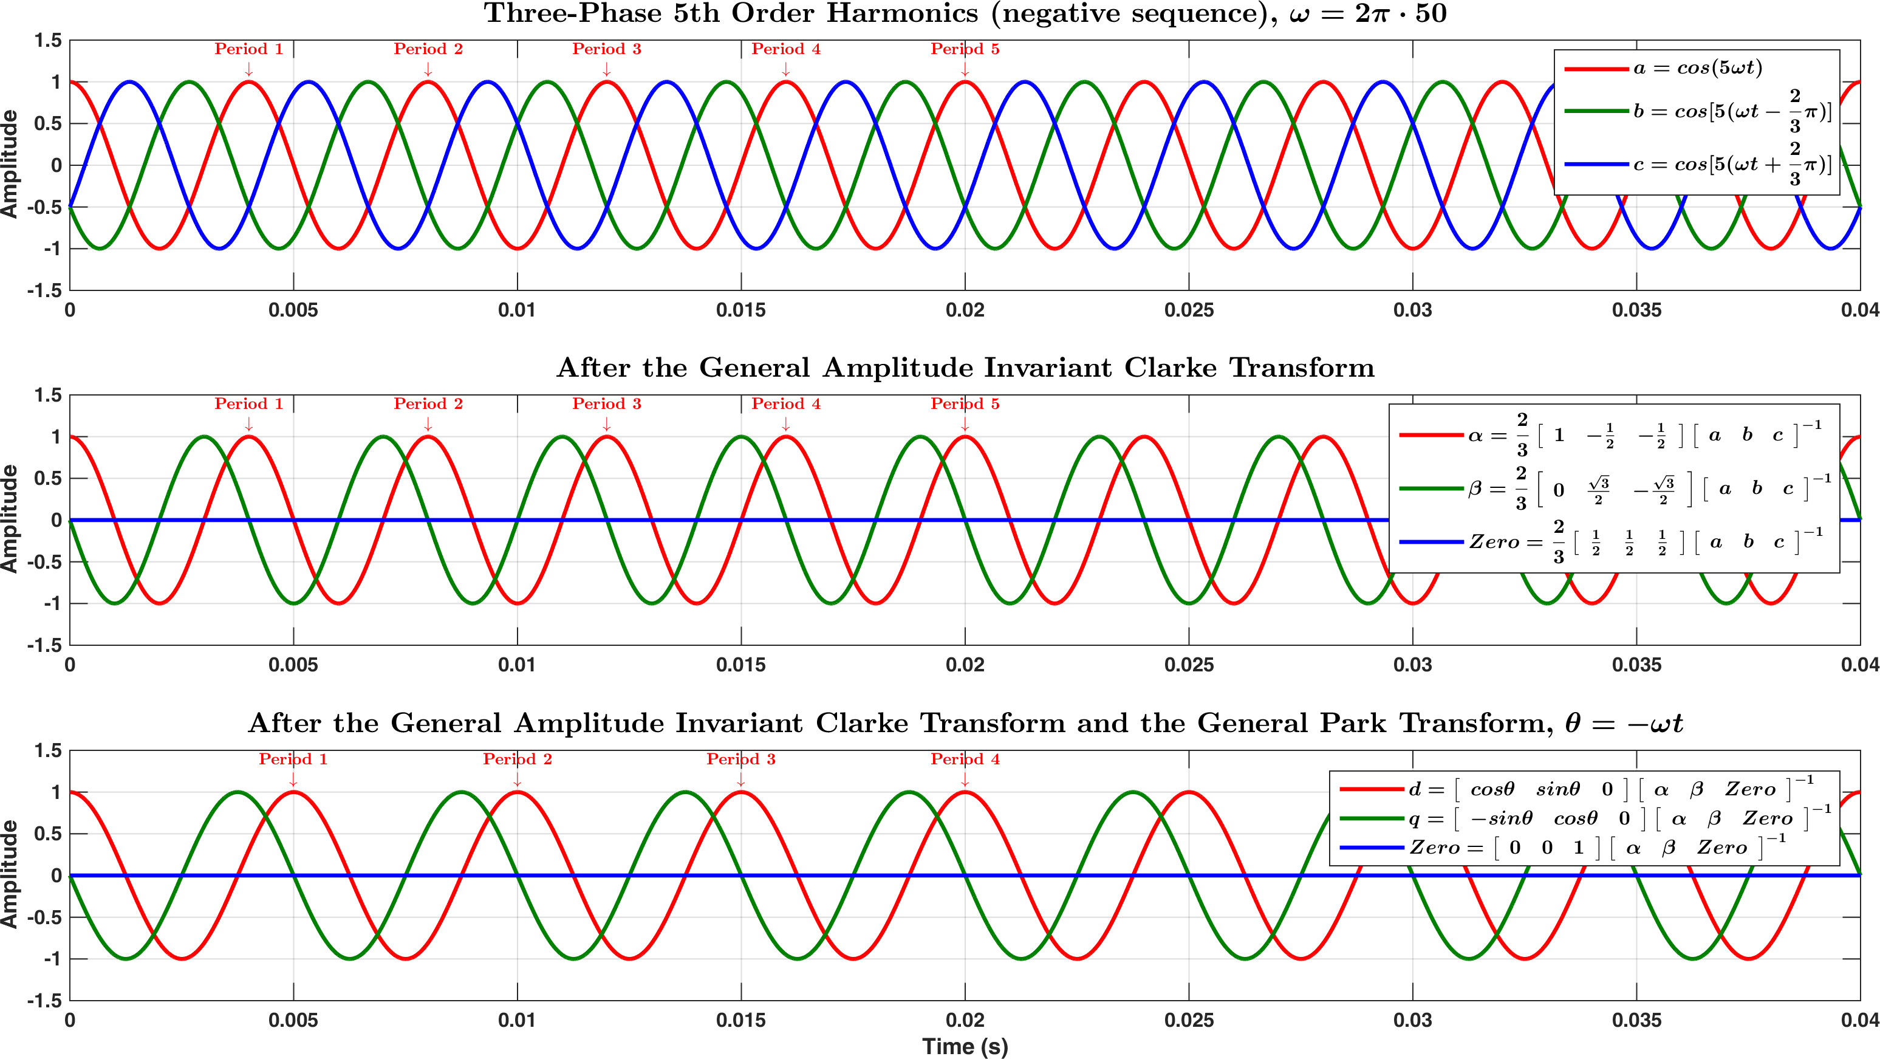

Figure .

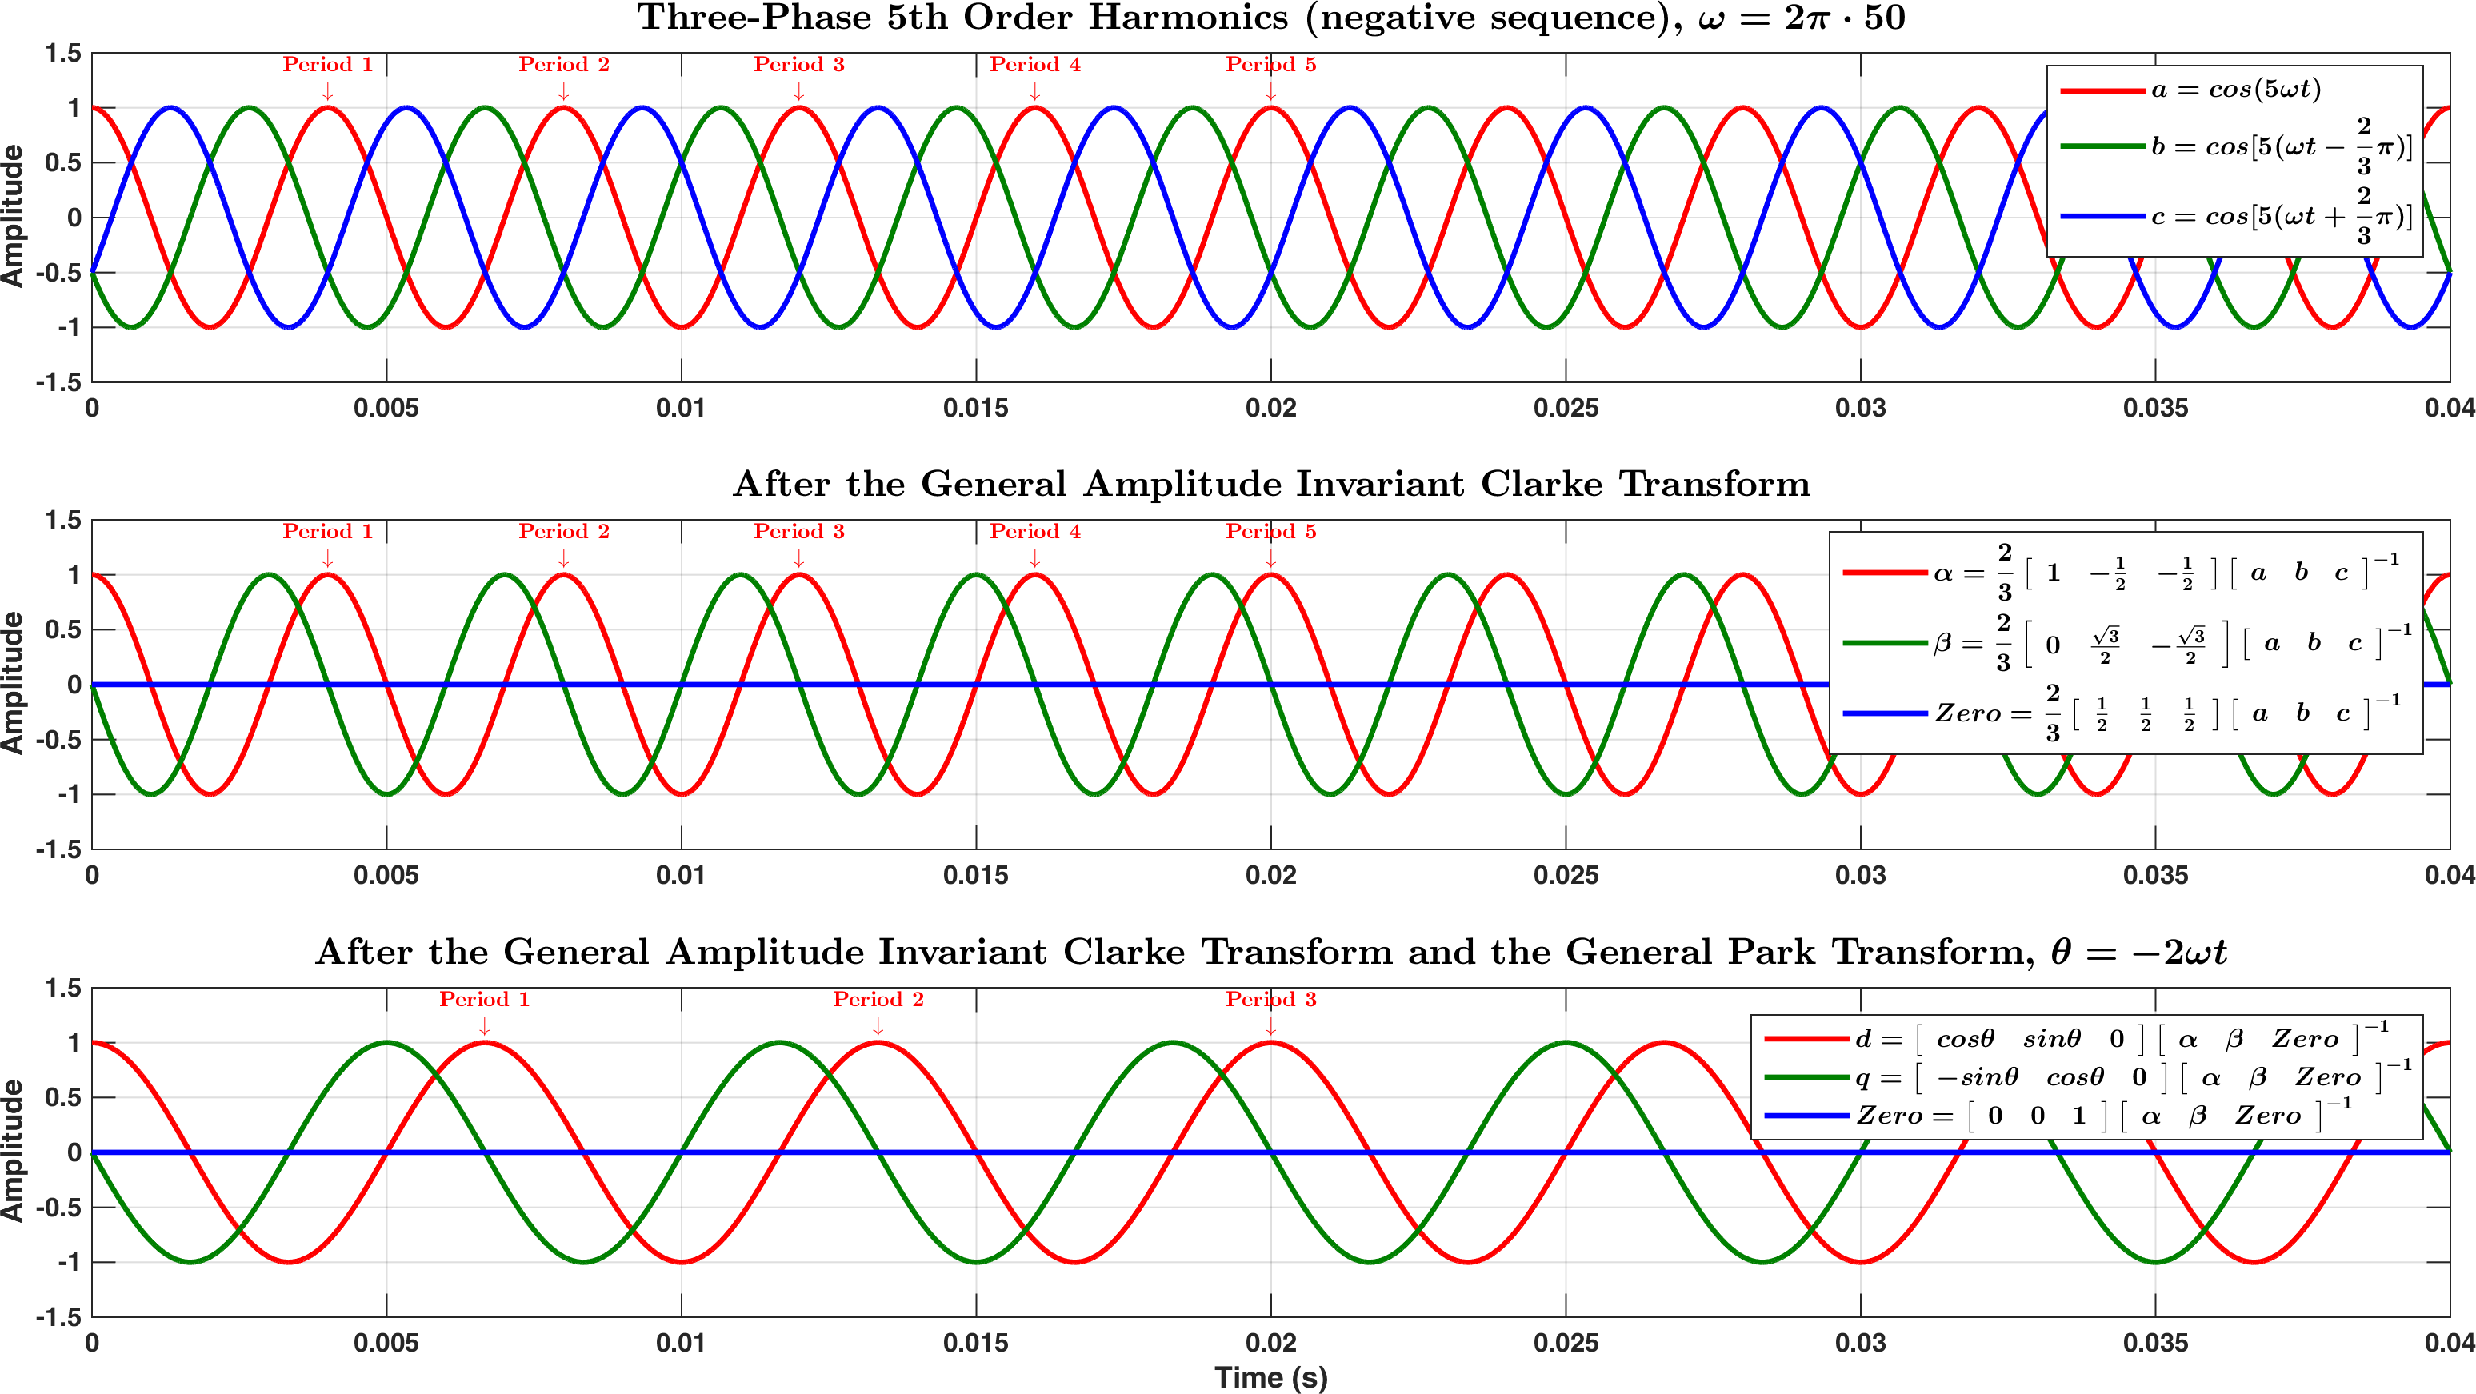

Figure .

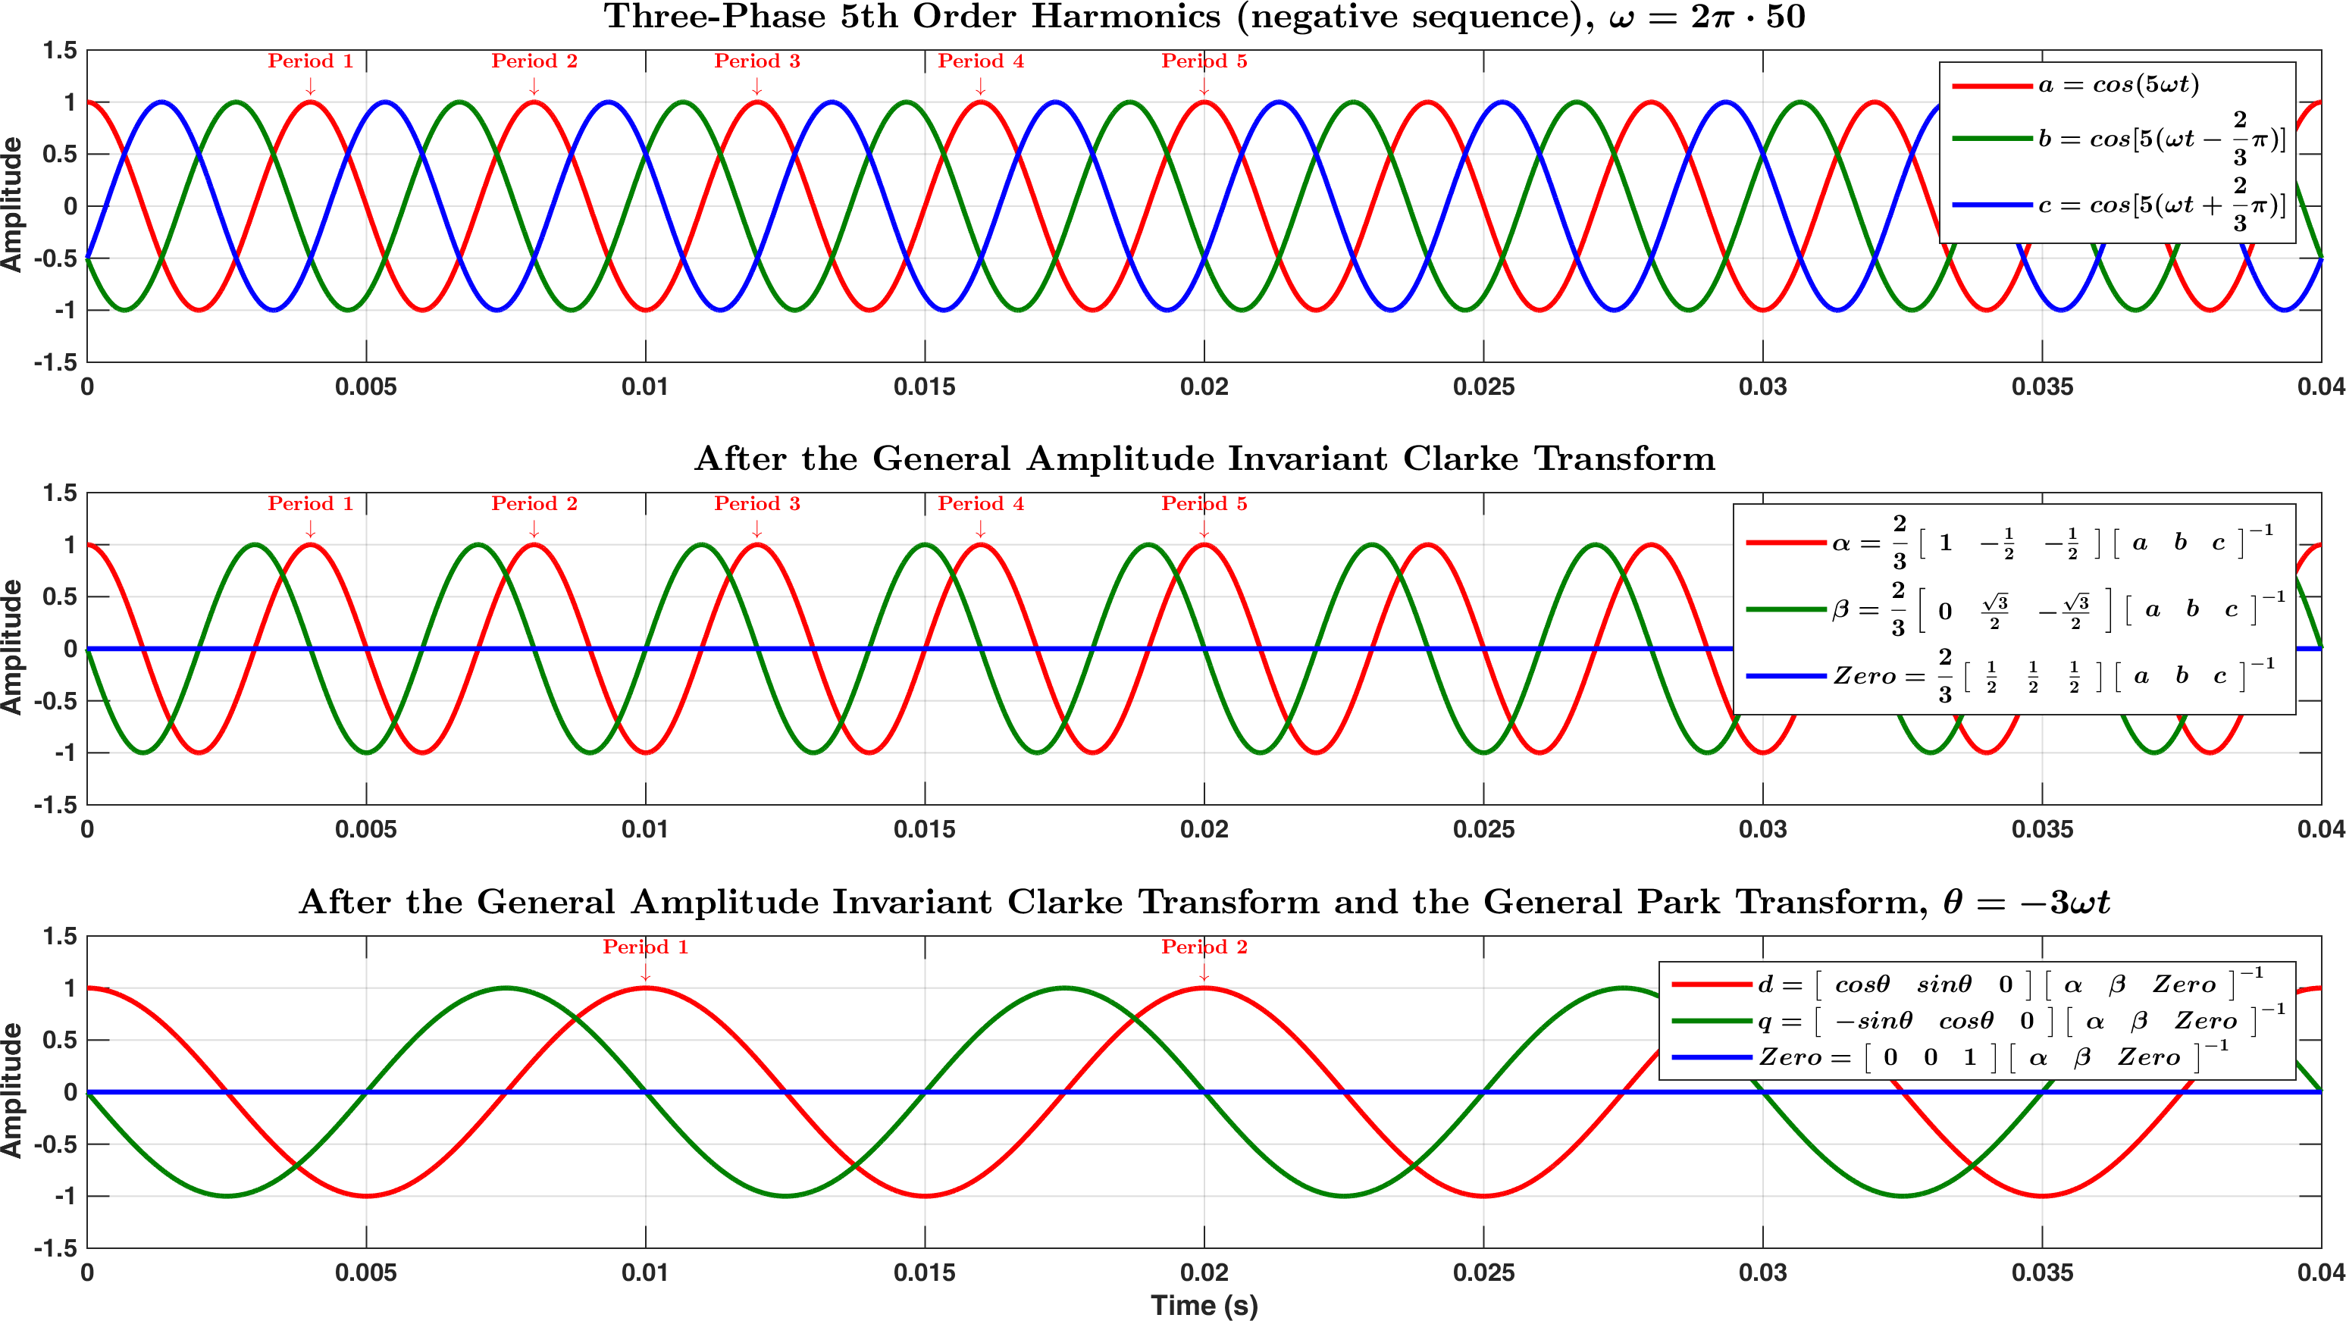

Figure .

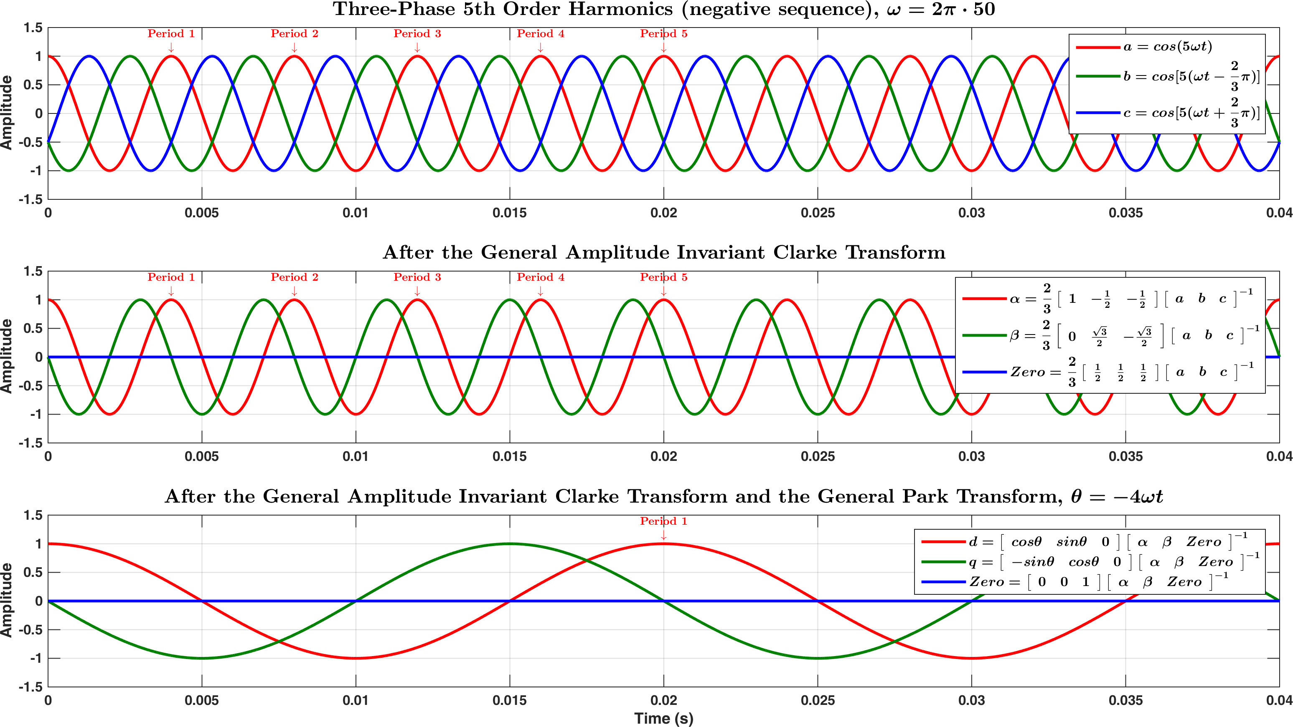

Figure .

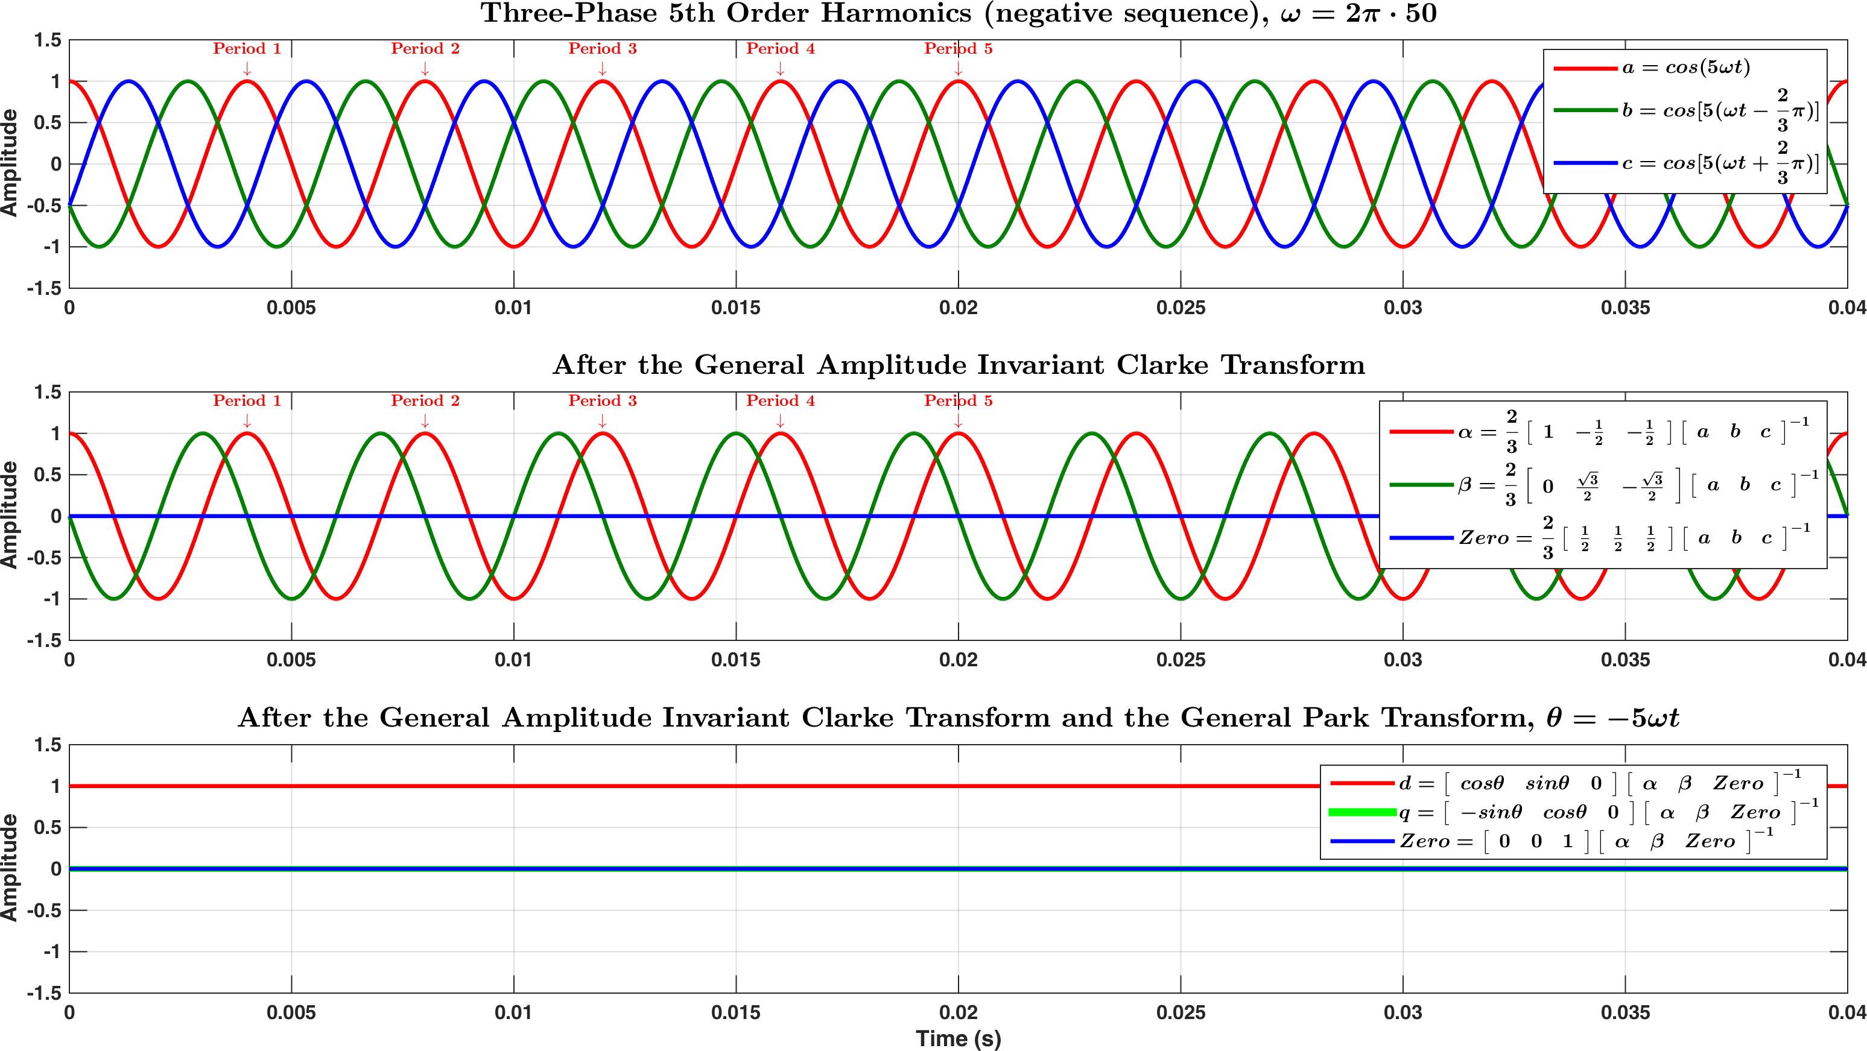

Figure .

# Conclusion

# Reference

[1] R. Teodorescu, M. Liserre, and P. Rodríguez, ‘Grid Synchronization in Three-Phase Power Converters’, in *Grid Converters for Photovoltaic and Wind Power Systems*, John Wiley & Sons, Ltd, 2011, pp. 169–204.

[2] E. Clarke, *Circuit analysis of AC power systems, Symmetrical and Related Components*, 1 vols. Wiley, 1943.

[3] R. H. Park, ‘Two-reaction theory of synchronous machines generalized method of analysis-part I’, *Trans. Am. Inst. Electr. Eng.*, vol. 48, no. 3, pp. 716–727, Jul. 1929.

[4] R. H. Park, ‘Two-reaction theory of synchronous machines — Part II’, *Electr. Eng.*, vol. 52, no. 1, pp. 44–45, Jan. 1933.

[5] S. Gao, ‘Grid Synchronisation of VSC-HVDC System’, The University of Manchester, Manchester, England, UK, 2014.

[6] P. Rodríguez, R. Teodorescu, I. Candela, A. V. Timbus, M. Liserre, and F. Blaabjerg, ‘New Positive Sequence voltage detector for grid synchronization of power converters under faulty grid conditions’, in *2006 37th IEEE Power Electronics Specialists Conference*, 2006, pp. 1–7.

[7] R. Teodorescu, M. Liserre, and P. Rodríguez, ‘Grid Synchronization in Single-Phase Power Converters’, in *Grid Converters for Photovoltaic and Wind Power Systems*, John Wiley & Sons, Ltd, 2011, pp. 43–91.

# Appendix A: Clarke Transform as a Quadrature Signal Generator

By varying the input sequence of the three-phase $abc$ quantities, the Clarke Transform can be used to generate 90° shifted (lagging) signals for the three inputs respectively.

Define the three-phase quantities as:

|  |  |
| --- | --- |
| $$\left[\begin{matrix}V_{a} \\ V_{b} \\ V_{c}\end{matrix}\right]=\left[\begin{matrix}v_{a}sinθ \\ v_{a}\sin\left(θ-120°\right) \\ v_{a}\sin\left(θ+120°\right)\end{matrix}\right]$$ | Ap.1 |

The Clarke Transform for these three-phase quantities is thus:

|  |  |
| --- | --- |
| $$\left[\begin{matrix}V_{α} \\ V_{β} \\ V_{0}\end{matrix}\right]=\frac{2}{3}\left[\begin{matrix}1 & -\frac{1}{2} & -\frac{1}{2} \\ 0 & \frac{\sqrt{3}}{2} & -\frac{\sqrt{3}}{2} \\ \frac{1}{2} & \frac{1}{2} & \frac{1}{2}\end{matrix}\right]\left[\begin{matrix}V_{a} \\ V_{b} \\ V_{c}\end{matrix}\right]$$ $$⇒$$ |  |
| $$V_{α}=\frac{2}{3}\left(V_{a}-\frac{1}{2}V_{b}-\frac{1}{2}V_{c}\right)$$ | Ap.2 |
| $$V_{β}=\frac{2}{3}\left(\frac{\sqrt{3}}{2}V_{b}-\frac{\sqrt{3}}{2}V_{c}\right)$$ | Ap.3 |

(continues to the next page)

By, referencing Ap.1, Ap.2 can be expanded as:

|  |  |
| --- | --- |
| $$V_{α}=\frac{2}{3}\left(V_{a}-\frac{1}{2}V_{b}-\frac{1}{2}V_{c}\right)$$ $$=\frac{2}{3}\left[v_{a}\sin{θ-\frac{1}{2}v_{a}\sin\left(θ-120°\right)}-\frac{1}{2}v_{a}\sin\left(θ+120°\right)\right]$$ $$=\frac{2}{3}v_{a}\left\{\sin{θ-\frac{1}{2}\left[\sin\left(θ-120°\right)+\sin\left(θ+120°\right)\right]}\right\}$$ $$=\frac{2}{3}v_{a}\left[\sin{θ}-\frac{1}{2}\left(2\sin{\frac{θ-120°+θ+120°}{2}}\cos{\frac{θ-120°-θ-120°}{2}}\right)\right]$$ $$=\frac{2}{3}v_{a}\left\{\sin{θ}-\frac{1}{2}\left[2\sin{θ}\cos\left(-120°\right)\right]\right\}$$ $$=\frac{2}{3}v_{a}\left[\sin{θ}-\frac{1}{2}\left(-\sin{θ}\right)\right]$$ $$=\frac{2}{3}v_{a}\left(\sin{θ}+\frac{1}{2}\sin{θ}\right)$$ $$=v_{a}\sin{θ}$$ $$=V_{a}$$ | Ap.4 |

As shown in Ap.4, in this case, $V_{α}$ is an exact copy of $V_{a}$.

By, referencing Ap.1, Ap.3 can be expanded as:

|  |  |
| --- | --- |
| $$V_{β}=\frac{2}{3}\left(\frac{\sqrt{3}}{2}V_{b}-\frac{\sqrt{3}}{2}V_{c}\right)$$ $$=\frac{\sqrt{3}}{3}v_{a}\left[\sin\left(θ-120°\right)-\sin\left(θ+120°\right)\right]$$ $$=\frac{\sqrt{3}}{3}v_{a}\left(2\cos{\frac{θ-120°+θ+120°}{2}\sin{\frac{θ-120°-θ-120°}{2}}}\right)$$ $$=\frac{\sqrt{3}}{3}v_{a}\left[2\cos{θ}\sin\left(-120°\right)\right]$$ $$=\frac{\sqrt{3}}{3}v_{a}\left(-\sqrt{3}\cos{θ}\right)$$ $$=-v_{a}\cos{θ}$$ $$=v_{a}\sin\left(θ-90°\right)$$ $$=V_{a}∠-90°$$ | Ap.5 |
| $$=V_{α}∠-90°$$ | Ap.6 |

As shown in Ap.5 and Ap.6, $V_{β}$ is an 90° shifted (lagging) copy of $V_{α} \left(V_{α}=V_{a}\right)$. Therefore $V_{β}$ is the quadrature signal of $V_{a}$.

Similarly, by changing the order of the elements in Ap.1, the quadrature signal of $V_{b}$ can be found:

|  |  |
| --- | --- |
| $$\left[\begin{matrix}V_{α} \\ V_{β} \\ V_{0}\end{matrix}\right]=\frac{2}{3}\left[\begin{matrix}1 & -\frac{1}{2} & -\frac{1}{2} \\ 0 & \frac{\sqrt{3}}{2} & -\frac{\sqrt{3}}{2} \\ \frac{1}{2} & \frac{1}{2} & \frac{1}{2}\end{matrix}\right]\left[\begin{matrix}V_{b} \\ V_{c} \\ V_{a}\end{matrix}\right]$$ $$⇒$$ |  |
| $$V_{α}=\frac{2}{3}\left(V_{b}-\frac{1}{2}V_{c}-\frac{1}{2}V_{a}\right)$$ |  |
| $$V_{β}=\frac{2}{3}\left(\frac{\sqrt{3}}{2}V_{c}-\frac{\sqrt{3}}{2}V_{a}\right)$$ |  |

(continues to the next page)

|  |  |
| --- | --- |
|  |  |

|  |  |
| --- | --- |
|  |  |

Similarly, by changing the order of the elements in Ap.1, the quadrature signal of $V_{c}$ can be found:

|  |  |
| --- | --- |
| $$\left[\begin{matrix}V_{α} \\ V_{β} \\ V_{0}\end{matrix}\right]=\frac{2}{3}\left[\begin{matrix}1 & -\frac{1}{2} & -\frac{1}{2} \\ 0 & \frac{\sqrt{3}}{2} & -\frac{\sqrt{3}}{2} \\ \frac{1}{2} & \frac{1}{2} & \frac{1}{2}\end{matrix}\right]\left[\begin{matrix}V_{c} \\ V_{a} \\ V_{b}\end{matrix}\right]$$ $$⇒$$ |  |
| $$V_{α}=\frac{2}{3}\left(V_{c}-\frac{1}{2}V_{a}-\frac{1}{2}V_{b}\right)$$ |  |
| $$V_{β}=\frac{2}{3}\left(\frac{\sqrt{3}}{2}V_{a}-\frac{\sqrt{3}}{2}V_{b}\right)$$ |  |

(continues to the next page)

|  |  |
| --- | --- |
|  |  |

|  |  |
| --- | --- |
|  |  |

# Appendix B: Clarke Transform as A Common Mode Signal Filter

When there exists common mode noise that is identical to all three phases, e.g. white noise, triplen harmonics, the Clarke transform can be used as a filter.

Define *N* as this type of noise:

|  |  |
| --- | --- |
| $$\left[\begin{matrix}V_{α} \\ V_{β} \\ V_{0}\end{matrix}\right]=\frac{2}{3}\left[\begin{matrix}1 & -\frac{1}{2} & -\frac{1}{2} \\ 0 & \frac{\sqrt{3}}{2} & -\frac{\sqrt{3}}{2} \\ \frac{1}{2} & \frac{1}{2} & \frac{1}{2}\end{matrix}\right]\left[\begin{matrix}V_{a}+N \\ V_{b}+N \\ V_{c}+N\end{matrix}\right]$$ $$⇒$$ |  |
| $$V_{α}=\frac{2}{3}\left[\left(V_{a}+N\right)-\frac{1}{2}\left(V_{b}+N\right)-\frac{1}{2}\left(V_{c}+N\right)\right]$$ $$=\frac{2}{3}\left[\left(V_{a}-\frac{1}{2}V_{b}-\frac{1}{2}V_{c}\right)+\left(N-\frac{1}{2}N-\frac{1}{2}N\right)\right]$$ $$=\frac{2}{3}\left(V_{a}-\frac{1}{2}V_{b}-\frac{1}{2}V_{c}\right)$$ $$=V_{a}$$ |  |
| $$V_{β}=\frac{2}{3}\left[\frac{\sqrt{3}}{2}\left(V_{b}+N\right)-\frac{\sqrt{3}}{2}\left(V_{c}+N\right)\right]$$ $$=\frac{\sqrt{3}}{3}\left[\left(V_{b}-V_{c}\right)+\left(N-N\right)\right]$$ $$=\frac{\sqrt{3}}{3}\left(V_{b}-V_{c}\right)$$ $$=V_{a}∠-90°$$ |  |
| $$V_{0}=\frac{2}{3}\left[\frac{1}{2}\left(V_{a}+N\right)+\frac{1}{2}\left(V_{b}+N\right)+\frac{1}{2}\left(V_{c}+N\right)\right]$$ $$=\frac{2}{3}\left[\frac{1}{2}\left(V_{a}+V_{b}+V_{c}\right)+\frac{3}{2}N\right]$$ $$=\frac{1}{3}\left(V_{a}+V_{b}+V_{c}\right)+N$$ $$when the three-phase system is balanced:$$ $$V_{0}=\frac{1}{3}\left(V_{a}+V_{b}+V_{c}\right)+N=0+N=N$$ |  |

# Appendix C: Combined Clarke and Park Transform

This section explains how to achieve the Clarke Transform and the Park Transform in one step as a single combined transform. However, combining the Clarke Transform and the Park Transform into one single transform might not be the best practice due to increased complexity. Such increased complexity could make it more difficult to debug and it could also make the implementation less intuitive (and thus more prone to error).

#### General Combined Clarke and Park Transform

This section derives the General Combined Clarke and Park Transform and its inverse. A summary is available in Section C3.

From Section 1, the followings are yielded:

**General Amplitude Invariant Clarke Transform:**

|  |  |
| --- | --- |
| $$\left[\begin{matrix}α \\ β \\ Zero\end{matrix}\right]= \frac{2}{3}\left[\begin{matrix}1 & -\frac{1}{2} & -\frac{1}{2} \\ 0 & \frac{\sqrt{3}}{2} & -\frac{\sqrt{3}}{2} \\ \frac{1}{2} & \frac{1}{2} & \frac{1}{2}\end{matrix}\right]\left[\begin{matrix}a \\ b \\ c\end{matrix}\right]$$ |  |

**The inverse of the General Amplitude Invariant Clarke Transform:**

|  |  |
| --- | --- |
| $$\left[\begin{matrix}a \\ b \\ c\end{matrix}\right]=\left[\begin{matrix}1 & 0 & 1 \\ -\frac{1}{2} & \frac{\sqrt{3}}{2} & 1 \\ -\frac{1}{2} & -\frac{\sqrt{3}}{2} & 1\end{matrix}\right]\left[\begin{matrix}α \\ β \\ Zero\end{matrix}\right]$$ |  |

Define the following terms:

|  |  |
| --- | --- |
| $$K_{ClkGen}=\frac{2}{3}\left[\begin{matrix}1 & -\frac{1}{2} & -\frac{1}{2} \\ 0 & \frac{\sqrt{3}}{2} & -\frac{\sqrt{3}}{2} \\ \frac{1}{2} & \frac{1}{2} & \frac{1}{2}\end{matrix}\right]$$ | Eq.93 |
| $$K_{ClkGen}^{-1}=\left[\begin{matrix}1 & 0 & 1 \\ -\frac{1}{2} & \frac{\sqrt{3}}{2} & 1 \\ -\frac{1}{2} & -\frac{\sqrt{3}}{2} & 1\end{matrix}\right]$$ | Eq.94 |

where the subscript “ $ClkGen$” is used to denote “General Clarke Transform”.

From Section 2, the followings are yielded:

**General Park Transform:**

|  |  |
| --- | --- |
| $$\left[\begin{matrix}d \\ q \\ Zero\end{matrix}\right]= \left[\begin{matrix}cosθ & sinθ & 0 \\ -sinθ & cosθ & 0 \\ 0 & 0 & 1\end{matrix}\right]\left[\begin{matrix}α \\ β \\ Zero\end{matrix}\right]$$ |  |

**The inverse of the General Park Transform:**

|  |  |
| --- | --- |
| $$\left[\begin{matrix}α \\ β \\ Zero\end{matrix}\right]= \left[\begin{matrix}cosθ & -sinθ & 0 \\ sinθ & cosθ & 0 \\ 0 & 0 & 1\end{matrix}\right]\left[\begin{matrix}d \\ q \\ Zero\end{matrix}\right]$$ |  |

Define the following terms:

|  |  |
| --- | --- |
| $$K_{ParkGen}=\left[\begin{matrix}cosθ & sinθ & 0 \\ -sinθ & cosθ & 0 \\ 0 & 0 & 1\end{matrix}\right]$$ | Eq.95 |
| $$K_{ParkGen}^{-1}=\left[\begin{matrix}cosθ & -sinθ & 0 \\ sinθ & cosθ & 0 \\ 0 & 0 & 1\end{matrix}\right]$$ | Eq.96 |

where the subscript “ $ParkGen$” is used to denote “General Park Transform”.

Now, Eq.1 and Eq.5 can be rewritten as Eq.97 and Eq.98, respectively:

|  |  |
| --- | --- |
| $$\left[\begin{matrix}α \\ β \\ Zero\end{matrix}\right]= K_{ClkGen}\left[\begin{matrix}a \\ b \\ c\end{matrix}\right]$$ | Eq.97 |
| $$\left[\begin{matrix}d \\ q \\ Zero\end{matrix}\right]= K_{ParkGen}\left[\begin{matrix}α \\ β \\ zero\end{matrix}\right]$$ | Eq.98 |
| $$⇒$$ |  |
| $$\left[\begin{matrix}d \\ q \\ Zero\end{matrix}\right]=K_{ParkGen}K_{ClkGen}\left[\begin{matrix}a \\ b \\ c\end{matrix}\right]$$ | Eq.99 |

By referencing Eq.93 and Eq.95:

|  |  |
| --- | --- |
| $$K_{ParkGen}K_{ClkGen}= \left[\begin{matrix}cosθ & sinθ & 0 \\ -sinθ & cosθ & 0 \\ 0 & 0 & 1\end{matrix}\right]\frac{2}{3}\left[\begin{matrix}1 & -\frac{1}{2} & -\frac{1}{2} \\ 0 & \frac{\sqrt{3}}{2} & -\frac{\sqrt{3}}{2} \\ \frac{1}{2} & \frac{1}{2} & \frac{1}{2}\end{matrix}\right]$$ |  |
| $$=\frac{2}{3}\left[\begin{matrix}cosθ & -\frac{1}{2}cosθ+\frac{\sqrt{3}}{2}sinθ & -\frac{1}{2}cosθ-\frac{\sqrt{3}}{2}sinθ \\ -sinθ & \frac{1}{2}sinθ+\frac{\sqrt{3}}{2}cosθ & \frac{1}{2}sinθ-\frac{\sqrt{3}}{2}cosθ \\ \frac{1}{2} & \frac{1}{2} & \frac{1}{2}\end{matrix}\right]$$ | Eq.100 |

Eq.100 can be simplified as Eq.101:

|  |  |  |
| --- | --- | --- |
| $$\frac{2}{3}\left[\begin{matrix}cosθ & -\frac{1}{2}cosθ+\frac{\sqrt{3}}{2}sinθ & -\frac{1}{2}cosθ-\frac{\sqrt{3}}{2}sinθ \\ -sinθ & \frac{1}{2}sinθ+\frac{\sqrt{3}}{2}cosθ & \frac{1}{2}sinθ-\frac{\sqrt{3}}{2}cosθ \\ \frac{1}{2} & \frac{1}{2} & \frac{1}{2}\end{matrix}\right]$$ | |  |
| $$=\frac{2}{3}\left[\begin{matrix}cosθ & cos120°cosθ+sin120°sinθ & cos120°cosθ-sin120°sinθ \\ -sinθ & -\left(cos120°sinθ-sin120°cosθ\right) & -\left(cos120°sinθ+sin120°cosθ\right) \\ \frac{1}{2} & \frac{1}{2} & \frac{1}{2}\end{matrix}\right]$$ | |  |
| $$=\frac{2}{3}\left[\begin{matrix}cosθ & cos\left(θ-120°\right) & cos\left(θ+120°\right) \\ -sinθ & -sin\left(θ-120°\right) & -sin\left(θ+120°\right) \\ \frac{1}{2} & \frac{1}{2} & \frac{1}{2}\end{matrix}\right]$$ | Eq.101 | |

For ease of implementation in MATLAB, Eq.100 may also be rewritten as Eq.102:

|  |  |
| --- | --- |
| $$\frac{2}{3}\left[\begin{matrix}cosθ & -\frac{1}{2}cosθ+\frac{\sqrt{3}}{2}sinθ & -\frac{1}{2}cosθ-\frac{\sqrt{3}}{2}sinθ \\ -sinθ & \frac{1}{2}sinθ+\frac{\sqrt{3}}{2}cosθ & \frac{1}{2}sinθ-\frac{\sqrt{3}}{2}cosθ \\ \frac{1}{2} & \frac{1}{2} & \frac{1}{2}\end{matrix}\right]$$ |  |
| $$=\frac{2}{3}\left\{cosθ\left[\begin{matrix}1 & -\frac{1}{2} & -\frac{1}{2} \\ 0 & \frac{\sqrt{3}}{2} & -\frac{\sqrt{3}}{2} \\ 0 & 0 & 0\end{matrix}\right]+sinθ\left[\begin{matrix}0 & \frac{\sqrt{3}}{2} & -\frac{\sqrt{3}}{2} \\ -1 & \frac{1}{2} & \frac{1}{2} \\ 0 & 0 & 0\end{matrix}\right]+\left[\begin{matrix}0 & 0 & 0 \\ 0 & 0 & 0 \\ \frac{1}{2} & \frac{1}{2} & \frac{1}{2}\end{matrix}\right]\right\}$$ | Eq.102 |

Eq.99 can now be rewritten as Eq.103 or Eq.104 or Eq.105 or Eq.106:

|  |  |
| --- | --- |
| $$\left[\begin{matrix}d \\ q \\ Zero\end{matrix}\right]=K_{ParkGen}K_{ClkGen}\left[\begin{matrix}a \\ b \\ c\end{matrix}\right]$$ |  |
| $$⇒$$ |  |
| $$\left[\begin{matrix}d \\ q \\ Zero\end{matrix}\right]=\frac{2}{3}\left[\begin{matrix}cosθ & -\frac{1}{2}cosθ+\frac{\sqrt{3}}{2}sinθ & -\frac{1}{2}cosθ-\frac{\sqrt{3}}{2}sinθ \\ -sinθ & \frac{1}{2}sinθ+\frac{\sqrt{3}}{2}cosθ & \frac{1}{2}sinθ-\frac{\sqrt{3}}{2}cosθ \\ \frac{1}{2} & \frac{1}{2} & \frac{1}{2}\end{matrix}\right]\left[\begin{matrix}a \\ b \\ c\end{matrix}\right]$$ | Eq.103 |
| $$\left[\begin{matrix}d \\ q \\ Zero\end{matrix}\right]=\frac{2}{3}\left[\begin{matrix}cosθ & cos\left(θ-120°\right) & cos\left(θ+120°\right) \\ -sinθ & -sin\left(θ-120°\right) & -sin\left(θ+120°\right) \\ \frac{1}{2} & \frac{1}{2} & \frac{1}{2}\end{matrix}\right]\left[\begin{matrix}a \\ b \\ c\end{matrix}\right]$$ | Eq.104 |
| $$\left[\begin{matrix}d \\ q \\ Zero\end{matrix}\right]=\frac{2}{3}\left\{cosθ\left[\begin{matrix}1 & -\frac{1}{2} & -\frac{1}{2} \\ 0 & \frac{\sqrt{3}}{2} & -\frac{\sqrt{3}}{2} \\ 0 & 0 & 0\end{matrix}\right]+sinθ\left[\begin{matrix}0 & \frac{\sqrt{3}}{2} & -\frac{\sqrt{3}}{2} \\ -1 & \frac{1}{2} & \frac{1}{2} \\ 0 & 0 & 0\end{matrix}\right]+\left[\begin{matrix}0 & 0 & 0 \\ 0 & 0 & 0 \\ \frac{1}{2} & \frac{1}{2} & \frac{1}{2}\end{matrix}\right]\right\}\left[\begin{matrix}a \\ b \\ c\end{matrix}\right]$$ | Eq.105 |
| $$\left[\begin{matrix}d \\ q \\ Zero\end{matrix}\right]=\frac{2}{3}\left\{cosθ\left[\begin{matrix}1 & -\frac{1}{2} & -\frac{1}{2} \\ 0 & \frac{\sqrt{3}}{2} & -\frac{\sqrt{3}}{2} \\ 0 & 0 & 0\end{matrix}\right]\left[\begin{matrix}a \\ b \\ c\end{matrix}\right]+sinθ\left[\begin{matrix}0 & \frac{\sqrt{3}}{2} & -\frac{\sqrt{3}}{2} \\ -1 & \frac{1}{2} & \frac{1}{2} \\ 0 & 0 & 0\end{matrix}\right]\left[\begin{matrix}a \\ b \\ c\end{matrix}\right]+\left[\begin{matrix}0 & 0 & 0 \\ 0 & 0 & 0 \\ \frac{1}{2} & \frac{1}{2} & \frac{1}{2}\end{matrix}\right]\left[\begin{matrix}a \\ b \\ c\end{matrix}\right]\right\}$$ | Eq.106 |

By referencing Eq.94 and Eq.96, the inverse transforms in Eq.2 and Eq.8 can be rewritten as Eq.107 and Eq.108, respectively:

|  |  |
| --- | --- |
| $$\left[\begin{matrix}a \\ b \\ c\end{matrix}\right]=K_{ClkGen}^{-1}\left[\begin{matrix}α \\ β \\ Zero\end{matrix}\right]$$ | Eq.107 |
| $$\left[\begin{matrix}α \\ β \\ zero\end{matrix}\right]= K_{ParkGen}^{-1}\left[\begin{matrix}d \\ q \\ Zero\end{matrix}\right]$$ | Eq.108 |
| $$⇒$$ |  |
| $$\left[\begin{matrix}a \\ b \\ c\end{matrix}\right]=K_{ClkGen}^{-1}K_{ParkGen}^{-1}\left[\begin{matrix}d \\ q \\ Zero\end{matrix}\right]$$ | Eq.109 |

By referencing Eq.94 and Eq.96:

|  |  |
| --- | --- |
| $$K_{ClkGen}^{-1}K_{ParkGen}^{-1}=\left[\begin{matrix}1 & 0 & 1 \\ -\frac{1}{2} & \frac{\sqrt{3}}{2} & 1 \\ -\frac{1}{2} & -\frac{\sqrt{3}}{2} & 1\end{matrix}\right]\left[\begin{matrix}cosθ & -sinθ & 0 \\ sinθ & cosθ & 0 \\ 0 & 0 & 1\end{matrix}\right]$$ |  |
| $$=\left[\begin{matrix}cosθ & -sinθ & 1 \\ -\frac{1}{2}cosθ+\frac{\sqrt{3}}{2}sinθ & \frac{1}{2}sinθ+\frac{\sqrt{3}}{2}cosθ & 1 \\ -\frac{1}{2}cosθ-\frac{\sqrt{3}}{2}sinθ & \frac{1}{2}sinθ-\frac{\sqrt{3}}{2}cosθ & 1\end{matrix}\right]$$ | Eq.110 |

Eq.110 can be simplified as Eq.111:

|  |  |
| --- | --- |
| $$K_{ClkGen}^{-1}K_{ParkGen}^{-1}=\left[\begin{matrix}cosθ & -sinθ & 1 \\ cos\left(θ-120°\right) & -sin\left(θ-120°\right) & 1 \\ cos\left(θ+120°\right) & -sin\left(θ+120°\right) & 1\end{matrix}\right]$$ | Eq.111 |

For ease of implementation in MATLAB, Eq.110 may also be rewritten as Eq.112:

|  |  |
| --- | --- |
| $$K_{ClkGen}^{-1}K_{ParkGen}^{-1}=cosθ\left[\begin{matrix}1 & 0 & 0 \\ -\frac{1}{2} & \frac{\sqrt{3}}{2} & 0 \\ -\frac{1}{2} & -\frac{\sqrt{3}}{2} & 0\end{matrix}\right]+sinθ\left[\begin{matrix}0 & -1 & 0 \\ \frac{\sqrt{3}}{2} & \frac{1}{2} & 0 \\ -\frac{\sqrt{3}}{2} & \frac{1}{2} & 0\end{matrix}\right]+\left[\begin{matrix}0 & 0 & 1 \\ 0 & 0 & 1 \\ 0 & 0 & 1\end{matrix}\right]$$ | Eq.112 |

Eq.109 can now be rewritten as Eq.113 or Eq.114 or Eq.115 or Eq.116:

|  |  |
| --- | --- |
| $$\left[\begin{matrix}a \\ b \\ c\end{matrix}\right]=K_{ClkGen}^{-1}K_{ParkGen}^{-1}\left[\begin{matrix}d \\ q \\ Zero\end{matrix}\right]$$ |  |
| $$\left[\begin{matrix}a \\ b \\ c\end{matrix}\right]=\left[\begin{matrix}cosθ & -sinθ & 1 \\ -\frac{1}{2}cosθ+\frac{\sqrt{3}}{2}sinθ & \frac{1}{2}sinθ+\frac{\sqrt{3}}{2}cosθ & 1 \\ -\frac{1}{2}cosθ-\frac{\sqrt{3}}{2}sinθ & \frac{1}{2}sinθ-\frac{\sqrt{3}}{2}cosθ & 1\end{matrix}\right]\left[\begin{matrix}d \\ q \\ Zero\end{matrix}\right]$$ | Eq.113 |
| $$\left[\begin{matrix}a \\ b \\ c\end{matrix}\right]=\left[\begin{matrix}cosθ & -sinθ & 1 \\ cos\left(θ-120°\right) & -sin\left(θ-120°\right) & 1 \\ cos\left(θ+120°\right) & -sin\left(θ+120°\right) & 1\end{matrix}\right]\left[\begin{matrix}d \\ q \\ Zero\end{matrix}\right]$$ | Eq.114 |
| $$\left[\begin{matrix}a \\ b \\ c\end{matrix}\right]=\left\{cosθ\left[\begin{matrix}1 & 0 & 0 \\ -\frac{1}{2} & \frac{\sqrt{3}}{2} & 0 \\ -\frac{1}{2} & -\frac{\sqrt{3}}{2} & 0\end{matrix}\right]+sinθ\left[\begin{matrix}0 & -1 & 0 \\ \frac{\sqrt{3}}{2} & \frac{1}{2} & 0 \\ -\frac{\sqrt{3}}{2} & \frac{1}{2} & 0\end{matrix}\right]+\left[\begin{matrix}0 & 0 & 1 \\ 0 & 0 & 1 \\ 0 & 0 & 1\end{matrix}\right]\right\}\left[\begin{matrix}d \\ q \\ Zero\end{matrix}\right]$$ | Eq.115 |
| $$\left[\begin{matrix}a \\ b \\ c\end{matrix}\right]=cosθ\left[\begin{matrix}1 & 0 & 0 \\ -\frac{1}{2} & \frac{\sqrt{3}}{2} & 0 \\ -\frac{1}{2} & -\frac{\sqrt{3}}{2} & 0\end{matrix}\right]\left[\begin{matrix}d \\ q \\ Zero\end{matrix}\right]+sinθ\left[\begin{matrix}0 & -1 & 0 \\ \frac{\sqrt{3}}{2} & \frac{1}{2} & 0 \\ -\frac{\sqrt{3}}{2} & \frac{1}{2} & 0\end{matrix}\right]\left[\begin{matrix}d \\ q \\ Zero\end{matrix}\right]+\left[\begin{matrix}0 & 0 & 1 \\ 0 & 0 & 1 \\ 0 & 0 & 1\end{matrix}\right]\left[\begin{matrix}d \\ q \\ Zero\end{matrix}\right]$$ | Eq.116 |

#### Summary of the General Combined Clarke and Park Transform

From Section C2, the General Combined Clarke and Park Transform can be summarised as the followings:

$\left[\begin{matrix}d \\ q \\ Zero\end{matrix}\right]=K_{ParkGen}K_{ClkGen}\left[\begin{matrix}a \\ b \\ c\end{matrix}\right]$

$$\left[\begin{matrix}d \\ q \\ Zero\end{matrix}\right]=\frac{2}{3}\left[\begin{matrix}cosθ & -\frac{1}{2}cosθ+\frac{\sqrt{3}}{2}sinθ & -\frac{1}{2}cosθ-\frac{\sqrt{3}}{2}sinθ \\ -sinθ & \frac{1}{2}sinθ+\frac{\sqrt{3}}{2}cosθ & \frac{1}{2}sinθ-\frac{\sqrt{3}}{2}cosθ \\ \frac{1}{2} & \frac{1}{2} & \frac{1}{2}\end{matrix}\right]\left[\begin{matrix}a \\ b \\ c\end{matrix}\right]$$

$$\left[\begin{matrix}d \\ q \\ Zero\end{matrix}\right]=\frac{2}{3}\left[\begin{matrix}cosθ & cos\left(θ-120°\right) & cos\left(θ+120°\right) \\ -sinθ & -sin\left(θ-120°\right) & -sin\left(θ+120°\right) \\ \frac{1}{2} & \frac{1}{2} & \frac{1}{2}\end{matrix}\right]\left[\begin{matrix}a \\ b \\ c\end{matrix}\right]$$

$$\left[\begin{matrix}d \\ q \\ Zero\end{matrix}\right]=\frac{2}{3}\left\{cosθ\left[\begin{matrix}1 & -\frac{1}{2} & -\frac{1}{2} \\ 0 & \frac{\sqrt{3}}{2} & -\frac{\sqrt{3}}{2} \\ 0 & 0 & 0\end{matrix}\right]+sinθ\left[\begin{matrix}0 & \frac{\sqrt{3}}{2} & -\frac{\sqrt{3}}{2} \\ -1 & \frac{1}{2} & \frac{1}{2} \\ 0 & 0 & 0\end{matrix}\right]+\left[\begin{matrix}0 & 0 & 0 \\ 0 & 0 & 0 \\ \frac{1}{2} & \frac{1}{2} & \frac{1}{2}\end{matrix}\right]\right\}\left[\begin{matrix}a \\ b \\ c\end{matrix}\right]$$

$$\left[\begin{matrix}d \\ q \\ Zero\end{matrix}\right]=\frac{2}{3}\left\{cosθ\left[\begin{matrix}1 & -\frac{1}{2} & -\frac{1}{2} \\ 0 & \frac{\sqrt{3}}{2} & -\frac{\sqrt{3}}{2} \\ 0 & 0 & 0\end{matrix}\right]\left[\begin{matrix}a \\ b \\ c\end{matrix}\right]+sinθ\left[\begin{matrix}0 & \frac{\sqrt{3}}{2} & -\frac{\sqrt{3}}{2} \\ -1 & \frac{1}{2} & \frac{1}{2} \\ 0 & 0 & 0\end{matrix}\right]\left[\begin{matrix}a \\ b \\ c\end{matrix}\right]+\left[\begin{matrix}0 & 0 & 0 \\ 0 & 0 & 0 \\ \frac{1}{2} & \frac{1}{2} & \frac{1}{2}\end{matrix}\right]\left[\begin{matrix}a \\ b \\ c\end{matrix}\right]\right\}$$

The inverse transform is available in the next page.

From Section C2, the inverse General Combined Clarke and Park Transform can be summarised as the followings:

$$\left[\begin{matrix}a \\ b \\ c\end{matrix}\right]=K_{ClkGen}^{-1}K_{ParkGen}^{-1}\left[\begin{matrix}d \\ q \\ Zero\end{matrix}\right]$$

$$\left[\begin{matrix}a \\ b \\ c\end{matrix}\right]=\left[\begin{matrix}cosθ & -sinθ & 1 \\ -\frac{1}{2}cosθ+\frac{\sqrt{3}}{2}sinθ & \frac{1}{2}sinθ+\frac{\sqrt{3}}{2}cosθ & 1 \\ -\frac{1}{2}cosθ-\frac{\sqrt{3}}{2}sinθ & \frac{1}{2}sinθ-\frac{\sqrt{3}}{2}cosθ & 1\end{matrix}\right]\left[\begin{matrix}d \\ q \\ Zero\end{matrix}\right]$$

$$\left[\begin{matrix}a \\ b \\ c\end{matrix}\right]=\left[\begin{matrix}cosθ & -sinθ & 1 \\ cos\left(θ-120°\right) & -sin\left(θ-120°\right) & 1 \\ cos\left(θ+120°\right) & -sin\left(θ+120°\right) & 1\end{matrix}\right]\left[\begin{matrix}d \\ q \\ Zero\end{matrix}\right]$$

$$\left[\begin{matrix}a \\ b \\ c\end{matrix}\right]=\left\{cosθ\left[\begin{matrix}1 & 0 & 0 \\ -\frac{1}{2} & \frac{\sqrt{3}}{2} & 0 \\ -\frac{1}{2} & -\frac{\sqrt{3}}{2} & 0\end{matrix}\right]+sinθ\left[\begin{matrix}0 & -1 & 0 \\ \frac{\sqrt{3}}{2} & \frac{1}{2} & 0 \\ -\frac{\sqrt{3}}{2} & \frac{1}{2} & 0\end{matrix}\right]+\left[\begin{matrix}0 & 0 & 1 \\ 0 & 0 & 1 \\ 0 & 0 & 1\end{matrix}\right]\right\}\left[\begin{matrix}d \\ q \\ Zero\end{matrix}\right]$$

$$\left[\begin{matrix}a \\ b \\ c\end{matrix}\right]=cosθ\left[\begin{matrix}1 & 0 & 0 \\ -\frac{1}{2} & \frac{\sqrt{3}}{2} & 0 \\ -\frac{1}{2} & -\frac{\sqrt{3}}{2} & 0\end{matrix}\right]\left[\begin{matrix}d \\ q \\ Zero\end{matrix}\right]+sinθ\left[\begin{matrix}0 & -1 & 0 \\ \frac{\sqrt{3}}{2} & \frac{1}{2} & 0 \\ -\frac{\sqrt{3}}{2} & \frac{1}{2} & 0\end{matrix}\right]\left[\begin{matrix}d \\ q \\ Zero\end{matrix}\right]+\left[\begin{matrix}0 & 0 & 1 \\ 0 & 0 & 1 \\ 0 & 0 & 1\end{matrix}\right]\left[\begin{matrix}d \\ q \\ Zero\end{matrix}\right]$$

#### Special Combined Clarke and Park Transform

This section derives the Special Combined Clarke and Park Transform and its inverse. A summary is available in Section C5.

From Section 1, the followings are yielded:

**Special Amplitude Invariant Clarke Transform:**

|  |  |
| --- | --- |
| $$\left[\begin{matrix}α \\ β\end{matrix}\right]= \frac{2}{3}\left[\begin{matrix}1 & -\frac{1}{2} & -\frac{1}{2} \\ 0 & \frac{\sqrt{3}}{2} & -\frac{\sqrt{3}}{2}\end{matrix}\right]\left[\begin{matrix}a \\ b \\ c\end{matrix}\right]$$ |  |

**The inverse of the Special Amplitude Invariant Clarke Transform:**

|  |  |
| --- | --- |
| $$\left[\begin{matrix}a \\ b \\ c\end{matrix}\right]= \left[\begin{matrix}1 & 0 \\ -\frac{1}{2} & \frac{\sqrt{3}}{2} \\ -\frac{1}{2} & -\frac{\sqrt{3}}{2}\end{matrix}\right]\left[\begin{matrix}α \\ β\end{matrix}\right]$$ |  |

Define the following terms:

|  |  |
| --- | --- |
| $$K_{ClkSpl}=\frac{2}{3}\left[\begin{matrix}1 & -\frac{1}{2} & -\frac{1}{2} \\ 0 & \frac{\sqrt{3}}{2} & -\frac{\sqrt{3}}{2}\end{matrix}\right]$$ | Eq.117 |
| $$K_{ClkSpl}^{-1}= \left[\begin{matrix}1 & 0 \\ -\frac{1}{2} & \frac{\sqrt{3}}{2} \\ -\frac{1}{2} & -\frac{\sqrt{3}}{2}\end{matrix}\right]$$ | Eq.118 |

where the subscript “ $ClkSpl$” is used to denote “Special Clarke Transform”.

From Section 2, the followings are yielded:

**Special Park Transform:**

|  |  |
| --- | --- |
| $$\left[\begin{matrix}d \\ q\end{matrix}\right]= \left[\begin{matrix}cosθ & sinθ \\ -sinθ & cosθ\end{matrix}\right]\left[\begin{matrix}α \\ β\end{matrix}\right]$$ |  |

**The inverse of the Special Park Transform:**

|  |  |
| --- | --- |
| $$\left[\begin{matrix}α \\ β\end{matrix}\right]= \left[\begin{matrix}cosθ & -sinθ \\ sinθ & cosθ\end{matrix}\right]\left[\begin{matrix}d \\ q\end{matrix}\right]$$ |  |

Define the following terms:

|  |  |
| --- | --- |
| $$K_{ParkSpl}=\left[\begin{matrix}cosθ & sinθ \\ -sinθ & cosθ\end{matrix}\right]$$ | Eq.119 |
| $$K_{ParkSpl}^{-1}=\left[\begin{matrix}cosθ & -sinθ \\ sinθ & cosθ\end{matrix}\right]$$ | Eq.120 |

where the subscript “ $ParkSpl$” is used to denote “Special Park Transform”.

Now, Eq.3 and Eq.10 can be written as:

|  |  |
| --- | --- |
| $$\left[\begin{matrix}α \\ β\end{matrix}\right]=K_{ClkSpl}\left[\begin{matrix}a \\ b \\ c\end{matrix}\right]$$ | Eq.121 |
| $$\left[\begin{matrix}d \\ q\end{matrix}\right]= K_{ParkSpl}\left[\begin{matrix}α \\ β\end{matrix}\right]$$ | Eq.122 |
| $$⇒$$ |  |
| $$\left[\begin{matrix}d \\ q\end{matrix}\right]= K_{ParkSpl}K_{ClkSpl}\left[\begin{matrix}a \\ b \\ c\end{matrix}\right]$$ | Eq.123 |

By referencing Eq.117 and Eq.119:

|  |  |
| --- | --- |
| $$K_{ParkSpl}K_{ClkSpl}=\left[\begin{matrix}cosθ & sinθ \\ -sinθ & cosθ\end{matrix}\right]\frac{2}{3}\left[\begin{matrix}1 & -\frac{1}{2} & -\frac{1}{2} \\ 0 & \frac{\sqrt{3}}{2} & -\frac{\sqrt{3}}{2}\end{matrix}\right]$$ |  |
| $$=\frac{2}{3}\left[\begin{matrix}cosθ & -\frac{1}{2}cosθ+\frac{\sqrt{3}}{2}sinθ & -\frac{1}{2}cosθ-\frac{\sqrt{3}}{2}sinθ \\ -sinθ & \frac{1}{2}sinθ+\frac{\sqrt{3}}{2}cosθ & \frac{1}{2}sinθ-\frac{\sqrt{3}}{2}cosθ\end{matrix}\right]$$ | Eq.124 |

Eq.124 can be simplified as Eq.125:

|  |  |
| --- | --- |
| $$K_{ParkSpl}K_{ClkSpl}=\frac{2}{3}\left[\begin{matrix}cosθ & -\frac{1}{2}cosθ+\frac{\sqrt{3}}{2}sinθ & -\frac{1}{2}cosθ-\frac{\sqrt{3}}{2}sinθ \\ -sinθ & \frac{1}{2}sinθ+\frac{\sqrt{3}}{2}cosθ & \frac{1}{2}sinθ-\frac{\sqrt{3}}{2}cosθ\end{matrix}\right]$$ |  |
| $$=\frac{2}{3}\left[\begin{matrix}cosθ & cos\left(θ-120°\right) & cos\left(θ+120°\right) \\ -sinθ & -sin\left(θ-120°\right) & -sin\left(θ+120°\right)\end{matrix}\right]$$ | Eq.125 |

For ease of implementation, Eq.124 may also be rewritten as Eq.126:

|  |  |
| --- | --- |
| $$K_{ParkSpl}K_{ClkSpl}=\frac{2}{3}\left[\begin{matrix}cosθ & -\frac{1}{2}cosθ+\frac{\sqrt{3}}{2}sinθ & -\frac{1}{2}cosθ-\frac{\sqrt{3}}{2}sinθ \\ -sinθ & \frac{1}{2}sinθ+\frac{\sqrt{3}}{2}cosθ & \frac{1}{2}sinθ-\frac{\sqrt{3}}{2}cosθ\end{matrix}\right]$$ |  |
| $$=\frac{2}{3}\left\{cosθ\left[\begin{matrix}1 & -\frac{1}{2} & -\frac{1}{2} \\ 0 & \frac{\sqrt{3}}{2} & -\frac{\sqrt{3}}{2}\end{matrix}\right]+sinθ\left[\begin{matrix}0 & \frac{\sqrt{3}}{2} & -\frac{\sqrt{3}}{2} \\ -1 & \frac{1}{2} & \frac{1}{2}\end{matrix}\right]\right\}$$ | Eq.126 |

Eq.123 can now be rewritten as Eq.127 or Eq.128 or Eq.129 or Eq.130:

|  |  |
| --- | --- |
| $$\left[\begin{matrix}d \\ q\end{matrix}\right]= K_{ParkSpl}K_{ClkSpl}\left[\begin{matrix}a \\ b \\ c\end{matrix}\right]$$ |  |
| $$\left[\begin{matrix}d \\ q\end{matrix}\right]= \frac{2}{3}\left[\begin{matrix}cosθ & -\frac{1}{2}cosθ+\frac{\sqrt{3}}{2}sinθ & -\frac{1}{2}cosθ-\frac{\sqrt{3}}{2}sinθ \\ -sinθ & \frac{1}{2}sinθ+\frac{\sqrt{3}}{2}cosθ & \frac{1}{2}sinθ-\frac{\sqrt{3}}{2}cosθ\end{matrix}\right]\left[\begin{matrix}a \\ b \\ c\end{matrix}\right]$$ | Eq.127 |
| $$\left[\begin{matrix}d \\ q\end{matrix}\right]= \frac{2}{3}\left[\begin{matrix}cosθ & cos\left(θ-120°\right) & cos\left(θ+120°\right) \\ -sinθ & -sin\left(θ-120°\right) & -sin\left(θ+120°\right)\end{matrix}\right]\left[\begin{matrix}a \\ b \\ c\end{matrix}\right]$$ | Eq.128 |
| $$\left[\begin{matrix}d \\ q\end{matrix}\right]=\frac{2}{3}\left\{cosθ\left[\begin{matrix}1 & -\frac{1}{2} & -\frac{1}{2} \\ 0 & \frac{\sqrt{3}}{2} & -\frac{\sqrt{3}}{2}\end{matrix}\right]+sinθ\left[\begin{matrix}0 & \frac{\sqrt{3}}{2} & -\frac{\sqrt{3}}{2} \\ -1 & \frac{1}{2} & \frac{1}{2}\end{matrix}\right]\right\}\left[\begin{matrix}a \\ b \\ c\end{matrix}\right]$$ | Eq.129 |
| $$\left[\begin{matrix}d \\ q\end{matrix}\right]= \frac{2}{3}\left\{cosθ\left[\begin{matrix}1 & -\frac{1}{2} & -\frac{1}{2} \\ 0 & \frac{\sqrt{3}}{2} & -\frac{\sqrt{3}}{2}\end{matrix}\right]\left[\begin{matrix}a \\ b \\ c\end{matrix}\right]+sinθ\left[\begin{matrix}0 & \frac{\sqrt{3}}{2} & -\frac{\sqrt{3}}{2} \\ -1 & \frac{1}{2} & \frac{1}{2}\end{matrix}\right]\left[\begin{matrix}a \\ b \\ c\end{matrix}\right]\right\}$$ | Eq.130 |

By referencing Eq.118 and Eq.120, the inverse transforms in Eq.4 and Eq.13 can be rewritten as Eq.131 and Eq.132, respectively:

|  |  |
| --- | --- |
| $$\left[\begin{matrix}a \\ b \\ c\end{matrix}\right]= K_{ClkSpl}^{-1}\left[\begin{matrix}α \\ β\end{matrix}\right]$$ | Eq.131 |
| $$\left[\begin{matrix}α \\ β\end{matrix}\right]= K_{ParkSpl}^{-1}\left[\begin{matrix}d \\ q\end{matrix}\right]$$ | Eq.132 |
| $$⇒$$ |  |
| $$\left[\begin{matrix}a \\ b \\ c\end{matrix}\right]=K_{ClkSpl}^{-1}K_{ParkSpl}^{-1}\left[\begin{matrix}d \\ q\end{matrix}\right]$$ | Eq.133 |

By referencing Eq.118 and Eq.120:

|  |  |
| --- | --- |
| $$K_{ClkSpl}^{-1}K_{ParkSpl}^{-1}= \left[\begin{matrix}1 & 0 \\ -\frac{1}{2} & \frac{\sqrt{3}}{2} \\ -\frac{1}{2} & -\frac{\sqrt{3}}{2}\end{matrix}\right]\left[\begin{matrix}cosθ & -sinθ \\ sinθ & cosθ\end{matrix}\right]$$ |  |
| $$=\left[\begin{matrix}cosθ & -sinθ \\ -\frac{1}{2}cosθ+\frac{\sqrt{3}}{2}sinθ & \frac{1}{2}sinθ+\frac{\sqrt{3}}{2}cosθ \\ -\frac{1}{2}cosθ-\frac{\sqrt{3}}{2}sinθ & \frac{1}{2}sinθ-\frac{\sqrt{3}}{2}cosθ\end{matrix}\right]$$ | Eq.134 |

Eq.134 can be simplified as Eq.135:

|  |  |
| --- | --- |
| $$K_{ClkSpl}^{-1}K_{ParkSpl}^{-1}=\left[\begin{matrix}cosθ & -sinθ \\ -\frac{1}{2}cosθ+\frac{\sqrt{3}}{2}sinθ & \frac{1}{2}sinθ+\frac{\sqrt{3}}{2}cosθ \\ -\frac{1}{2}cosθ-\frac{\sqrt{3}}{2}sinθ & \frac{1}{2}sinθ-\frac{\sqrt{3}}{2}cosθ\end{matrix}\right]$$ |  |
| $$=\left[\begin{matrix}cosθ & -sinθ \\ cos\left(θ-120°\right) & -sin\left(θ-120°\right) \\ cos\left(θ+120°\right) & -sin\left(θ+120°\right)\end{matrix}\right]$$ | Eq.135 |

For ease of implementation in MATLAB, Eq.134 may be rewritten as Eq.136:

|  |  |
| --- | --- |
| $$K_{ClkSpl}^{-1}K_{ParkSpl}^{-1}=\left[\begin{matrix}cosθ & -sinθ \\ -\frac{1}{2}cosθ+\frac{\sqrt{3}}{2}sinθ & \frac{1}{2}sinθ+\frac{\sqrt{3}}{2}cosθ \\ -\frac{1}{2}cosθ-\frac{\sqrt{3}}{2}sinθ & \frac{1}{2}sinθ-\frac{\sqrt{3}}{2}cosθ\end{matrix}\right]$$ |  |
| $$=cosθ\left[\begin{matrix}1 & 0 \\ -\frac{1}{2} & \frac{\sqrt{3}}{2} \\ -\frac{1}{2} & -\frac{\sqrt{3}}{2}\end{matrix}\right]+sinθ\left[\begin{matrix}0 & -1 \\ \frac{\sqrt{3}}{2} & \frac{1}{2} \\ -\frac{\sqrt{3}}{2} & \frac{1}{2}\end{matrix}\right]$$ | Eq.136 |

Eq.133 can now be rewritten as Eq.137 or Eq.138 or Eq.139 or Eq.140:

|  |  |
| --- | --- |
| $$\left[\begin{matrix}a \\ b \\ c\end{matrix}\right]=K_{ClkSpl}^{-1}K_{ParkSpl}^{-1}\left[\begin{matrix}d \\ q\end{matrix}\right]$$ |  |
| $$\left[\begin{matrix}a \\ b \\ c\end{matrix}\right]=\left[\begin{matrix}cosθ & -sinθ \\ -\frac{1}{2}cosθ+\frac{\sqrt{3}}{2}sinθ & \frac{1}{2}sinθ+\frac{\sqrt{3}}{2}cosθ \\ -\frac{1}{2}cosθ-\frac{\sqrt{3}}{2}sinθ & \frac{1}{2}sinθ-\frac{\sqrt{3}}{2}cosθ\end{matrix}\right]\left[\begin{matrix}d \\ q\end{matrix}\right]$$ | Eq.137 |
| $$\left[\begin{matrix}a \\ b \\ c\end{matrix}\right]=\left[\begin{matrix}cosθ & -sinθ \\ cos\left(θ-120°\right) & -sin\left(θ-120°\right) \\ cos\left(θ+120°\right) & -sin\left(θ+120°\right)\end{matrix}\right]\left[\begin{matrix}d \\ q\end{matrix}\right]$$ | Eq.138 |
| $$\left[\begin{matrix}a \\ b \\ c\end{matrix}\right]=\left\{cosθ\left[\begin{matrix}1 & 0 \\ -\frac{1}{2} & \frac{\sqrt{3}}{2} \\ -\frac{1}{2} & -\frac{\sqrt{3}}{2}\end{matrix}\right]+sinθ\left[\begin{matrix}0 & -1 \\ \frac{\sqrt{3}}{2} & \frac{1}{2} \\ -\frac{\sqrt{3}}{2} & \frac{1}{2}\end{matrix}\right]\right\}\left[\begin{matrix}d \\ q\end{matrix}\right]$$ | Eq.139 |
| $$\left[\begin{matrix}a \\ b \\ c\end{matrix}\right]=cosθ\left[\begin{matrix}1 & 0 \\ -\frac{1}{2} & \frac{\sqrt{3}}{2} \\ -\frac{1}{2} & -\frac{\sqrt{3}}{2}\end{matrix}\right]\left[\begin{matrix}d \\ q\end{matrix}\right]+sinθ\left[\begin{matrix}0 & -1 \\ \frac{\sqrt{3}}{2} & \frac{1}{2} \\ -\frac{\sqrt{3}}{2} & \frac{1}{2}\end{matrix}\right]\left[\begin{matrix}d \\ q\end{matrix}\right]$$ | Eq.140 |

#### Summary of the Special Combined Clarke and Park Transform

From Section C4, the Special Combined Clarke and Park Transform can be summarised as the followings:

$$\left[\begin{matrix}d \\ q\end{matrix}\right]=K_{ParkSpl}K_{ClkSpl}\left[\begin{matrix}a \\ b \\ c\end{matrix}\right]$$

$$\left[\begin{matrix}d \\ q\end{matrix}\right]=\frac{2}{3}\left[\begin{matrix}cosθ & -\frac{1}{2}cosθ+\frac{\sqrt{3}}{2}sinθ & -\frac{1}{2}cosθ-\frac{\sqrt{3}}{2}sinθ \\ -sinθ & \frac{1}{2}sinθ+\frac{\sqrt{3}}{2}cosθ & \frac{1}{2}sinθ-\frac{\sqrt{3}}{2}cosθ\end{matrix}\right]\left[\begin{matrix}a \\ b \\ c\end{matrix}\right]$$

$$\left[\begin{matrix}d \\ q\end{matrix}\right]=\frac{2}{3}\left[\begin{matrix}cosθ & cos\left(θ-120°\right) & cos\left(θ+120°\right) \\ -sinθ & -sin\left(θ-120°\right) & -sin\left(θ+120°\right)\end{matrix}\right]\left[\begin{matrix}a \\ b \\ c\end{matrix}\right]$$

$$\left[\begin{matrix}d \\ q\end{matrix}\right]=\frac{2}{3}\left\{cosθ\left[\begin{matrix}1 & -\frac{1}{2} & -\frac{1}{2} \\ 0 & \frac{\sqrt{3}}{2} & -\frac{\sqrt{3}}{2}\end{matrix}\right]+sinθ\left[\begin{matrix}0 & \frac{\sqrt{3}}{2} & -\frac{\sqrt{3}}{2} \\ -1 & \frac{1}{2} & \frac{1}{2}\end{matrix}\right]\right\}\left[\begin{matrix}a \\ b \\ c\end{matrix}\right]$$

$$\left[\begin{matrix}d \\ q\end{matrix}\right]=\frac{2}{3}\left\{cosθ\left[\begin{matrix}1 & -\frac{1}{2} & -\frac{1}{2} \\ 0 & \frac{\sqrt{3}}{2} & -\frac{\sqrt{3}}{2}\end{matrix}\right]\left[\begin{matrix}a \\ b \\ c\end{matrix}\right]+sinθ\left[\begin{matrix}0 & \frac{\sqrt{3}}{2} & -\frac{\sqrt{3}}{2} \\ -1 & \frac{1}{2} & \frac{1}{2}\end{matrix}\right]\left[\begin{matrix}a \\ b \\ c\end{matrix}\right]\right\}$$

The inverse transform is available in the next page.

From Section C4, the inverse Special Combined Clarke and Park Transform can be summarised as the followings:

$$\left[\begin{matrix}a \\ b \\ c\end{matrix}\right]=K_{ClkSpl}^{-1}K_{ParkSpl}^{-1}\left[\begin{matrix}d \\ q\end{matrix}\right]$$

$$\left[\begin{matrix}a \\ b \\ c\end{matrix}\right]=\left[\begin{matrix}cosθ & -sinθ \\ -\frac{1}{2}cosθ+\frac{\sqrt{3}}{2}sinθ & \frac{1}{2}sinθ+\frac{\sqrt{3}}{2}cosθ \\ -\frac{1}{2}cosθ-\frac{\sqrt{3}}{2}sinθ & \frac{1}{2}sinθ-\frac{\sqrt{3}}{2}cosθ\end{matrix}\right]\left[\begin{matrix}d \\ q\end{matrix}\right]$$

$$\left[\begin{matrix}a \\ b \\ c\end{matrix}\right]=\left[\begin{matrix}cosθ & -sinθ \\ cos\left(θ-120°\right) & -sin\left(θ-120°\right) \\ cos\left(θ+120°\right) & -sin\left(θ+120°\right)\end{matrix}\right]\left[\begin{matrix}d \\ q\end{matrix}\right]$$

$$\left[\begin{matrix}a \\ b \\ c\end{matrix}\right]=\left\{cosθ\left[\begin{matrix}1 & 0 \\ -\frac{1}{2} & \frac{\sqrt{3}}{2} \\ -\frac{1}{2} & -\frac{\sqrt{3}}{2}\end{matrix}\right]+sinθ\left[\begin{matrix}0 & -1 \\ \frac{\sqrt{3}}{2} & \frac{1}{2} \\ -\frac{\sqrt{3}}{2} & \frac{1}{2}\end{matrix}\right]\right\}\left[\begin{matrix}d \\ q\end{matrix}\right]$$

$$\left[\begin{matrix}a \\ b \\ c\end{matrix}\right]=cosθ\left[\begin{matrix}1 & 0 \\ -\frac{1}{2} & \frac{\sqrt{3}}{2} \\ -\frac{1}{2} & -\frac{\sqrt{3}}{2}\end{matrix}\right]\left[\begin{matrix}d \\ q\end{matrix}\right]+sinθ\left[\begin{matrix}0 & -1 \\ \frac{\sqrt{3}}{2} & \frac{1}{2} \\ -\frac{\sqrt{3}}{2} & \frac{1}{2}\end{matrix}\right]\left[\begin{matrix}d \\ q\end{matrix}\right]$$

#### DSRF Combined Clarke and Park Transform

This section derives the DSRF Combined Clarke and Park Transform and its inverse. A summary is available in Section C7.

From Section 2.3, the following is yielded:

**DSRF Park Transform:**

|  |  |
| --- | --- |
| $$\left[\begin{matrix}d_{+DSRF} \\ q_{+DSRF} \\ \begin{matrix}d_{-DSRF} \\ q_{-DSRF}\end{matrix}\end{matrix}\right]= \left[\begin{matrix}cosθ & sinθ \\ -sinθ & cosθ \\ cosθ & -sinθ \\ sinθ & cosθ\end{matrix}\right]\left[\begin{matrix}α \\ β\end{matrix}\right]$$ |  |

**The inverse DSRF Park Transform:**

|  |  |
| --- | --- |
| $$\left[\begin{matrix}α \\ β\end{matrix}\right]= \frac{1}{2}\left[\begin{matrix}cosθ & -sinθ & cosθ & sinθ \\ sinθ & cosθ & -sinθ & cosθ\end{matrix}\right]\left[\begin{matrix}d_{+DSRF} \\ q_{+DSRF} \\ \begin{matrix}d_{-DSRF} \\ q_{-DSRF}\end{matrix}\end{matrix}\right]$$ |  |

Define the following terms:

|  |  |
| --- | --- |
| $$K_{ParkDSRF}= \left[\begin{matrix}cosθ & sinθ \\ -sinθ & cosθ \\ cosθ & -sinθ \\ sinθ & cosθ\end{matrix}\right]$$ | Eq.141 |
| $$K_{ParkDSRF}^{-1}=\frac{1}{2}\left[\begin{matrix}cosθ & -sinθ & cosθ & sinθ \\ sinθ & cosθ & -sinθ & cosθ\end{matrix}\right]$$ | Eq.142 |

where the subscript “ $ParkDSRF$” is used to denote “DSRF Park Transform”.

By referencing Eq.121 and Eq.141:

|  |  |
| --- | --- |
| $$\left[\begin{matrix}d_{+DSRF} \\ q_{+DSRF} \\ \begin{matrix}d_{-DSRF} \\ q_{-DSRF}\end{matrix}\end{matrix}\right]=K_{ParkDSRF}K_{ClkSpl}\left[\begin{matrix}a \\ b \\ c\end{matrix}\right]$$ | Eq.143 |
| $$K_{ParkDSRF}K_{ClkSpl}=\left[\begin{matrix}cosθ & sinθ \\ -sinθ & cosθ \\ cosθ & -sinθ \\ sinθ & cosθ\end{matrix}\right]\frac{2}{3}\left[\begin{matrix}1 & -\frac{1}{2} & -\frac{1}{2} \\ 0 & \frac{\sqrt{3}}{2} & -\frac{\sqrt{3}}{2}\end{matrix}\right]$$ |  |
| $$=\frac{2}{3}\left[\begin{matrix}cosθ & -\frac{1}{2}cosθ+\frac{\sqrt{3}}{2}sinθ & -\frac{1}{2}cosθ-\frac{\sqrt{3}}{2}sinθ \\ -sinθ & \frac{1}{2}sinθ+\frac{\sqrt{3}}{2}cosθ & \frac{1}{2}sinθ-\frac{\sqrt{3}}{2}cosθ \\ cosθ & -\frac{1}{2}cosθ-\frac{\sqrt{3}}{2}sinθ & -\frac{1}{2}cosθ+\frac{\sqrt{3}}{2}sinθ \\ sinθ & -\frac{1}{2}sinθ+\frac{\sqrt{3}}{2}cosθ & -\frac{1}{2}sinθ-\frac{\sqrt{3}}{2}cosθ\end{matrix}\right]$$ | Eq.144 |

Eq.144 can be simplified as Eq.145:

|  |  |
| --- | --- |
| $$K_{ParkDSRF}K_{ClkSpl}=\frac{2}{3}\left[\begin{matrix}cosθ & -\frac{1}{2}cosθ+\frac{\sqrt{3}}{2}sinθ & -\frac{1}{2}cosθ-\frac{\sqrt{3}}{2}sinθ \\ -sinθ & \frac{1}{2}sinθ+\frac{\sqrt{3}}{2}cosθ & \frac{1}{2}sinθ-\frac{\sqrt{3}}{2}cosθ \\ cosθ & -\frac{1}{2}cosθ-\frac{\sqrt{3}}{2}sinθ & -\frac{1}{2}cosθ+\frac{\sqrt{3}}{2}sinθ \\ sinθ & -\frac{1}{2}sinθ+\frac{\sqrt{3}}{2}cosθ & -\frac{1}{2}sinθ-\frac{\sqrt{3}}{2}cosθ\end{matrix}\right]$$ |  |
| $$=\frac{2}{3}\left[\begin{matrix}cosθ & cos\left(θ-120°\right) & cos\left(θ+120°\right) \\ -sinθ & -sin\left(θ-120°\right) & -sin\left(θ+120°\right) \\ cosθ & cos\left(θ+120°\right) & cos\left(θ-120°\right) \\ sinθ & sin\left(θ+120°\right) & sin\left(θ-120°\right)\end{matrix}\right]$$ | Eq.145 |

For ease of implementation in MATLAB, Eq.144 may be rewritten as Eq.146:

|  |  |
| --- | --- |
| $$K_{ParkDSRF}K_{ClkSpl}=\frac{2}{3}\left[\begin{matrix}cosθ & -\frac{1}{2}cosθ+\frac{\sqrt{3}}{2}sinθ & -\frac{1}{2}cosθ-\frac{\sqrt{3}}{2}sinθ \\ -sinθ & \frac{1}{2}sinθ+\frac{\sqrt{3}}{2}cosθ & \frac{1}{2}sinθ-\frac{\sqrt{3}}{2}cosθ \\ cosθ & -\frac{1}{2}cosθ-\frac{\sqrt{3}}{2}sinθ & -\frac{1}{2}cosθ+\frac{\sqrt{3}}{2}sinθ \\ sinθ & -\frac{1}{2}sinθ+\frac{\sqrt{3}}{2}cosθ & -\frac{1}{2}sinθ-\frac{\sqrt{3}}{2}cosθ\end{matrix}\right]$$ |  |
| $$=\frac{2}{3}\left\{cosθ\left[\begin{matrix}1 & -\frac{1}{2} & -\frac{1}{2} \\ 0 & \frac{\sqrt{3}}{2} & -\frac{\sqrt{3}}{2} \\ 1 & -\frac{1}{2} & -\frac{1}{2} \\ 0 & \frac{\sqrt{3}}{2} & -\frac{\sqrt{3}}{2}\end{matrix}\right]+sinθ\left[\begin{matrix}0 & \frac{\sqrt{3}}{2} & -\frac{\sqrt{3}}{2} \\ -1 & \frac{1}{2} & \frac{1}{2} \\ 0 & -\frac{\sqrt{3}}{2} & \frac{\sqrt{3}}{2} \\ 1 & -\frac{1}{2} & -\frac{1}{2}\end{matrix}\right]\right\}$$ | Eq.146 |

(continues to the next page)

Eq.143 can now be rewritten as Eq.147 or Eq.148 or Eq.149 or Eq.150:

|  |  |
| --- | --- |
| $$\left[\begin{matrix}d_{+DSRF} \\ q_{+DSRF} \\ \begin{matrix}d_{-DSRF} \\ q_{-DSRF}\end{matrix}\end{matrix}\right]=K_{ParkDSRF}K_{ClkSpl}\left[\begin{matrix}a \\ b \\ c\end{matrix}\right]$$ |  |
| $$\left[\begin{matrix}d_{+DSRF} \\ q_{+DSRF} \\ \begin{matrix}d_{-DSRF} \\ q_{-DSRF}\end{matrix}\end{matrix}\right]=\frac{2}{3}\left[\begin{matrix}cosθ & -\frac{1}{2}cosθ+\frac{\sqrt{3}}{2}sinθ & -\frac{1}{2}cosθ-\frac{\sqrt{3}}{2}sinθ \\ -sinθ & \frac{1}{2}sinθ+\frac{\sqrt{3}}{2}cosθ & \frac{1}{2}sinθ-\frac{\sqrt{3}}{2}cosθ \\ cosθ & -\frac{1}{2}cosθ-\frac{\sqrt{3}}{2}sinθ & -\frac{1}{2}cosθ+\frac{\sqrt{3}}{2}sinθ \\ sinθ & -\frac{1}{2}sinθ+\frac{\sqrt{3}}{2}cosθ & -\frac{1}{2}sinθ-\frac{\sqrt{3}}{2}cosθ\end{matrix}\right]\left[\begin{matrix}a \\ b \\ c\end{matrix}\right]$$ | Eq.147 |
| $$\left[\begin{matrix}d_{+DSRF} \\ q_{+DSRF} \\ \begin{matrix}d_{-DSRF} \\ q_{-DSRF}\end{matrix}\end{matrix}\right]=\frac{2}{3}\left[\begin{matrix}cosθ & cos\left(θ-120°\right) & cos\left(θ+120°\right) \\ -sinθ & -sin\left(θ-120°\right) & -sin\left(θ+120°\right) \\ cosθ & cos\left(θ+120°\right) & cos\left(θ-120°\right) \\ sinθ & sin\left(θ+120°\right) & sin\left(θ-120°\right)\end{matrix}\right]\left[\begin{matrix}a \\ b \\ c\end{matrix}\right]$$ | Eq.148 |
| $$\left[\begin{matrix}d_{+DSRF} \\ q_{+DSRF} \\ \begin{matrix}d_{-DSRF} \\ q_{-DSRF}\end{matrix}\end{matrix}\right]=\frac{2}{3}\left\{cosθ\left[\begin{matrix}1 & -\frac{1}{2} & -\frac{1}{2} \\ 0 & \frac{\sqrt{3}}{2} & -\frac{\sqrt{3}}{2} \\ 1 & -\frac{1}{2} & -\frac{1}{2} \\ 0 & \frac{\sqrt{3}}{2} & -\frac{\sqrt{3}}{2}\end{matrix}\right]+sinθ\left[\begin{matrix}0 & \frac{\sqrt{3}}{2} & -\frac{\sqrt{3}}{2} \\ -1 & \frac{1}{2} & \frac{1}{2} \\ 0 & -\frac{\sqrt{3}}{2} & \frac{\sqrt{3}}{2} \\ 1 & -\frac{1}{2} & -\frac{1}{2}\end{matrix}\right]\right\}\left[\begin{matrix}a \\ b \\ c\end{matrix}\right]$$ | Eq.149 |
| $$\left[\begin{matrix}d_{+DSRF} \\ q_{+DSRF} \\ \begin{matrix}d_{-DSRF} \\ q_{-DSRF}\end{matrix}\end{matrix}\right]=\frac{2}{3}\left\{cosθ\left[\begin{matrix}1 & -\frac{1}{2} & -\frac{1}{2} \\ 0 & \frac{\sqrt{3}}{2} & -\frac{\sqrt{3}}{2} \\ 1 & -\frac{1}{2} & -\frac{1}{2} \\ 0 & \frac{\sqrt{3}}{2} & -\frac{\sqrt{3}}{2}\end{matrix}\right]\left[\begin{matrix}a \\ b \\ c\end{matrix}\right]+sinθ\left[\begin{matrix}0 & \frac{\sqrt{3}}{2} & -\frac{\sqrt{3}}{2} \\ -1 & \frac{1}{2} & \frac{1}{2} \\ 0 & -\frac{\sqrt{3}}{2} & \frac{\sqrt{3}}{2} \\ 1 & -\frac{1}{2} & -\frac{1}{2}\end{matrix}\right]\left[\begin{matrix}a \\ b \\ c\end{matrix}\right]\right\}$$ | Eq.150 |

By referencing Eq.4, Eq.20, Eq.118 and Eq.142:

|  |  |  |
| --- | --- | --- |
| $$\left[\begin{matrix}a \\ b \\ c\end{matrix}\right]=K_{ClkSpl}^{-1}K_{ParkDSRF}^{-1}\left[\begin{matrix}d_{+DSRF} \\ q_{+DSRF} \\ \begin{matrix}d_{-DSRF} \\ q_{-DSRF}\end{matrix}\end{matrix}\right]$$ | Eq.151 | |
| $$K_{ClkSpl}^{-1}K_{ParkDSRF}^{-1}=\left[\begin{matrix}1 & 0 \\ -\frac{1}{2} & \frac{\sqrt{3}}{2} \\ -\frac{1}{2} & -\frac{\sqrt{3}}{2}\end{matrix}\right]\frac{1}{2}\left[\begin{matrix}cosθ & -sinθ & cosθ & sinθ \\ sinθ & cosθ & -sinθ & cosθ\end{matrix}\right]$$ | |  |
| $$=\frac{1}{2}\left[\begin{matrix}cosθ & -sinθ & cosθ & sinθ \\ -\frac{1}{2}cosθ+\frac{\sqrt{3}}{2}sinθ & \frac{1}{2}sinθ+\frac{\sqrt{3}}{2}cosθ & -\frac{1}{2}cosθ-\frac{\sqrt{3}}{2}sinθ & -\frac{1}{2}sinθ+\frac{\sqrt{3}}{2}cosθ \\ -\frac{1}{2}cosθ-\frac{\sqrt{3}}{2}sinθ & \frac{1}{2}sinθ-\frac{\sqrt{3}}{2}cosθ & -\frac{1}{2}cosθ+\frac{\sqrt{3}}{2}sinθ & -\frac{1}{2}sinθ-\frac{\sqrt{3}}{2}cosθ\end{matrix}\right]$$ | | Eq.152 |

Eq.152 can be simplified as Eq.153:

|  |  |
| --- | --- |
| $$K_{ClkSpl}^{-1}K_{ParkDSRF}^{-1}=\frac{1}{2}\left[\begin{matrix}cosθ & -sinθ & cosθ & sinθ \\ -\frac{1}{2}cosθ+\frac{\sqrt{3}}{2}sinθ & \frac{1}{2}sinθ+\frac{\sqrt{3}}{2}cosθ & -\frac{1}{2}cosθ-\frac{\sqrt{3}}{2}sinθ & -\frac{1}{2}sinθ+\frac{\sqrt{3}}{2}cosθ \\ -\frac{1}{2}cosθ-\frac{\sqrt{3}}{2}sinθ & \frac{1}{2}sinθ-\frac{\sqrt{3}}{2}cosθ & -\frac{1}{2}cosθ+\frac{\sqrt{3}}{2}sinθ & -\frac{1}{2}sinθ-\frac{\sqrt{3}}{2}cosθ\end{matrix}\right]$$ | |
| $$=\frac{1}{2}\left[\begin{matrix}cosθ & -sinθ & cosθ & sinθ \\ cos\left(θ-120°\right) & -sin\left(θ-120°\right) & cos\left(θ+120°\right) & sin\left(θ+120°\right) \\ cos\left(θ+120°\right) & -sin\left(θ+120°\right) & cos\left(θ-120°\right) & sin\left(θ-120°\right)\end{matrix}\right]$$ | Eq.153 |

For ease of implementation, Eq.152 may be rewritten as Eq.154:

|  |  |
| --- | --- |
| $$K_{ClkSpl}^{-1}K_{ParkDSRF}^{-1}=\frac{1}{2}\left[\begin{matrix}cosθ & -sinθ & cosθ & sinθ \\ -\frac{1}{2}cosθ+\frac{\sqrt{3}}{2}sinθ & \frac{1}{2}sinθ+\frac{\sqrt{3}}{2}cosθ & -\frac{1}{2}cosθ-\frac{\sqrt{3}}{2}sinθ & -\frac{1}{2}sinθ+\frac{\sqrt{3}}{2}cosθ \\ -\frac{1}{2}cosθ-\frac{\sqrt{3}}{2}sinθ & \frac{1}{2}sinθ-\frac{\sqrt{3}}{2}cosθ & -\frac{1}{2}cosθ+\frac{\sqrt{3}}{2}sinθ & -\frac{1}{2}sinθ-\frac{\sqrt{3}}{2}cosθ\end{matrix}\right]$$ | |
| $$=\frac{1}{2}\left\{cosθ\left[\begin{matrix}1 & 0 & 1 & 0 \\ -\frac{1}{2} & \frac{\sqrt{3}}{2} & -\frac{1}{2} & \frac{\sqrt{3}}{2} \\ -\frac{1}{2} & -\frac{\sqrt{3}}{2} & -\frac{1}{2} & -\frac{\sqrt{3}}{2}\end{matrix}\right]+sinθ\left[\begin{matrix}0 & -1 & 0 & 1 \\ \frac{\sqrt{3}}{2} & \frac{1}{2} & -\frac{\sqrt{3}}{2} & -\frac{1}{2} \\ -\frac{\sqrt{3}}{2} & \frac{1}{2} & \frac{\sqrt{3}}{2} & -\frac{1}{2}\end{matrix}\right]\right\}$$ | Eq.154 |

Eq.151 can now be rewritten as Eq.155 or Eq.156 or Eq.157 or Eq.158:

|  |  |  |
| --- | --- | --- |
| $$\left[\begin{matrix}a \\ b \\ c\end{matrix}\right]=K_{ClkSpl}^{-1}K_{ParkDSRF}^{-1}\left[\begin{matrix}d_{+DSRF} \\ q_{+DSRF} \\ \begin{matrix}d_{-DSRF} \\ q_{-DSRF}\end{matrix}\end{matrix}\right]$$ |  | |
| $$\left[\begin{matrix}a \\ b \\ c\end{matrix}\right]$$ $$=\frac{1}{2}\left[\begin{matrix}cosθ & -sinθ & cosθ & sinθ \\ -\frac{1}{2}cosθ+\frac{\sqrt{3}}{2}sinθ & \frac{1}{2}sinθ+\frac{\sqrt{3}}{2}cosθ & -\frac{1}{2}cosθ-\frac{\sqrt{3}}{2}sinθ & -\frac{1}{2}sinθ+\frac{\sqrt{3}}{2}cosθ \\ -\frac{1}{2}cosθ-\frac{\sqrt{3}}{2}sinθ & \frac{1}{2}sinθ-\frac{\sqrt{3}}{2}cosθ & -\frac{1}{2}cosθ+\frac{\sqrt{3}}{2}sinθ & -\frac{1}{2}sinθ-\frac{\sqrt{3}}{2}cosθ\end{matrix}\right]\left[\begin{matrix}d_{+DSRF} \\ q_{+DSRF} \\ \begin{matrix}d_{-DSRF} \\ q_{-DSRF}\end{matrix}\end{matrix}\right]$$ | | Eq.155 |
| $$\left[\begin{matrix}a \\ b \\ c\end{matrix}\right]=\frac{1}{2}\left[\begin{matrix}cosθ & -sinθ & cosθ & sinθ \\ cos\left(θ-120°\right) & -sin\left(θ-120°\right) & cos\left(θ+120°\right) & sin\left(θ+120°\right) \\ cos\left(θ+120°\right) & -sin\left(θ+120°\right) & cos\left(θ-120°\right) & sin\left(θ-120°\right)\end{matrix}\right]\left[\begin{matrix}d_{+DSRF} \\ q_{+DSRF} \\ \begin{matrix}d_{-DSRF} \\ q_{-DSRF}\end{matrix}\end{matrix}\right]$$ | | Eq.156 |
| $$\left[\begin{matrix}a \\ b \\ c\end{matrix}\right]=\frac{1}{2}\left\{cosθ\left[\begin{matrix}1 & 0 & 1 & 0 \\ -\frac{1}{2} & \frac{\sqrt{3}}{2} & -\frac{1}{2} & \frac{\sqrt{3}}{2} \\ -\frac{1}{2} & -\frac{\sqrt{3}}{2} & -\frac{1}{2} & -\frac{\sqrt{3}}{2}\end{matrix}\right]+sinθ\left[\begin{matrix}0 & -1 & 0 & 1 \\ \frac{\sqrt{3}}{2} & \frac{1}{2} & -\frac{\sqrt{3}}{2} & -\frac{1}{2} \\ -\frac{\sqrt{3}}{2} & \frac{1}{2} & \frac{\sqrt{3}}{2} & -\frac{1}{2}\end{matrix}\right]\right\}\left[\begin{matrix}d_{+DSRF} \\ q_{+DSRF} \\ \begin{matrix}d_{-DSRF} \\ q_{-DSRF}\end{matrix}\end{matrix}\right]$$ | | Eq.157 |
| $$\left[\begin{matrix}a \\ b \\ c\end{matrix}\right]=\frac{1}{2}\left\{cosθ\left[\begin{matrix}1 & 0 & 1 & 0 \\ -\frac{1}{2} & \frac{\sqrt{3}}{2} & -\frac{1}{2} & \frac{\sqrt{3}}{2} \\ -\frac{1}{2} & -\frac{\sqrt{3}}{2} & -\frac{1}{2} & -\frac{\sqrt{3}}{2}\end{matrix}\right]\left[\begin{matrix}d_{+DSRF} \\ q_{+DSRF} \\ \begin{matrix}d_{-DSRF} \\ q_{-DSRF}\end{matrix}\end{matrix}\right]+sinθ\left[\begin{matrix}0 & -1 & 0 & 1 \\ \frac{\sqrt{3}}{2} & \frac{1}{2} & -\frac{\sqrt{3}}{2} & -\frac{1}{2} \\ -\frac{\sqrt{3}}{2} & \frac{1}{2} & \frac{\sqrt{3}}{2} & -\frac{1}{2}\end{matrix}\right]\left[\begin{matrix}d_{+DSRF} \\ q_{+DSRF} \\ \begin{matrix}d_{-DSRF} \\ q_{-DSRF}\end{matrix}\end{matrix}\right]\right\}$$ | | Eq.158 |

#### Summary of the DSRF Combined Clarke and Park Transform

From Section C6, the DSRF Combined Clarke and Park Transform can be summarised as the followings:

$$\left[\begin{matrix}d_{+DSRF} \\ q_{+DSRF} \\ \begin{matrix}d_{-DSRF} \\ q_{-DSRF}\end{matrix}\end{matrix}\right]=K_{ParkDSRF}K_{ClkSpl}\left[\begin{matrix}a \\ b \\ c\end{matrix}\right]$$

$$\left[\begin{matrix}d_{+DSRF} \\ q_{+DSRF} \\ \begin{matrix}d_{-DSRF} \\ q_{-DSRF}\end{matrix}\end{matrix}\right]=\frac{2}{3}\left[\begin{matrix}cosθ & -\frac{1}{2}cosθ+\frac{\sqrt{3}}{2}sinθ & -\frac{1}{2}cosθ-\frac{\sqrt{3}}{2}sinθ \\ -sinθ & \frac{1}{2}sinθ+\frac{\sqrt{3}}{2}cosθ & \frac{1}{2}sinθ-\frac{\sqrt{3}}{2}cosθ \\ cosθ & -\frac{1}{2}cosθ-\frac{\sqrt{3}}{2}sinθ & -\frac{1}{2}cosθ+\frac{\sqrt{3}}{2}sinθ \\ sinθ & -\frac{1}{2}sinθ+\frac{\sqrt{3}}{2}cosθ & -\frac{1}{2}sinθ-\frac{\sqrt{3}}{2}cosθ\end{matrix}\right]\left[\begin{matrix}a \\ b \\ c\end{matrix}\right]$$

$$\left[\begin{matrix}d_{+DSRF} \\ q_{+DSRF} \\ \begin{matrix}d_{-DSRF} \\ q_{-DSRF}\end{matrix}\end{matrix}\right]=\frac{2}{3}\left[\begin{matrix}cosθ & cos\left(θ-120°\right) & cos\left(θ+120°\right) \\ -sinθ & -sin\left(θ-120°\right) & -sin\left(θ+120°\right) \\ cosθ & cos\left(θ+120°\right) & cos\left(θ-120°\right) \\ sinθ & sin\left(θ+120°\right) & sin\left(θ-120°\right)\end{matrix}\right]\left[\begin{matrix}a \\ b \\ c\end{matrix}\right]$$

$$\left[\begin{matrix}d_{+DSRF} \\ q_{+DSRF} \\ \begin{matrix}d_{-DSRF} \\ q_{-DSRF}\end{matrix}\end{matrix}\right]=\frac{2}{3}\left\{cosθ\left[\begin{matrix}1 & -\frac{1}{2} & -\frac{1}{2} \\ 0 & \frac{\sqrt{3}}{2} & -\frac{\sqrt{3}}{2} \\ 1 & -\frac{1}{2} & -\frac{1}{2} \\ 0 & \frac{\sqrt{3}}{2} & -\frac{\sqrt{3}}{2}\end{matrix}\right]+sinθ\left[\begin{matrix}0 & \frac{\sqrt{3}}{2} & -\frac{\sqrt{3}}{2} \\ -1 & \frac{1}{2} & \frac{1}{2} \\ 0 & -\frac{\sqrt{3}}{2} & \frac{\sqrt{3}}{2} \\ 1 & -\frac{1}{2} & -\frac{1}{2}\end{matrix}\right]\right\}\left[\begin{matrix}a \\ b \\ c\end{matrix}\right]$$

$$\left[\begin{matrix}d_{+DSRF} \\ q_{+DSRF} \\ \begin{matrix}d_{-DSRF} \\ q_{-DSRF}\end{matrix}\end{matrix}\right]=\frac{2}{3}\left\{cosθ\left[\begin{matrix}1 & -\frac{1}{2} & -\frac{1}{2} \\ 0 & \frac{\sqrt{3}}{2} & -\frac{\sqrt{3}}{2} \\ 1 & -\frac{1}{2} & -\frac{1}{2} \\ 0 & \frac{\sqrt{3}}{2} & -\frac{\sqrt{3}}{2}\end{matrix}\right]\left[\begin{matrix}a \\ b \\ c\end{matrix}\right]+sinθ\left[\begin{matrix}0 & \frac{\sqrt{3}}{2} & -\frac{\sqrt{3}}{2} \\ -1 & \frac{1}{2} & \frac{1}{2} \\ 0 & -\frac{\sqrt{3}}{2} & \frac{\sqrt{3}}{2} \\ 1 & -\frac{1}{2} & -\frac{1}{2}\end{matrix}\right]\left[\begin{matrix}a \\ b \\ c\end{matrix}\right]\right\}$$

The inverse transform is available in the next page.

From Section C6, the inverse DSRF Combined Clarke and Park Transform can be summarised as the followings:

$$\left[\begin{matrix}a \\ b \\ c\end{matrix}\right]=K_{ClkSpl}^{-1}K_{ParkDSRF}^{-1}\left[\begin{matrix}d_{+DSRF} \\ q_{+DSRF} \\ \begin{matrix}d_{-DSRF} \\ q_{-DSRF}\end{matrix}\end{matrix}\right]$$

$$\left[\begin{matrix}a \\ b \\ c\end{matrix}\right]=\frac{1}{2}\left[\begin{matrix}cosθ & -sinθ & cosθ & sinθ \\ -\frac{1}{2}cosθ+\frac{\sqrt{3}}{2}sinθ & \frac{1}{2}sinθ+\frac{\sqrt{3}}{2}cosθ & -\frac{1}{2}cosθ-\frac{\sqrt{3}}{2}sinθ & -\frac{1}{2}sinθ+\frac{\sqrt{3}}{2}cosθ \\ -\frac{1}{2}cosθ-\frac{\sqrt{3}}{2}sinθ & \frac{1}{2}sinθ-\frac{\sqrt{3}}{2}cosθ & -\frac{1}{2}cosθ+\frac{\sqrt{3}}{2}sinθ & -\frac{1}{2}sinθ-\frac{\sqrt{3}}{2}cosθ\end{matrix}\right]\left[\begin{matrix}d_{+DSRF} \\ q_{+DSRF} \\ \begin{matrix}d_{-DSRF} \\ q_{-DSRF}\end{matrix}\end{matrix}\right]$$

$$\left[\begin{matrix}a \\ b \\ c\end{matrix}\right]=\frac{1}{2}\left[\begin{matrix}cosθ & -sinθ & cosθ & sinθ \\ cos\left(θ-120°\right) & -sin\left(θ-120°\right) & cos\left(θ+120°\right) & sin\left(θ+120°\right) \\ cos\left(θ+120°\right) & -sin\left(θ+120°\right) & cos\left(θ-120°\right) & sin\left(θ-120°\right)\end{matrix}\right]\left[\begin{matrix}d_{+DSRF} \\ q_{+DSRF} \\ \begin{matrix}d_{-DSRF} \\ q_{-DSRF}\end{matrix}\end{matrix}\right]$$

$$\left[\begin{matrix}a \\ b \\ c\end{matrix}\right]=\frac{1}{2}\left\{cosθ\left[\begin{matrix}1 & 0 & 1 & 0 \\ -\frac{1}{2} & \frac{\sqrt{3}}{2} & -\frac{1}{2} & \frac{\sqrt{3}}{2} \\ -\frac{1}{2} & -\frac{\sqrt{3}}{2} & -\frac{1}{2} & -\frac{\sqrt{3}}{2}\end{matrix}\right]+sinθ\left[\begin{matrix}0 & -1 & 0 & 1 \\ \frac{\sqrt{3}}{2} & \frac{1}{2} & -\frac{\sqrt{3}}{2} & -\frac{1}{2} \\ -\frac{\sqrt{3}}{2} & \frac{1}{2} & \frac{\sqrt{3}}{2} & -\frac{1}{2}\end{matrix}\right]\right\}\left[\begin{matrix}d_{+DSRF} \\ q_{+DSRF} \\ \begin{matrix}d_{-DSRF} \\ q_{-DSRF}\end{matrix}\end{matrix}\right]$$

$$\left[\begin{matrix}a \\ b \\ c\end{matrix}\right]=\frac{1}{2}\left\{cosθ\left[\begin{matrix}1 & 0 & 1 & 0 \\ -\frac{1}{2} & \frac{\sqrt{3}}{2} & -\frac{1}{2} & \frac{\sqrt{3}}{2} \\ -\frac{1}{2} & -\frac{\sqrt{3}}{2} & -\frac{1}{2} & -\frac{\sqrt{3}}{2}\end{matrix}\right]\left[\begin{matrix}d_{+DSRF} \\ q_{+DSRF} \\ \begin{matrix}d_{-DSRF} \\ q_{-DSRF}\end{matrix}\end{matrix}\right]+sinθ\left[\begin{matrix}0 & -1 & 0 & 1 \\ \frac{\sqrt{3}}{2} & \frac{1}{2} & -\frac{\sqrt{3}}{2} & -\frac{1}{2} \\ -\frac{\sqrt{3}}{2} & \frac{1}{2} & \frac{\sqrt{3}}{2} & -\frac{1}{2}\end{matrix}\right]\left[\begin{matrix}d_{+DSRF} \\ q_{+DSRF} \\ \begin{matrix}d_{-DSRF} \\ q_{-DSRF}\end{matrix}\end{matrix}\right]\right\}$$